Pastor’s Bible Class

The Twenty-Second Sunday after Pentecost

Hymn #783 “Take My Life and Let It Be”
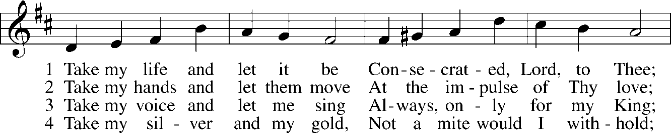
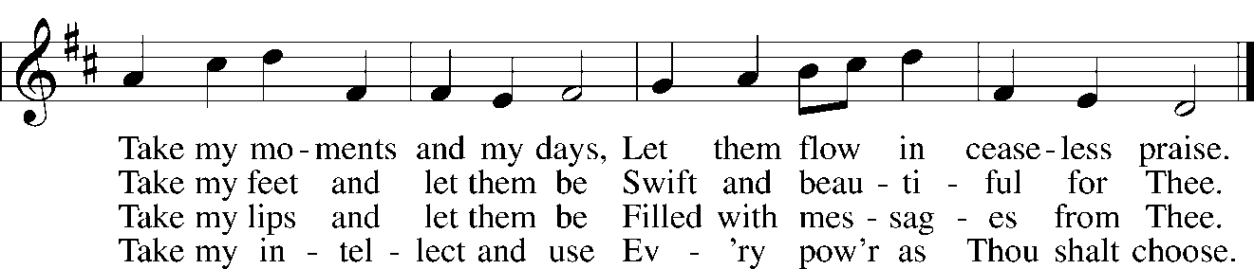

5 Take my will and make it Thine,  It shall be no longer mine;  Take my heart, it is Thine own,  It shall be Thy royal throne | 6 Take my love, my Lord, I pour  At Thy feet its treasure store;  Take myself, and I will be  Ever, only, all for Thee.
Read Ecclesiastes 5:10-20
1. This text speaks to the dangers of worldly wealth. What specific perils are highlighted in this text?

2. What important truth about wealth is revealed in verses 19-20?

Read Mark 10:23-31
3. Review and summarize the action from last week’s reading that leads into today’s text.

4. Why were the disciples, “amazed at his words” in verse 24?

5. What is the meaning of Jesus’ words in verses 24-25? See Ephesians 2:8-9.

8. Jesus says, “With man it is impossible, but not with God. For all things are possible with God.” How do we see these words applied in the following texts?

A. Genesis 1:1-3

B. Genesis 15:1-6

C. Mark 5:38-42

9. How do we understand the teaching from Jesus in verses 29-31? See:

A. Romans 8:31

B. Acts 2:42-47 and Acts 4:32

10. It’s important to see this reading in its proper context. Look at the following to better understand Mark’s underlying message:

A. Mark 8:31-33

B. Mark 9:12-13

C. Mark 9:30-32

D. Mark 10:32-34

Devotional Thought (The Lutheran Study Bible)
“Jesus teaches His disciples that not even people with the greatest worldly means can enter the Kingdom of God on their own merit. We cannot justify ourselves; we receive salvation (and inherit eternal life) solely by grace through faith in Jesus, just like a little child” (TLSB, 1680).

Prayer
O God, Your divine wisdom sets in order all things in heaven and on earth. Put away from us all things hurtful and give us those things that are beneficial for us; through Jesus Christ, Your Son, our Lord, who lives and reigns with You and the Holy Spirit, one God, now and forever. Amen.

THE RICH YOUNG RULER
This text is paralleled at Matthew 19:16-26 and Luke 18:18-27. From the three accounts this man has been called "the rich young ruler." Very likely a synagogue ruler. Christ had taught His disciples a lesson in verses 13-16 but they still had not really learned. Note utter contrast between verses 15 and 17.

Mark 10:17 As Jesus started on his way, a man ran up to him and fell on his knees before him. "Good teacher," he asked, "what must I do to inherit eternal life?"
The genitive absolute tense likely pictures Jesus emerging from the house mentioned in verse 10. Perhaps this young man was waiting for Jesus to emerge. Mark's account is more vivid than that of Matthew and Luke. Matthew 2 19:16-17 supplements are this point. He not only addressed Jesus as "good" but also asked what "good" He should do. Negative higher critics claim that Matthew rewrote Mark to tone down the harsh theology. That implies, of course, that it didn't really happen and plainly maintains that the authors of the Gospels determined the character of theology. The young man uses the word "good" in the unregenerate sense, not the Biblical sense. Just because people call Jesus "good" does not mean they are believers nor that they know what is truly good. "Inherit" in this context means "acquire." Beck: "To get." NEB: "To win." He wants to earn it.

Mark 10:18 "Why do you call me good?" Jesus answered. "No one is good -- except God alone."
Jesus does not say that He is not good nor does He deny that He is God.
Bengel: The young man perceived in Jesus the presence of goodness in some degree; otherwise he would not have applied to Him: but he did not perceive it in its full extent: otherwise he would not have left Him. Much less did he perceive His Godhead. Wherefore, Jesus does not accept from him the title of goodness without the title of Godhead.

Mark 10:19 "You know the commandments: 'Do not murder, do not commit adultery, do not steal, do not give false testimony, do not defraud, honor your father and mother.'"
This young man needs Law to show him his sin. Romans 3:20; Galatians 3:24. Jesus quotes commandments 5 through 8. "Do no defraud" has been interpreted variously:
- Lenski: Sum of ninth and tenth commandments;
- Beck: Don't rob;
- Hendriksen: "Do not withhold from your neighbor the love you owe him."
The fourth commandment is quoted last. Jesus quotes only the second table of the Law, for in this way He can the more quickly show this man his sin. That becomes clear in verse 21.

Mark 10:20 "Teacher," he declared, "all these I have kept since I was a boy."
He is totally Pharisaical. "I myself have kept." NEB, NIV: "Since I was a boy." Beck: "Since I was a child."

Mark 10:21 Jesus looked at him and loved him. " One thing you lack," he said. "Go, sell everything you have and give to the poor, and you will have treasure in heaven. Then come, follow me."
At this point Matthew 19:20 uses "he asked" with the question "What do I still lack?" Mark gives Jesus' answer: "One thing lacks you." (You lack one thing). The man's question plainly shows his honest dissatisfaction with himself.
Bengel states that "looked at him and loved him" denotes a hendiadys: "He lovingly beheld him." A good suggestion.
Note the utter contrast between the words "all" in verse 20, and "one" in verse 21. The "all" was not enough. The "one" is the final test. In verse 18 Jesus practically tells the man that he does not know what "good" means. In verse 21 He tells him that he does not know what true love toward God and man is. The "treasure in heaven" is not eschatological, but present. It is a promise. And to follow Jesus means to trust Him for all needed good for soul and body.
Bengel: This 'one thing' is a heart freed from the idolatry of creatures.
Ylvisaker: This particular command is based on the universal requirement of unconditional self-denial and the surrender of all for Christ's sake . . . It is a moral standard Jesus presents in these words for all, not only for the few . . . The demand is spiritual . . . It is important that we cut loose from everything which serves to hinder our salvation.
Hendriksen: To the young man, supplying this lack was a matter of 'addition.' But to Jesus, taking care of this lack was a matter of 'substitution.' Look at Galatians 2:10-21; Philippians 3:7ff.
Note that not only the young man, but also the disciples had something to learn.

Mark 10:22 At this the man's face fell. He went away sad, because he had great wealth.
Note the utter contrast between 17 and 22. This young Pharisee did not tempt Jesus but energetically sought Him. But when he heard Jesus' demand, a demand for all of us, he was crushed.
Beck: He looked gloomy and went away sad.
Mark gives us his outward appearance and his inner reaction. Both are participles of attendant circumstance. "Because" is "You see," an explanation.

Mark 10:23 Jesus looked around and said to his disciples, "How hard it is for the rich to enter the kingdom of God!"
"He went on to say." Very often the wealthy, like this young man, cannot give up their love and trust in their wealth.

Mark 10:24 The disciples were amazed at his words. But Jesus said again, "Children, how hard it is to enter the kingdom of God!"
"They were amazed." A strong word, in the passive. Then Jesus makes another statement, an absolute statement. The Koine variant, followed by the KJV, is not found in our translations. "And the disciples were astonished at his words. But Jesus answereth again, and saith unto them, Children, how hard is it for them that trust in riches to enter into the kingdom of God! KJV." Lenski argues vehemently for it. But the statement has more point without the variant.
Note that Jesus addresses them with "Children."
Hendricksen: The twelve were very dear to Him; yet he knows how weak, how prone to error, they are.
True. Since Mark 8:27, the final ten months of Jesus' ministry, Jesus spends much time instructing the disciples. That should not be overlooked here.

Mark 10:25 " It is easier for a camel to go through the eye of a needle than for a rich man to enter the kingdom of God."
Don't worry about the variant readings. All translations agree with Nestle's Greek text reading. The single point of this verse is that which is impossible for man. Who is meant by "rich man?" It is plain from verse 26 what Jesus meant. The disciples were not wealthy but realized that Jesus included them. Jesus means any and every man who trusts in his earthly possessions more than in Jesus. Or maybe we should not even say: "more than."

Mark 10:26 The disciples were even more amazed, and said to each other, "Who then can be saved?"
"Even more amazed." A very strong expression. NEB: "They were more astonished than ever." Their amazement gave evidence to itself by what they said. The translations are divided between reading "to each other" and "to Him," nor does it make any difference. Matthew and Luke are of no help at this point. "Well then!" is an exclamation in the Greek, not translated by NIV. The disciples betray their synergism and openly contradict the passive used by Jesus which denotes God as agent.
Lenski: The sense is 'And then nobody can be saved!' i.e. what Jesus says cannot be true.

Mark 10:27 Jesus looked at them and said, "With man this is impossible, but not with God; all things are possible with God."
"Looked at them" again denotes Jesus' love. "He went on to say." On the thought in this verse look at Genesis 18:14 and Luke 1:37. "Man" means "people." Note the word order.
It is no more impossible for God to save a self-righteous rich man than to save a self-righteous poor man.
Stoeckhardt: God has the power to convert and renew sinful people so that their heart is torn loose from all earthly things and they cling to Him alone.
Don't overlook the fact that the disciples, and all of us, have a dear lesson to learn.

