Pastor’s Bible Class

The Third Sunday in Lent

#981 “To Your Temple, Lord, I Come”
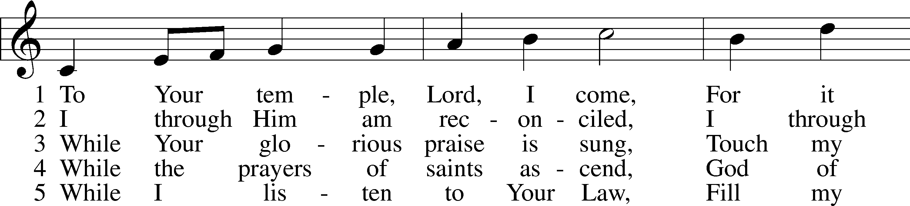
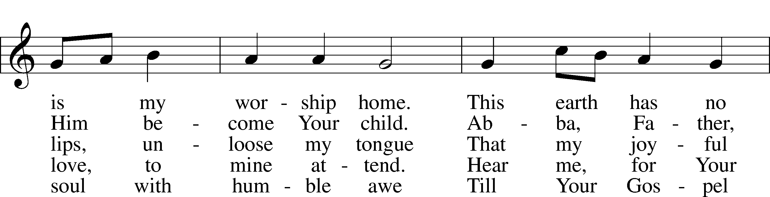
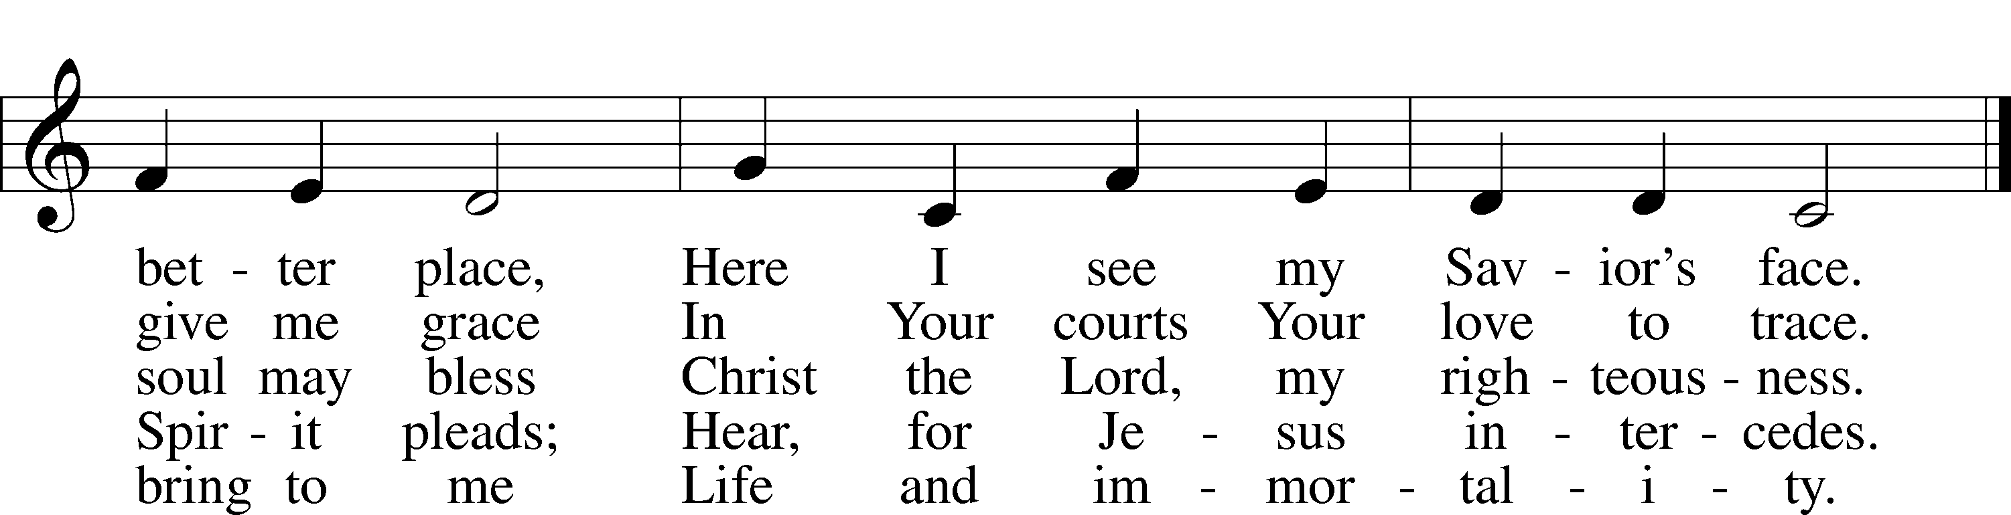

Read Exodus 20:1-17

1. To what momentous event does God point as He introduces His commandments in verse 2? Why?

2. We typically characterize jealously as an undesirable, if not sinful, characteristic. Why does God use this particular word in verse 5 to describe Himself?

3. As you reflect on the Ten Commandments as they appear in this text what details stand out? What questions does this list raise?

4. What occurs prior to and immediately following the giving of the Law at Sinai? See 19:16-20 and 20:18-21. What is the impact of this text?
Read I Corinthians 1:18-31

5. In this reading Paul comments on the message of the Cross. How does he characterize this Gospel message about Christ crucified?

6. Paul makes it clear that no human being has anything to boast about in God’s presence. How does the first reading from Exodus 20 underscore this truth?

7. Why is this concept so critical for us to understand?

Read John 2:13-25

8. What important information does John disclose in verse 13?

9. After Jesus clears the temple, the Jews demand that Jesus give a sign of His authority to disrupt the Passover feast (see also I Corinthians 1:22). What does this indicate about the Jews?

10. What is His answer and how do the Jews understand His answer?

11. How does their misunderstanding manifest itself in the future? See Matthew 26:60-61; 27:40 and Acts 6:14.

12. Read Revelation 21:22. How does this help us understand the words Jesus spoke in John 2:19?

Devotional Thought from “The Lutheran Study Bible”
With holy zeal, Jesus cleanses the temple, which has been turned into a marketplace, and He predicts His resurrection to those questioning His authority. When we disrespect God’s Word and sacred things, He calls us to repentance. Christ’s suffering, death and resurrection reveal God’s heart, which is zealous for those He loves (TLSB, 1782).

Closing Prayer
O risen Lord, give me a heart that fervently clings to You and Your Word. Amen.

