Pastor’s Bible Class

The Epiphany of Our Lord

“As with Gladness Men of Old” #397
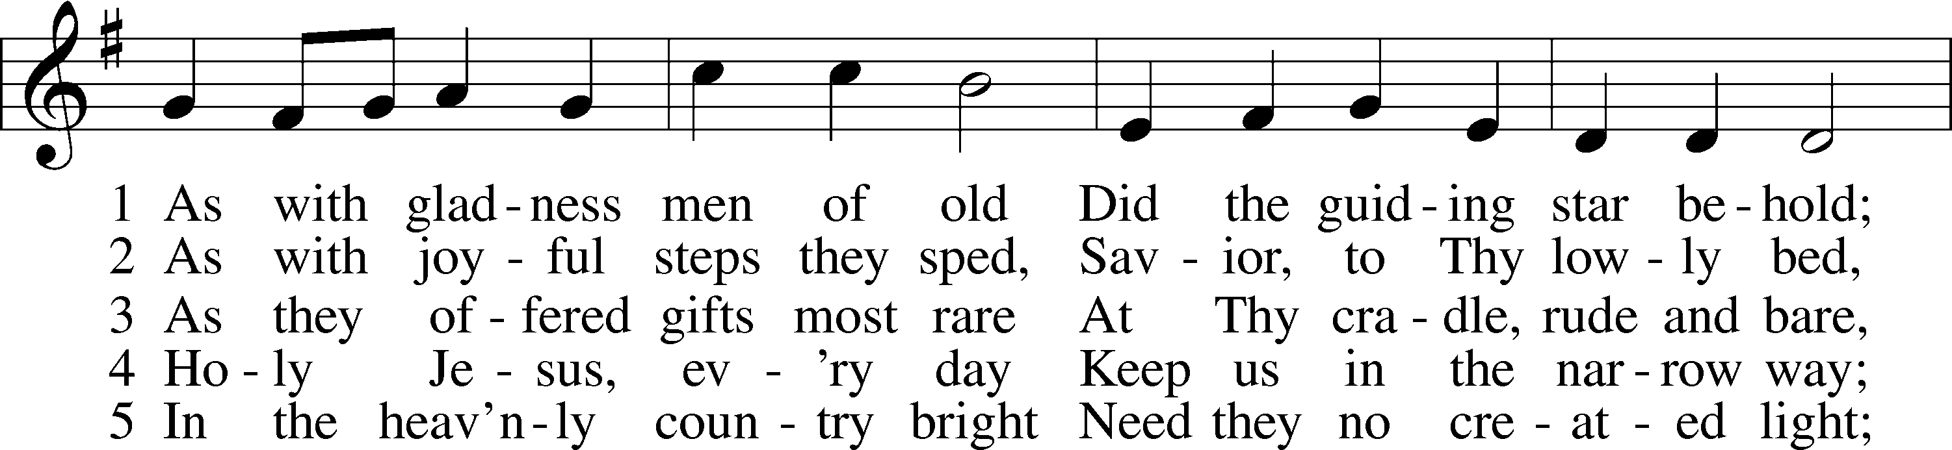
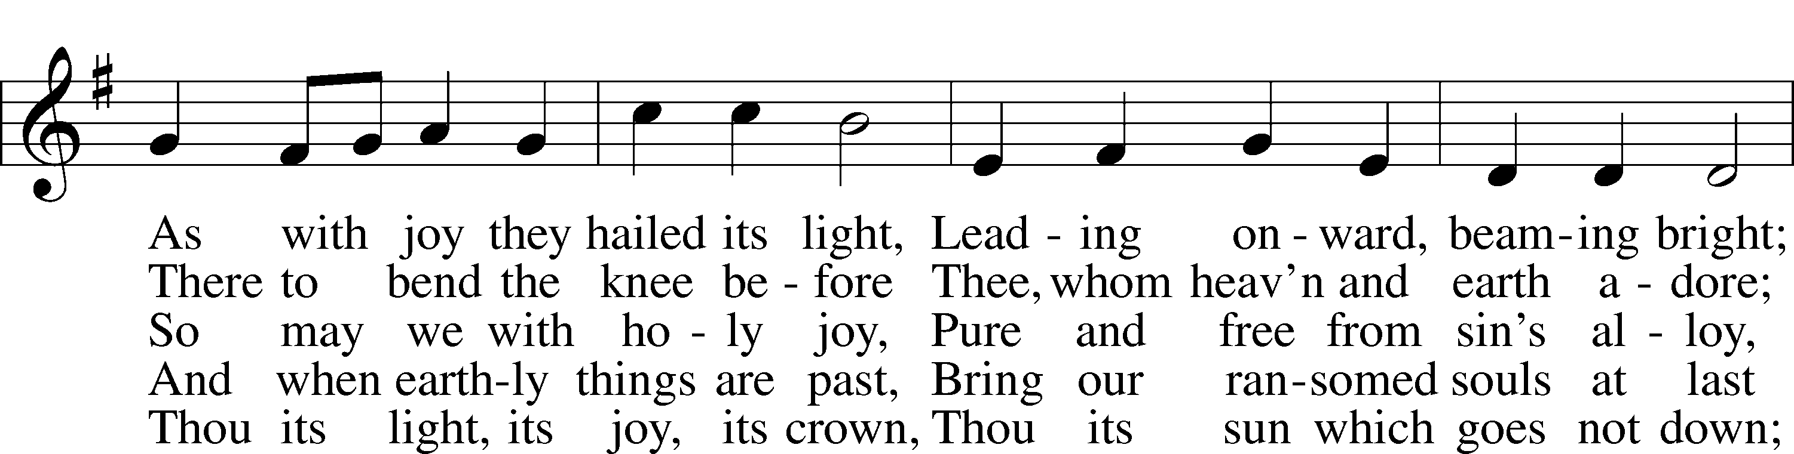
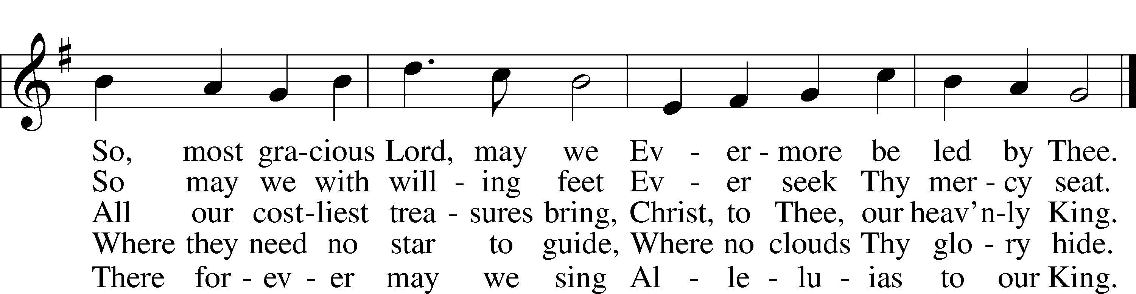

Read Matthew 2:1-12
1. In this section of his Gospel, Matthew makes no mention of Nazareth. Considering the fact that Matthew’s audience is Jewish, why does he choose to leave this detail out? See John 7:42.

2. Matthew 2:1 includes the Bible’s first mention of King Herod. Herod the Great ruled from around 40-1 B.C. He was “paranoid and ruthless, murdering his wife, three sons, mother-in-law, brother-in-law, uncle and many others” (Concordia Self-Study Bible, 1449). How does this help you understand what Matthew says in 2:3, “and all Jerusalem with him”?

3. Matthew tells us that Magi (or wise men) came “from the east.” Why did they come according to the information in the immediate text?

4. Why did the “star” influence them to make the 800 mile (at least) journey? See Numbers 24:17.

5. Herod was not a true Jew but an Idumean (Edomite) appointed by the Roman Senate. How does his question in 2:4 betray this impure pedigree?

6. Why does Herod want to know “the exact time the star had appeared?” See verse 16.

7. Why do you think Herod chose to take such a passive approach to discovering Jesus?

8. Tradition has always assumed that there were three wise men. Why? See verse 11.

9. What picture does Isaiah paint of the wise men’s visit in his prophecy from this week’s Old Testament reading in Isaiah 60:4-6? How does this change the story from Matthew?

10. In a note from the Lutheran Study Bible on Leviticus 2:1, we are told that frankincense was “mixed with the grain offering and also provided a central ingredient to the sacred incense burned twice daily in the incense altar inside the tent of meeting” (see also Exodus 30:34-36). What is the significance of this incense?

11. With what purpose is Myrrh connected in Exodus 30:22, 26-32?

12. What about in John 19:38-40?

13. Considering the following section in Matthew’s gospel, what is the purpose for the gifts of Gold?

14. In summary, what insights does this information provide about the gifts of the Magi?

Devotional Thought (From The Lutheran Study Bible)
God uses a star, Scripture, and a dream to guide the Magi on their way to and from Bethlehem. They are the first of many Gentiles to worship Jesus. Today, through his Word, the Father guides people of all nations to Christ. Jesus is the “star” the Father provided for us so that we can see our Savior. The Holy Spirit works faith in our hearts through the Gospel, and like the Magi, we joyfully offer our gifts of thanksgiving to Jesus

Prayer
“Holy Spirit, light divine, Shine upon this heart of mine;…Let me see my Savior’s face, Let me all His beauties trace; Show those glorious truths to me Which are only known to thee.” Amen. (LSB, 496:1-2)

