Pastor’s Bible Class

The Sixth Sunday of Easter

Hymn 584 “Faith and Truth and Life Bestowing”

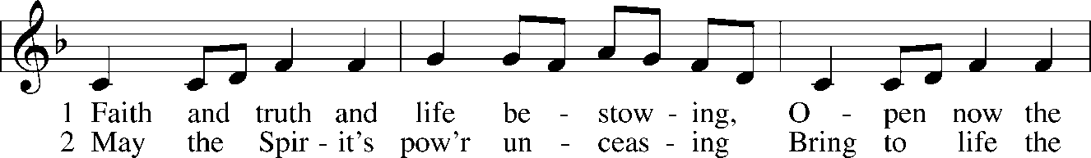
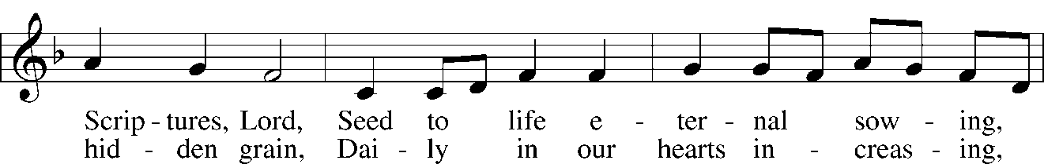
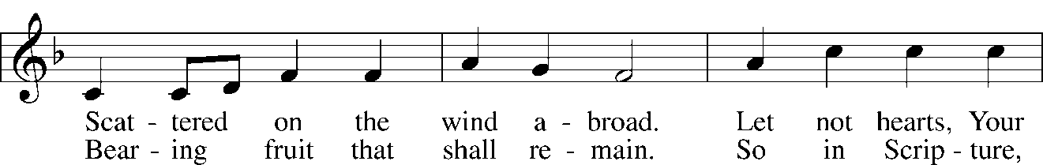
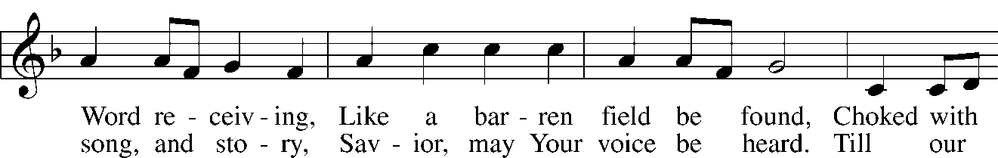
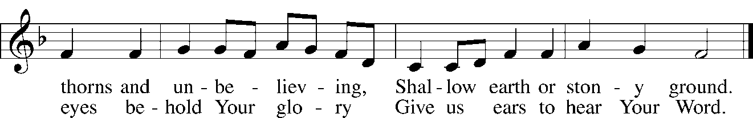

Read Acts 10:34-48
1. The context for today’s reading is found in Acts 10:1-33 where we are introduced to Cornelius, “a centurion… who feared God with all his household, gave alms generously to the people, and prayed continually to God” (Acts 10:1-2). What does this description tell you about the central, yet unnamed character in today’s first reading?

2. Read the rest of Acts 10:1-33 and note the significant action in the following facets of the account:

- Cornelius’s Vision in Acts 10:3-8

- Peter’s Vision in Acts 10:9-23

- Peter’s Introduction to Cornelius in Acts 10:24-33

3. When Peter finally opens his mouth he reiterates the inclusive nature of God’s love. Why was this message so shocking? See also Acts 10:28 and Acts 11:1-18.

4. In his 1535 Lectures on Galatians (LW:AE, Vol. 26, 210) Luther wrote about the faith of Cornelius in this way:

Cornelius was a righteous and holy man in accordance with the Old Testament on account of his faith in the coming Christ, just as all the patriarchs, prophets, and devout kings in the Old Testament were righteous, having received the Holy Spirit secretly on account of their faith in the coming Christ...Therefore if Cornelius had died before Christ was revealed, he still would not have been damned; for he had the faith of the patriarchs, who were saved solely by faith in the Christ to come…Therefore he remained a Gentile, uncircumcised, without the Law. Nevertheless, by faith in the coming Messiah he worshipped the same God as the patriarchs. But because the Messiah had come, it was necessary now that He be shown to him by the apostle Peter, not as One who was still to be expected but as One who had already come…Just as Cornelius did not observe the Law previously, so he did not observe it afterwards either. Consequently, this argument stands very firmly: Cornelius was justified without the Law; therefore the Law does not justify.

How do Luther’s thoughts help you understand the faith of this Gentile believer?

5. What is the essence of Peter’s message to Cornelius and his household?

6. The “gift of the Holy Spirit was poured out” on the Gentile hearers. What’s significant about this and how do we relate this action of God to the modern Church?

7. How does Peter speak of Baptism in verse 47 in relation to the extraordinary pouring out of the Spirit in verses 44-46?

8. Read Acts 11:1-18. What are the implications of Peter’s ministry to Cornelius for the early church?

Devotional Thought from “The Lutheran Study Bible”
Peter affirms for devout Cornelius that Jesus is truly the Christ; the Spirit affirms for Peter that the Gospel applies to all people without partiality. The Holy Spirit unites one and all in the Body of Christ (TLSB, 1856).

Closing Prayer
Father, thank you for the gift of salvation through your Son, Jesus Christ. Make me a faithful witness of your love. Amen.

GOD SHOWS NO PARTIALITY
Do not attempt to preach this text until you read Acts 10 and 11 in their entirety. It centers in Cornelius, a Gentile, and Peter, a Jew. God gives a vision to Peter which convinces him that Gentiles are not to be considered unclean in comparison to Jews and God causes Cornelius to send for Peter. Peter preaches Christ and Him crucified to Cornelius and this preaching of the Gospel brings the Holy Spirit to all those who heard the Word (Compare Hebrews 2:4).
This special gift of the Holy Spirit confirmed the truth of the Gospel. This preaching of the Gospel to the Gentiles caused offense in Jerusalem and so Peter went there and defended what he had done. The upshot of the whole matter was the observation, by the Jews themselves, in Acts 11:18: "Then God has also granted to the Gentiles repentance to life."
What was Pentecost all about? Repentance to life. What was the preaching of the Gospel all about? Repentance to life. Why the special gifts of the Holy Spirit in the early Church? To confirm for all, of all times, that this Gospel brings with it repentance to life. Every time the account centers in Christ and Him crucified.
In Volume 26, pages 203 to 211, of The American Edition of Luther's Works, with reference to Galatians 3:2, Luther has some wonderful remarks to make about the Book of Acts and in particular about this incident about Cornelius. Please read these pages in Luther before you preach on this text. You'll be the richer for it. We quote several passages:
Therefore in the entire Book of Acts, taken as a whole, nothing is discussed except that Jews as well as Gentiles, righteous men as well as sinners, are to be justified solely by faith in Christ Jesus, without Law or works. This is indicated both by the sermons of Peter, Paul, Stephen, Philip, and others, and by the examples of the Gentiles and the Jews. For just as through the Gospel God gave the Holy Spirit to Gentiles who lived without the Law, so He gave the Holy Spirit also to the Jews, not through the Law or through the worship and sacrifices commanded in the Law, but solely through the proclamation of faith . . . . Cornelius was a Gentile -- something that our opponents cannot deny, for the words that Peter uses in Acts 10:28 clearly testify to this. 'You know,' he says, 'how harmful it is for a Jew to visit a Gentile.' Therefore he was a Gentile. He was not circumcised, did not observe the Law, and did not even think about the Law, since it did not pertain to him. Yet he is justified and receives the Holy Spirit. And, as I have said, this argument -- that the Law neither helps nor contributes to righteousness -- is presented throughout the whole Book of Acts.
And, just one more quote from Luther, page 210:
Cornelius was a righteous and holy man in accordance with the Old Testament on account of his faith in the coming Christ, just as all the patriarchs, prophets, and devout kings in the Old Testament were righteous, having received the Holy Spirit secretly on account of their faith in the coming Christ. But the sophists do not make a distinction between faith in the coming Christ and faith in the Christ who has already come. Therefore if Cornelius had died before Christ was revealed, he still would not have been damned; for he had the faith of the patriarchs, who were saved solely by faith in the Christ to come, Acts 15:11. Therefore he remained a Gentile, uncircumcised, without the Law. Nevertheless, by faith in the coming Messiah he worshipped the same God as the patriarchs. But because the Messiah had come, it was necessary now that He be shown to him by the apostle Peter, not as One who was still to be expected but as One who had already come. . . Just as Cornelius did not observe the Law previously, so he did not observe it afterwards either. Consequently, this argument stands very firmly: Cornelius was justified without the Law; therefore the Law does not justify.
The Old Testament reading for this day, Isaiah 42:1-7, is a prophecy about Christ, God's Servant, who will bring forth justice to the nations and to whom God gave a covenant to the people, a light to the nations. This denotes the universal preaching of the Gospel, quite in keeping with our text from Acts 10. Even the Baptist spoke of this universal Gospel when he spoke John 1:29, but he was limited in his ministry to the Israelites.

Acts 10:34 Then Peter began to speak: "I now realize how true it is that God does not show favoritism"
Lenski calls "Than Peter began to speak" a sonorous formula for proceeding to an important address. A good observation. NIV gets at the thought of this verse: "I now realize how true it is that God does not show favoritism." Or NEB: "I now see how true it is that God has no favorites." Or Bengel: "I perceive from the concurrence of all things." What things? The vision of the sheet coming down from heaven and from the message of the angel to Cornelius.
Bengel: Peter had not thought before that God is a respecter of persons; but now first he experiences what makes it very clear that God is not a respecter of persons.
By the way, this principle was enunciated already in Deuteronomy 10:17. "Respecter of persons" occurs only here in the New Testament. The abstract noun is found at Romans 2:11; Ephesians 6:9; Colossians 3:25; and James 2:1. Neither of these words is found in Greek writers before the Christian era.
MM: The verb and the two cognate substantives are not found in LXX, and may be reckoned amongst the earliest definitely Christian words.
The unabridged edition of the large Greek lexicon bears this out. What is the great leveler among men? The Gospel of Jesus Christ.

Acts 10:35 "but accepts men from every nation who fear him and do what is right."
"But" following a negative, makes the contrast quite sharp, something like "quite to the contrary." AAT paraphrases: "It doesn't matter what people you belong to."
Kretzmann: In every nation of the world he that truly fears the Lord, that has his heart turned to Him in confident faith, and performs righteousness, shows by his entire manner of living that the fear of the Lord actuates him in all his doings, he is acceptable to God.
Stoeckhardt: Peter asserts now that everyone among all nations who fears the Lord and does right is acceptable to our God. This does not mean that among the heathen, who know not Christ, there are pious, God-fearing, righteous men who are acceptable before God, because when a heathen fears God and does what is right, then he is already converted and is a Christian, for without faith it is impossible to do good and to please God. Peter here means such heathen, like Cornelius, who believed the God of Israel, who hoped for the coming of the Messiah, and who proved their faith through their works. He, who of the heathen, who truly fears God, is well-pleasing in the sight of God as any pious Israelite, because God is not respecter of persons, and God does not distinguish between Jew and Gentile.
Lenski: This is the fear of which both testaments speak constantly, the mark of godly men, the fear of reverence, faith, obedience . . . In no way does Peter say or imply that a pagan who is serious about what he is pleased to call god is accepted by God . . . The sinner does righteousness when he repents, and a mark of this condition of righteousness when he repents is daily contrition and repentance. The contrite sinner does righteousness when he believes and accepts God's pardon in Christ Jesus.
God judges the accepted person on the basis of His own mercy and grace in Christ, not on the person's meritorious deeds. Israel was preferred not because of its nationality but only and purely because of God's Covenant of Grace. Read Ezekiel 16:1-14 for an Old Testament picture of why God chose Israel. Only, only, only because of His mercy.

Acts 10:36 "You know the message God sent to the people of Israel, telling the good news of peace through Jesus Christ, who is Lord of all."
Cornelius and his friends know three things:
- The Gospel message;
- The happenings;
- And, how God anointed Jesus of Nazareth, etc.
"The message" in verse 36 means the Gospel specifically as is clearly apparent from the remainder of the verse. "The people of Israel" is clearly the Old Testament Covenant people, the heirs of the promises. "Peace" is clearly the peace between God and man, not between Jew and Gentile. It is "through Jesus Christ." Had there been no Jesus Christ and His atoning work, there would not have been such peace.
By the way, on this verse look at Psalm 107:20; 147:18ff; and Isaiah 52:7. Peter is speaking to people who are acquainted with the Old Testament.
The antecedent of "of all" simply must be Jesus Christ. Christ is Lord of all. And in this context Peter means that the universality of the atonement and the utter impartiality of God clearly shows Christ to be Lord of all. Compare the contents of the hymn: "Crown Him with Many Crowns."

Acts 10:37 "You know what has happened throughout Judea, beginning in Galilee after the baptism that John preached--"
Bengel: 'You know' from older proofs than my coming and therefore they needed not a fuller narration . . . 'From Galilee' compare John 1:43; 2:1 . . . 'After John' is the boundary between the Old and the New Testaments. 'The baptism,' that most celebrated ordinance.
Kretzmann: They knew the historical fact that the Word concerning Jesus was made known, published, by Himself, in His prophetical ministry, beginning from Galilee, after the baptism which John preached.
Note that baptism is distinguished in this verse from Jesus' anointing with the Holy Spirit in the next verse. They are not the same thing.
This instance of "Judea" must be one of those which means "the Jewish Land." It does not mean Judea, the province, here. The work began in Galilee but spread throughout the Jewish land. The point is that no one could excuse himself by saying that he had not heard. The preaching of the Gospel began with the Baptism, whose baptism truly forgave sins. He started preaching and baptizing just southeast of the Sea of Galilee: "Repent for the Kingdom of heaven is here." "Behold the Lamb of God which takes away the sin of the world." But the preaching centered in Christ and Christ alone, and was published by Him.

Acts 10:38 "how God anointed Jesus of Nazareth with the Holy Spirit and power, and how he went around doing good and healing all who were under the power of the devil, because God was with him."
God anointed Jesus of Nazareth with the Holy Spirit immediately after He was baptized. God anointed the human nature of Jesus. This had been prophesied in Isaiah 61:1. God anointed His Son with the Spirit without measure. It was with power. The word "power" is the word often used for "miracle" in the Synoptics.
At this point we go to the end of the verse first. On the words "because God was with him," the Formula of Concord, Solid Declaration, Article VII, Lord's Supper, Tappert 575, 36:
The Scriptures do the same thing when they reproduce and explain the statement 'The Word became flesh' with such equivalent phrases as, 'The Word dwelt in us,' 'in Christ the whole fullness of the deity dwells bodily' or 'God was with him' or 'God was in Christ' and similar expressions. Thus the Scriptures explain that the divine essence has not been transformed into the human nature but that both untransformed natures are personally united.
In other words, the words "because God was with Him" means that both natures are found in one Person. And now we return to the words which precede.
Kretzmann: They knew about the person of Jesus Christ of Nazareth, namely, that God Himself anointed Him with the Holy Ghost and with power, who then traveled through the country doing good, performing miracles as the Benefactor of mankind, and healing all those that were kept in subjection by the devil, as the Lord and Master, before whom the spirits of darkness must bow; for God was with Him. These facts, with which his hearers were familiar in whole or in part, Peter impresses upon them as facts whose knowledge is necessary for salvation. Note that Peter emphasizes the deity of Jesus also in the last statement, which says that the two unchanged natures are united in the person of Christ.
Lenski: Peter is speaking to Gentiles who have come into contact with the synagogue; they seem to need no explanation in regard to the Holy Spirit and how that Spirit could anoint Jesus. The Old Testament must be far clearer in regard to the three Persons than the critics are willing to admit.

