Wednesday Bible Class

The Sixth Sunday after Pentecost

Hymn #465 “Now All the Vault of Heaven Resounds”
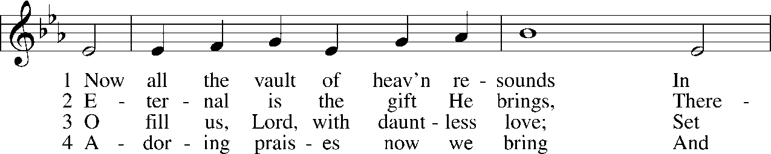
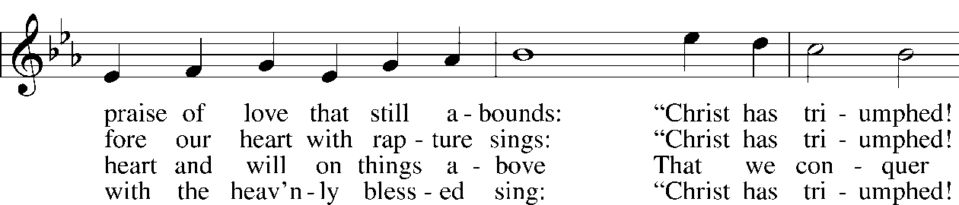
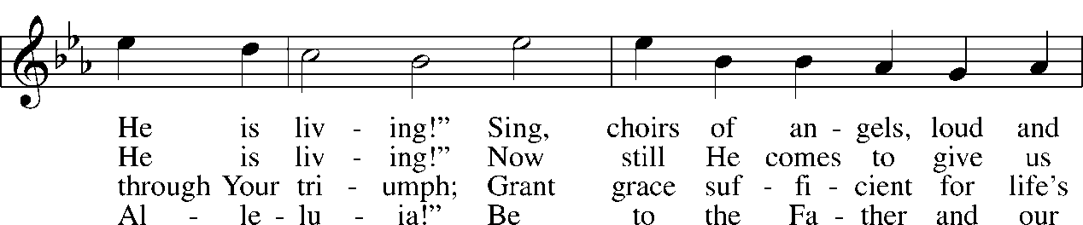
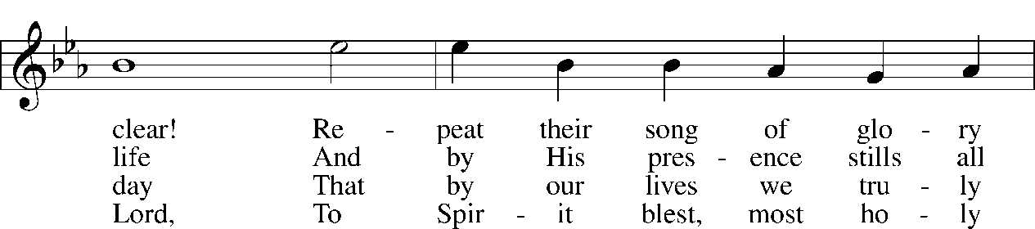
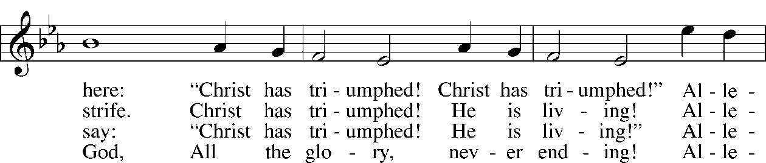
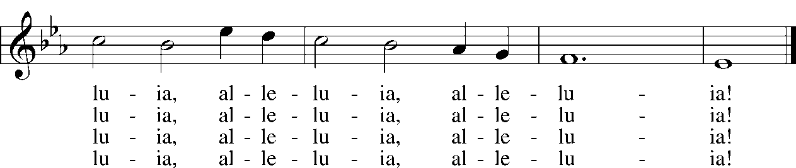

Read II Corinthians 12:1-10

1. What the subject of Paul’s “boasting” in the opening verse of our text? See II Corinthians 11:16-33.

2. What is the reason for his “boasting?” See II Corinthians 11:1-15.

3. Of what extraordinary experience is Paul boasting in today’s text? See verses 1b-6.

4. In verse 7, Paul reveals that “a thorn was given me in the flesh.” Where did this “thorn” come from and what was its purpose?

5. Harold Buls writes,

“Was this thorn physical, mental or spiritual? The first known opinion is that of Tertullian. He thought Paul suffered from severe headaches or ear aches. Chrysostom thought the thorn denoted persecution, mentioned often in Acts. The medieval monks thought it was sexual lust. Luther thought it was severe spiritual trials. And there have been many conjectures of a physical nature: epilepsy, eye-trouble, malaria, etc. There are about 25 different hypotheses. We know nothing more about Paul's view of Paradise (verse 2) or of the thorn in the flesh (verse 7) than what we are told here.”

Why is the ambiguity about Paul’s thorn important for us?

6. Read Matthew 26:36-44. How do these prayers of Jesus shed light on Paul’s (and our) repeated prayers for relief?

7. After reading this text, what, would say, is the purpose of weakness or suffering in the life of the believer? See also Hebrew 12:3-11.

Devotional Thought (The Lutheran Study Bible)
Like scarcely any other person, before or since, Paul tasted the powers and bliss of heaven, but at the same time suffered bitterly under the curse of sin. “You are dust, and to dust you shall return” (Genesis 3:19), yet believers truly already sit in the heavenly places (TLSB, 1997).

Prayer
Lord, help us keep our balance as we walk in one foot in the perishing world and the other in the world to come! Amen.

“Glory Versus the Cross”
by
Gene Edward Veith

Mother Teresa was a living saint, according to the popular mind, compassionately caring for the sick and dying and projecting a love that brought cynical secularists to their knees. After her death, the Vatican put her on a fast track to sainthood. But then a book on her life published some of her personal writings that showed Mother Teresa was wracked with spiritual depression and a sense that God had abandoned her.

The atheist Christopher Hitchens, who had earlier written a book attacking Mother Teresa for her pro-life views, crowed at the news. See, he wrote in Newsweek, she didn’t believe in this Christianity stuff at all. But even many who admired her were flabbergasted that this saintly woman who talked so much about serving Christ had such trouble feeling his presence. Maybe she wasn’t a saint after all.

For me, though, the news of Mother Teresa’s dark night of the soul made me think that maybe she really was a saint. Not in the Roman Catholic sense of a spiritual superhero. But in the biblical sense of a sinner whose hope is in Christ and not in herself. She did not follow her feelings, trust in her good works, or enjoy mystical experiences. Rather, she walked by faith and not by sight (2 Corinthians 5:7).

Luther was like that. He was subject to titanic glooms, as the poet Francis Thompson called them, times of spiritual struggle, terror, and despair. But Luther said that these inner trials drove him to trust the Word of God, not his feelings, and to cling not to his experiences but to the objective cross of Jesus Christ.

In writing about these matters, Luther identified what would become our contemporary culture’s blind spot when it comes to spiritual matters. He distinguished between what he called a “theology of glory” and “the theology of the cross.”

A theology of glory expects total success, finding all the answers, winning all the battles, and living happily ever after. The theology of glory is all about my strength, my power, and my works. A theologian of glory expects his church to be perfect and always to grow. If a theologian of glory gets sick, he expects God to heal him.

And if he experiences failure and weakness, if his church has problems and if he is not healed, then he is often utterly confused, questioning the sufficiency of his faith and sometimes questioning the very existence of God.

But, Luther pointed out, when God chose to save us, He did not follow the way of glory. He did not come as a great hero-king, defeating his enemies and establishing a mighty kingdom on earth. Rather, He came as a baby laid in an animal trough, a man of sorrows with no place to lay His head. And He saved us by the weakness and shame of dying on a cross. Those who follow Him will have crosses of their own: “If anyone would come after me, let him deny himself and take up his cross and follow me” (Matthew 16:24).

Not that we have to suffer for our own sins. But faith in the Gospel, putting our trust in what Christ accomplished for us on His cross, entails acknowledging our own weakness, the failure of our own works, the complete abnegation (renunciation) of our glory.

And as we find ourselves in the cross of Jesus, we can find Him in the far lesser crosses that we have to bear. When Christians suffer, according to Luther, Christ is with us in our suffering. Spiritual depression can drive us closer to Him, who knows better than anyone what it feels like to be wracked with physical pain, to be abandoned and rejected by those He loved, to be forsaken by His Father.

In Luther’s terms, Christ is “hidden” in our sufferings. If a child is hiding in the room, we do not see him, but he is nevertheless there. Similarly, in our sufferings, we do not perceive the hidden Christ, but He is nevertheless truly present, to be apprehended by faith.

To be sure, after the cross, Christ was glorified. God raised Him from the dead, and He ascended to God’s right hand. And Christ will come again “in glory” to judge the living and the dead. And we too are raised to new life. We too will be glorified in the eternal life to come, where we really will experience victory, have all of our problems washed away, and enjoy complete understanding.

But our access to that glory is through the cross. “To God alone be glory,” we say. Notice how the critical word in those Reformation slogans is “alone” (sola). God does have glory in Himself. But we do not.

Even in the secular spheres, contemporary Americans are mad after the theology of glory, expecting success on the job, perfect families, and either self-help remedies or government action to solve all our problems…But the truth of Christianity is evident in that everyone does, in fact, have problems, struggles, and sufferings. And this can be their point of contact for Christ, who on the cross not only “was wounded for our transgressions” but also “has borne our griefs” and “carried our sorrows” (Isaiah 53:4–5).

For Discussion…

- Why is a “theology of glory,” as defined by Veith, spiritually dangerous?

- How can “titanic gloom” be a good thing for the soul?

- What is your reaction to Luther’s idea of the “hidden” Christ?

- Read Colossians 3:1-3. How does this help us understand our lives under the cross?

Pentecost 7, July 23, 2006
Strengths versus Weaknesses
Sermon Theme: What, in fact, is our true strength?
Text: 2 Corinthians 12:7–10
Other Lessons: Psalm 143:1–2, 5–8; Ezekiel 2:1–5; Mark 6:1–6
Goal: That hearers, while acknowledging the strengths the Lord has given to each person, would in their weaknesses recognize their true strength, God’s grace in Christ.
Rev. Dennis J. Goff, senior pastor, St. Paul Lutheran Church, Lakeland, Florida
Liturgical Setting
During Pentecost, the power of God is graciously displayed through the work of the Holy Spirit, not as we talk about the Spirit, but as he makes known Christ (Jn 16:14). This Sunday in particular, the power we have in Christ is in focus.
In the Old Testament Reading from Ezekiel 2, the Lord is instructing Ezekiel to go to the Israelites who have rebelled against him. These people “are obstinate and stubborn” (v 4). Not many of us would be eager to take on that kind of assignment. Not only might we respond, “Why me, Lord?” but also, “How am I suppose to accomplish this?” How? Not by my own power or strength. “ ‘Not by might nor by power, but by my Spirit,’ says the Lord Almighty” (Zech 4:6). As for Ezekiel, so, too, the apostle Paul. So, too, all of us.
In the Psalm for the day, David is crying out to God for mercy and relief (vv 1–2). He is anxious for the Lord’s answer (v 7). However, while David’s request may be rather specific, he is nevertheless willing to pray, “Show me the way I should go” (v 8). Paul’s prayer, asking three times that the Lord take away the “thorn in [his] flesh” (Epistle, v 7), is similar. And while the answer didn’t turn out the way Paul desired, the Lord nevertheless showed him the way he should go: trusting God’s grace as sufficient, his power made perfect in weakness.
Relevant Context
In the opening verses of 2 Corinthians 12, Paul describes an unusual event. He is hesitant to admit that it was he to whom it happened—he has perhaps kept it a secret for fourteen years—but apparently he is speaking of himself. Truly, God only knows how this actually happened. Nonetheless, a man, presumably Paul, “was caught up to paradise” (v 4). Paul could be drawn into boasting about this, as one given greater privilege. But he refrains because he does not need to be—or want to be—the focus of attention. The focus is to be on Christ alone. Likewise, when a church worker or religious personality has particular gifts or abilities, it is always a temptation to honor that individual rather than acknowledge God alone as due the true honor. Each person has been given certain gifts and abilities with which to serve the Lord, but the glory goes only to God.
Textual Notes
V 7: tōn apokalupseōn, “of these . . . revelations.” Referring, obviously, to the experience related in 12:2–4, but the plural here and in 12:1 reminds that Paul had other revelations from Christ (Acts 9:1–6; 18:9–10; 22:17–18; 23:11; 27:23–24; also likely 1 Cor 7:10; Gal 1:17).
skolops tēi sarki, “a thorn in [the] flesh.” The speculation is endless, from poor eyesight, malaria, nervous disorders, or epilepsy to tortures of conscience such as sexual temptations to some persistent enemy. Ultimately, Scripture gives no answer, and apparently best so.
aggelos satana, “a messenger of Satan.” As in the case of Job (Job 1:12; 2:6–7, 10), or, for a very different reason, Saul (1 Sam 16:14), Paul’s trouble is administered by the devil—but to suit God’s gracious purpose: that Paul not exalt himself. The believer always remains in God’s care, for Satan may never afflict beyond what God allows.
Sermon Outline
Introduction: Many people have grown up learning that while we may have certain strengths in our personality, character, or vocational ability, we probably need to spend more time fixing or correcting our weaknesses. However, the reverse of that thinking suggests we not concentrate on our weaknesses but instead focus on our particular talents, so that we more fully live out our true strengths. It’s an attractive philosophy for business, but it may also have some real value in the way see our lives as Christians. The crucial question, though, is
What, in Fact, Is Our True Strength?
Is it any one of many talents, abilities, attitudes, or insights we might have? Or is it something else?
I. We all could identify any number of personal strengths.
A. Paul had some admirable, God-given personal strengths.
Paul exhibited a number of different strengths in his career as an apostle. (The preacher may wish to identify some examples.) Two that may be highlighted, though, are Paul’s missionary passion and his amazing perseverance. On three separate missionary trips, Paul crisscrossed the Roman world to bring the message of Christ’s death and resurrection to countless people and places. And when the message he was sharing was not being well received (e.g., Acts 14:19–20), he moved on and continued his effort. In the chapter before our text, Paul offers a litany of his experiences as a servant of Christ (2 Cor 11:23–29). “Who is weak, and I do not feel weak? Who is led into sin, and I do not inwardly burn?” (v 29). Nevertheless, he was able to deal with all he experienced because of the amazing spirit of perseverance that God had given him. Both Paul’s passion for mission and his perseverance to keep going were God-given strengths.
B. You, too, have important, God-given personal strengths.
The psalmist writes, “I praise you because I am fearfully and wonderfully made; your works are wonderful, I know that full well” (139:14). Each person, each member of the body of Christ, has been gifted and talented to the glory of God. While it is true that we all daily sin much and are indeed “poor, miserable sinner[s]” (LW, p. 136), we don’t want to let those “poor” and “miserable” characteristics of our sinful human nature be all we acknowledge or see. Attention to God-given strengths is indeed appropriate and need not be boastful. (Again, the preacher may wish to cite examples of the strengths God has given his people.) However, we remain “sinful and unclean”; we have sinned against God “by thought, word, and deed” (LW, p. 136). No matter what natural talent or acquired ability or spiritual gift we have been given, those traits do not erase the effects of our sinful nature. Too many times we rely on our professional abilities, our talents, our good nature, our parenting skills, our generosity for charitable contributions, or our acts of service and conclude that on the basis of these we have something to offer to God. And while our personal strengths need not be ignored and can be used effectively for God’s purposes, they are never sufficient. Certainly they do not justify us before God!
II. True strength, however, requires seeing our weaknesses.
A. Paul says he would boast not in his strengths, but in his weakness.
While Paul’s amazing perseverance is clearly articulated in 2 Corinthians 11, he also says in that same chapter, “If I must boast, I will boast of the things that show my weakness” (v 30). Why? What kind of wisdom is that in today’s culture? Paul reveals in our text that “when [he is] weak, then [he is] strong” (v 10). In the verses immediately before today’s pericope (12:1–6), Paul boasts about an experience he had, being “caught up to the third heaven” (v 2) for a glimpse of paradise. But in order that Paul not give himself credit for this extraordinary event, the Lord allowed something to afflict Paul. He calls this the “thorn in [his] flesh” (v 7). Whatever this was, it caused him to see his weakness all the more, driving him to rely daily on the power of God so that he might see his strength in God, not in himself (vv 8–10).
B. The Lord also uses our weaknesses to show us where true strength lies.
If we are honest with ourselves, we would all have to admit that there are certain things in life that don’t come easily for us and toward which we’re not favorably inclined. Likewise, most of us would acknowledge that there are some things we have a hard time dealing with in our lives. These may be physical afflictions (as may have been the case for Paul), emotional trials, family challenges, vocational stress, or whatever. And while we might pray repeatedly for the Lord to take away or change the situation, it may be that this is something that won’t go away because, for now at least, it is a way for the Lord to demonstrate that “[his] grace is sufficient for you” (v 9). By that thorn in your flesh, the Lord can draw you closer to him. He can use it to encourage you to lean on him and to help you see that his grace is sufficient. This grace is his undeserved mercy won on the cross and by the empty tomb. It is constant for you, now in life and forever when you die. And it is sufficient for you! When our weaknesses get overwhelming, we discover in the accepting arms of the forgiving Lord just how much he has done and is doing for us in his uncompromising love.
III. For our true strength is none of our personal strengths, but Christ.
Daily life brings constant reminders of some of our greatest weaknesses—impatience, greed, selfishness, thanklessness, and so on. All of these and more are characteristics of our sinful nature. The effects of this fallenness, too, weaken us, as our health is threatened, our loved ones die, our marriages seem to be unraveling, and our bills and debts pile up faster than our financial resources. All of these are characteristics of the imperfect, sinful, and weak world in which we live. Over and against life’s weaknesses, which we embody, is the strength of our risen and victorious Lord and Savior, who has given to us the strength of his mercy, love, forgiveness, peace, and hope. While some of the weaknesses we bear may never go away in this life, our true strength is found in the incarnation of him who is not only our Savior and God, but our brother and friend. “For we do not have a high priest who is unable to sympathize with our weaknesses, but we have one who has been tempted in every way, just as we are—yet was without sin” (Heb 4:15). And he does not merely sympathize with our weaknesses: he has overcome them. “Therefore, as it is written: ‘Let him who boasts boast in the Lord’ ” (1 Cor 1:31).
Conclusion: Our greatest weaknesses are God’s greatest strength. Paul writes in Rom 8:32, “He who did not spare his own Son, but gave him up for us all—how will he not also, along with him, graciously give us all things?” In other words, since the Lord has taken care of the greatest need we will ever have, which is salvation in him, he can then take care of all other needs as well. His grace is sufficient. His power is made perfect in our weakness.

MY GRACE IS SUFFICIENT FOR YOU
In the Notes for last Sunday's Epistle we mentioned that "grace" occurs with higher frequency in 2 Corinthians 8 than anywhere else in the New Testament. (The word "grace" occurs with highest frequency in Romans, so far as the entire book is concerned.) In verse 9 of today's pericope we have one of the best known instances of this word. It is quite similar to that found in 2 Corinthians 8:1 and 9, the saving, unmerited favor of our Lord Jesus Christ.
From the context we learn that the Corinthian Christians had compared Paul with the false teachers who had come to them. In comparison to them, they said, Paul was inferior. As in the case with the Galatian Christians, see Galatians 1-2, Paul defended his apostleship. He insists that he is not inferior. In fact, he is superior to them. But he distinguishes "two persons" within himself. In verse 5 he says: "On behalf of such a man will I boast; but on my own behalf I will not boast, except in regard to my weaknesses." He could boast of extra-ordinary revelations granted to him. In that sense he is certainly not inferior to anyone. And yet he says that he can boast only in his weaknesses. This is a great paradox. This can be applied to all Christians. Our text is very well known and has been the source of great comfort to countless Christians through the centuries.

2 Corinthians 12:7 To keep me from becoming conceited because of these surpassingly great revelations, there was given me a thorn in my flesh, a messenger of Satan, to torment me.
The reading of the first part of this verse is followed by none of our versions. "And because" in Greek is only translated in NIV: "And because of the surpassing greatness of the revelations, for this reason, to keep me from exalting myself" etc. The sense is clear without making a judgment about the reading. Therefore we say no more about it.
Though Paul uses the word "revelation" in the plural, it is clear that he is speaking especially about his rapture to the third heaven in verse 2. Because of the surpassing greatness of the revelations he was given a thorn either to or in his flesh.
Lenski: The man to whom the Lord had granted an actual visit to Paradise is the man to whom God gave a messenger of Satan to fisticuff him again and again.
Bengel: Having experienced the state of blessed angels, now he feels the power of an evil angel . . . . He had a revelation from heaven, a chastisement from hell.
All commentators draw a parallel between Job 2 and this instance.
It is now agreed that Paul had a "thorn" and not a "stake."
The point of comparison is the constant irritation. What this thorn physical,mental or spiritual? The first known opinion is that of Tertullian. He thought Paul suffered from severe headaches or ear aches. Chrysostom thought the thorn denoted persecution, mentioned often in Acts. The medieval monks thought it was sexual lust. Luther thought it was severe spiritual trials. And there have been many conjectures of a physical nature: epilepsy, eye-trouble, malaria, etc. etc. There are about 25 different hypotheses. We know nothing more about Paul's view of Paradise (verse 2) or of the thorn in the flesh (verse 7) than what we are told here.
The first is incomprehensible to us. And it is good that the Scriptures are silent on the second. If we would know precisely what Paul's malady was we would very likely not apply this text to our own thorns.
Hughes: There has been a discernible tendency for interpreters in different periods of the Church's history to see in the Apostles' temptation a more or less perfect reflection of the trials which beset their own lives.
That is evidently as God wants it. God wants us to apply this text to ourselves and our thorns.
Constant or a recurring buffeting is implied of the thorn. Boxers keep on hammering away at each other. The punches hurt. That's the picture in our text.
Bengel: The mind is vain and weak, which applauds itself on account of men's applause. How dangerous must self-exaltation be, when the apostle required so much restraint!
Tasker: There is nothing which tends to elate a Christian evangelist so much as the enjoyment of spiritual experiences.
That is true. Evangelists glory in the compliments showered upon them. Paul likely had the same problem. God sent him the thorn as a cross to humble him.

2 Corinthians 12:8 Three times I pleaded with the Lord to take it away from me.
"Concerning this, three times I begged the Lord to have him (Satan) leave me alone." The meaning is clear. Satan was in the thorn. The two were inseparable.
We are reminded of Jesus praying in the Garden of Gethsemane, Matthew 26:44. He also asked the Lord three times to take the cup from Him. Hebrews 5:7 gives us a very graphic picture of that situation. And Hebrews 5:8 tells us that thus Jesus learned obedience. Likewise Paul. Paul begged the Lord three times to take the thorn from him. Evidently, like Jesus, he said: "Thy will, not mine, be done."
Hughes: The three occasions on which Paul besought the Lord for deliverance were most probably associated with three separate and severe assaults of this messenger of Satan . . . as with the Lord, all outward circumstances suggested that Satan was about to score a crushing triumph.

2 Corinthians 12:9 But he said to me, "My grace is sufficient for you, for my power is made perfect in weakness." Therefore I will boast all the more gladly about my weaknesses, so that Christ's power may rest on me.
We have direct, not indirect, discourse here. Evidently God wanted His very answer to Paul preserved for all time. The answer is a lasting one. It must have made a deep impression on Paul as it has millions of times since.
The word order of the answer is unusual: "Sufficient for you is my grace." TEV: "My grace is all you need."
Evidently Paul received his answer after he had prayed the third time.
"Grace" here is clearly God's unmerited favor in Christ Jesus. Paul's prayer was answered, as in Jesus' case, though not in the way that Paul wanted it. Christian prayers are always answered.
Now follows the explanatory clause introduced by "for." It reads literally: "For the strength is brought to its goal in weakness."
We agree with Lenski that "is made perfect" is not a good translation at this point. Better might be "is brought to it's goal" which means "does its work." God's power does its work under the circumstance of the weakness of the Christian.
Evidently Paul means either that he would rather boast than complain or that he would rather boast in his weaknesses than in his visions. However, some feel that "boast" modifies "weaknesses." In that case the translation of RSV and NIV is in order.
"I will all the more gladly boast of my weaknesses." This is followed by a purpose clause. "Rest on me" literally means "overtent."
What is Paul saying in this verse? He is simply talking about contrition and faith. The thorn in, or for, the flesh caused him to see his sin, he pride. Look at verses 5 and 6 again.
Kretzmann: He could make statement which would well serve as a basis for boasting.
When Paul boasted that the Lord had done great things for him his flesh might so very easily attribute some of this to itself. We have already mentioned that Tasker talks about the elation of an evangelist. It can so easily get the better of him. To be effective, pastors need to be humble. And to be humble, they need to be contrite about their sins. All of this is true for all Christians. The Lord sent Paul a messenger from hell, a very disconcerting messenger, to make himself see himself as he truly was. Only then could the Gospel mean something to him.
Luther: If you will not be weak, My power can do nothing in you.
Thank God for your thorn!
The Book of Concord, (Tappert 207.160): It is the will of God that our bodies should be sacrifices, to show our obedience but not to pay for eternal death; for this God has another price, the death of His Son.
And (Tappert 582.70) True and worthy communicants, on the other hand, are those timid, perturbed Christians, weak in faith, who are heartily terrified because of their many and great sins, who consider themselves unworthy of this noble treasure and the benefits of Christ because of their great impurity, and who perceive their weakness in faith, deplore it, and heartily wish that they might serve God with a stronger and more cheerful faith and a purer obedience. This most venerable sacrament, the Lord's Supper, was instituted and ordained primarily for communicants like this as Christ says 'Come unto me, all who labor and are heavy laden, and I will give you rest'
Among other references look at 2 Corinthians 12:9. Paul is describing himself as a sinner who is pleading for mercy at the throne of God.

2 Corinthians 12:10 That is why, for Christ's sake, I delight in weaknesses, in insults, in hardships, in persecutions, in difficulties. For when I am weak, then I am strong.
In view of the power of Christ resting on the one who boasts in his weaknesses. Now follow four phrases beginning with "in" and followed by one phrase beginning with "huper."
"I delight in" or "I am content with."
Lenski notes that the first "in" phrase is explained by the other four nouns. The insults, hardships, persecution and calamities cause him weakness. Satan and godless men bring these situations into Paul's life.
This verse reminds us of Matt 5:11-12. It is all for Jesus' sake. The world will treat Christ's people the way the world treated Christ.
The text ends with the words: "For whenever I am weak, then I am strong."
Hughes: Human weakness provides the opportunity for divine power.
So sinful and proud is natural, fallen man that he must first be made to see that in his own supposed strength he is nothing. Until he see that he is nothing, God cannot help him.
Kretzmann: Those very experiences which another person would regard as evidences of the wrath of God, Paul knows to be proofs of God's fatherly devotion.
The whole passage reminds us of Hebrews 12:4-11.

