Pastor’s Bible Class

The Second Sunday in Lent

420 Christ, the Life of All the Living
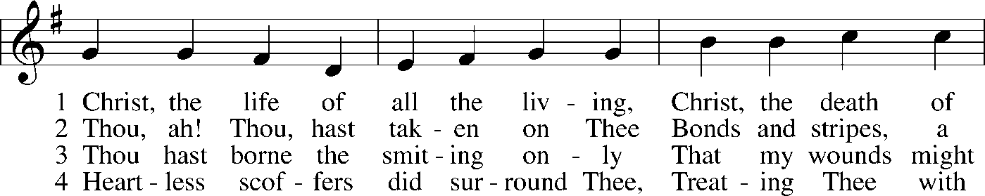
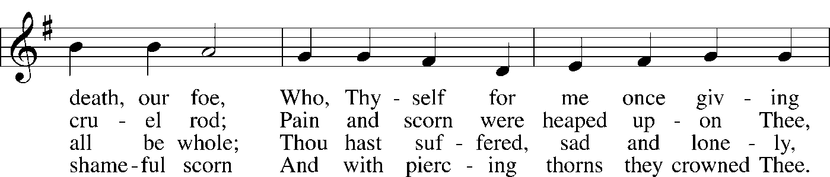
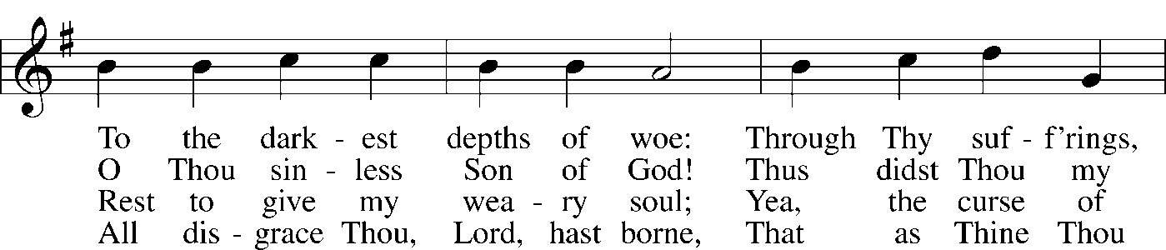
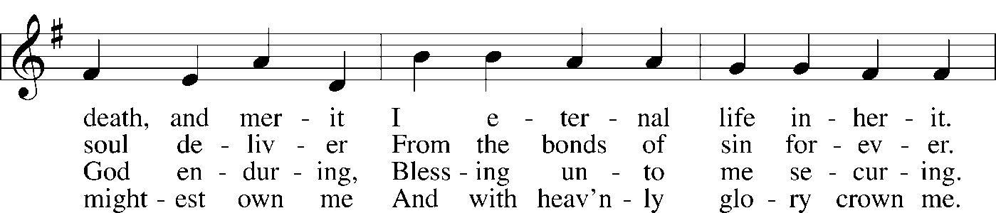
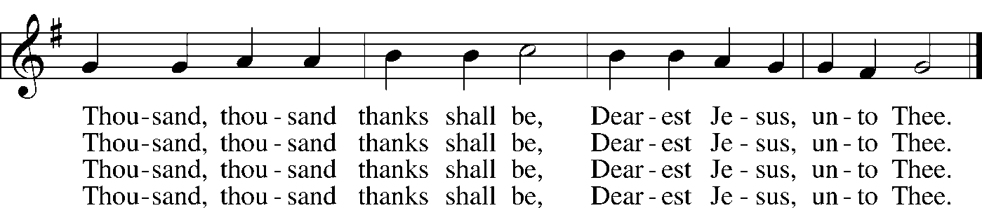

6. Thou hast suffered great affliction  And hast borne it patiently,  Even death by crucifixion,  Fully to atone for me;  Thou didst choose to be tormented  That my doom should be prevented.  Thousand, thousand thanks shall be,  Dearest Jesus, unto Thee. | 7. Then, for all that wrought my pardon,  For Thy sorrows deep and sore,  For Thine anguish in the Garden,  I will thank Thee evermore,  Thank Thee for Thy groaning, sighing,  For Thy bleeding and Thy dying,  For that last triumphant cry,  And shall praise Thee, Lord, on high.

Read Genesis 17:1-7; 15-16

1.

Read Mark 8:27-38

5.

Devotional Thought from “The Lutheran Study Bible”
For the first time in Mark, one of the Twelve recognizes Jesus as the Christ, God’s Anointed One. How slow we are and how dull is our understanding of Jesus’ divinity. We see and yet do not see. And so it is that Jesus graciously continues revealing Himself to us through Word and Sacrament. His Spirit works in us the faith that claims, “Jesus is the Christ” (TLSB, 1674).

Closing Prayer
Lord Jesus, help us to see You as the true Son of the Father, the Christ anointed as our Prophet, Priest and King. Rule us graciously for all eternity. Amen.

