Pastor’s Bible Class

The Ninth Sunday after Pentecost

Hymn 575 “My Hope Is Built on Nothing Less”
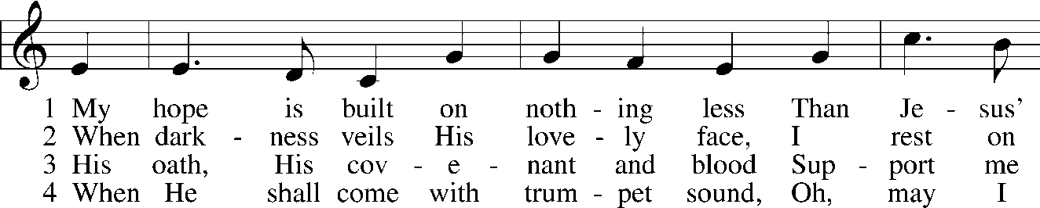
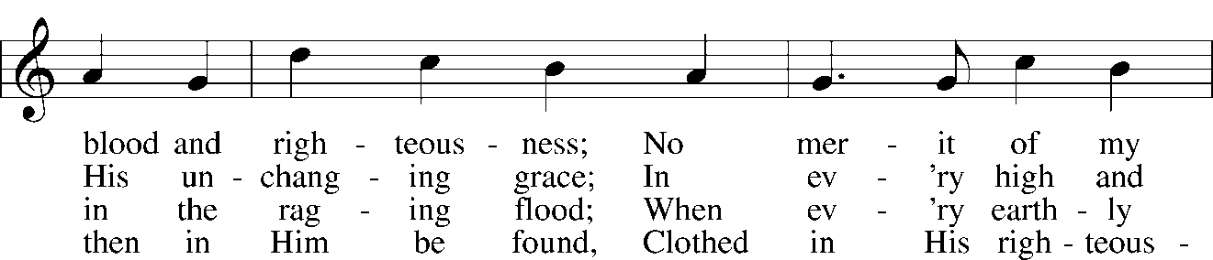
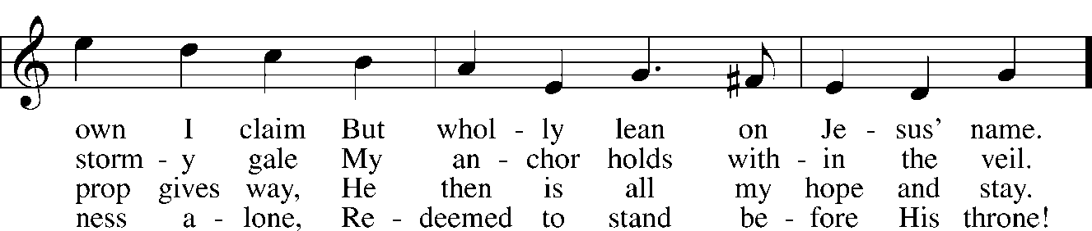
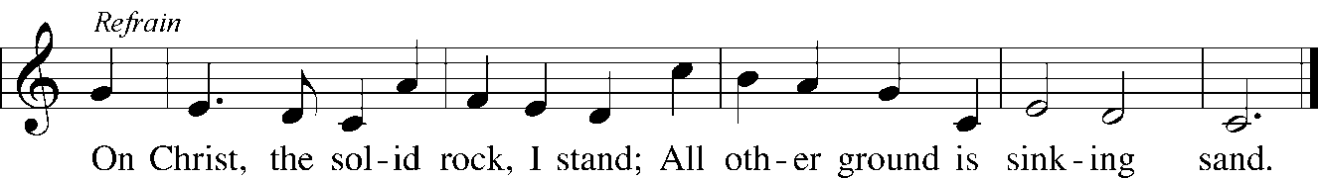

Read Genesis 9:8-17

1. Who is included in the covenant God establishes with Noah? See Genesis 9:8-10.

2. What is the difference between a conditional and unconditional covenant in Scripture and which is this?

3. In verse 12, God establishes a “sign of the covenant.” What other “signs” are established in Scripture and what is their purpose in relationship to the covenants established by God?
- Genesis 17:11
- Exodus 12:14
- Exodus 31:16-17
- Jeremiah 31:31-33; Hebrews 10:16-17 and Matthew 26:26-28

Read Mark 6:45-56

4. What significant events lead up to today’s text?
- Mark 6:1-6
- Mark 6:7-13
- Mark 6:14-29
- Mark 6: 30-44

5. Considering the list from question 4, what must the mindset of the disciples been as our text begins?

6. In verse 45, Mark tells us that Jesus “made” the disciples enter the boat. This Greek verb means to “constrain, urge or force.” Why did Jesus have to take such strong action to get the disciples into the boat? See John 6:14-15.

7. Based on the information from this text, how long is Jesus up on the mountainside by Himself praying?

8. Why did Jesus allow the disciples to struggle in the boat? See Romans 5:3-5.

9. What strikes you most about Jesus’ words in verse 50?

10. Read and explain the final sentence of the text (Mark 6:51-52).

Devotional Thought (The Lutheran Study Bible)
“Demonstrating mastery over the winds and waves for a second time, Jesus calms another storm. Even more amazing, however, is the fact that Jesus’ disciples still do not recognize His divine nature. Too often, our eyes are also blind and our hearts are just as hard. It is a good thing, therefore, that He who walked on the water that night also dies in Calvary’s darkness to save us from our hard-heartedness” (TLSB, 1669).

Prayer
Lord, save us when we are overcome by life’s storms and our hearts are darkened by unbelief. Make us ready to be surprised by You and help us not to try to limit You to what we can grasp. Amen.

