Pastor’s Bible Class

The Fourth Sunday of Easter

#710 “The Lord's My Shepherd, I'll Not Want”
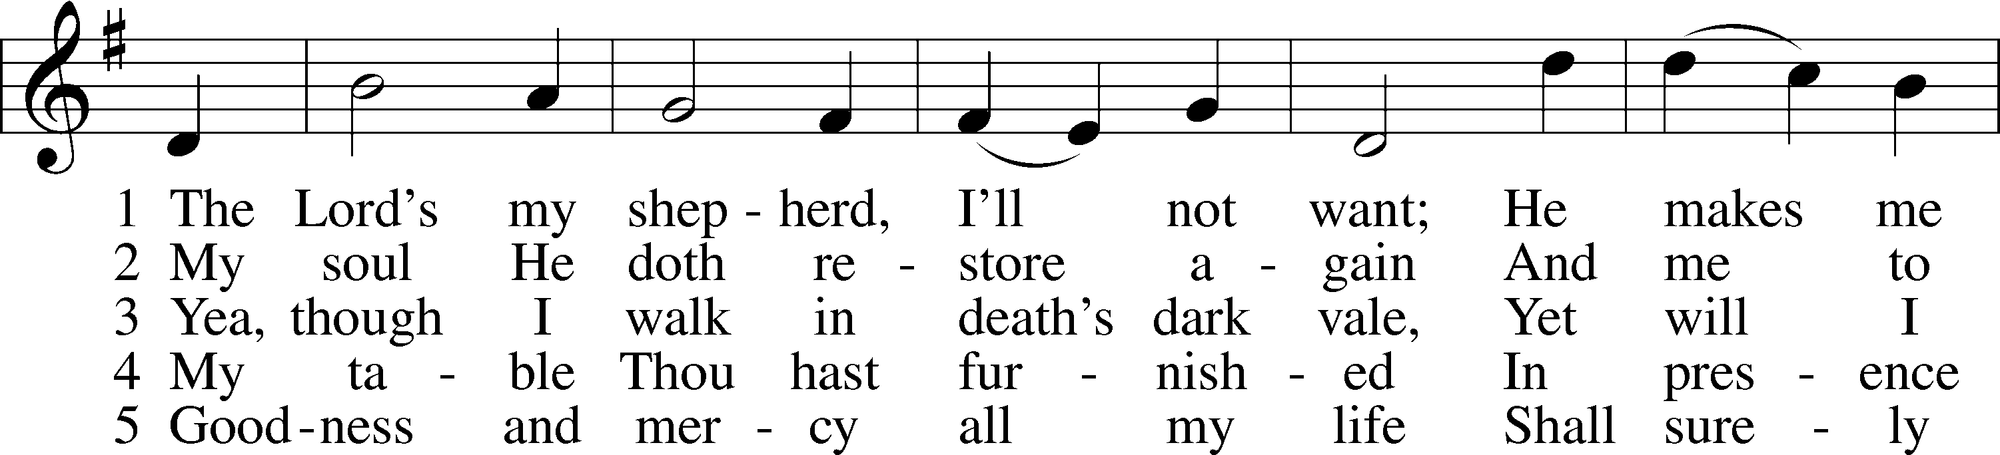
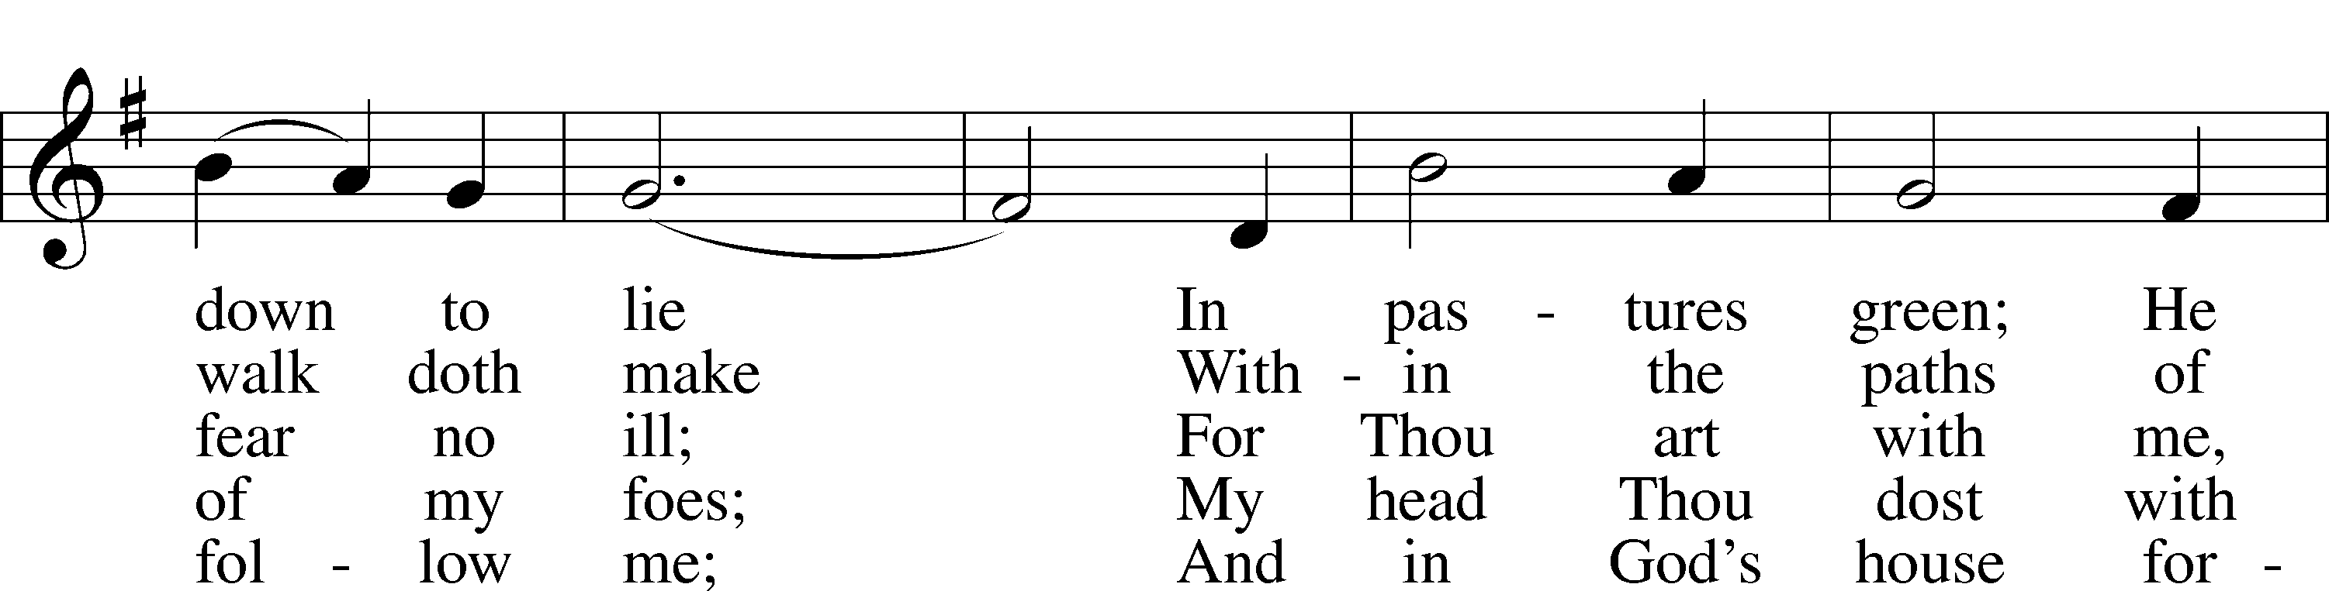
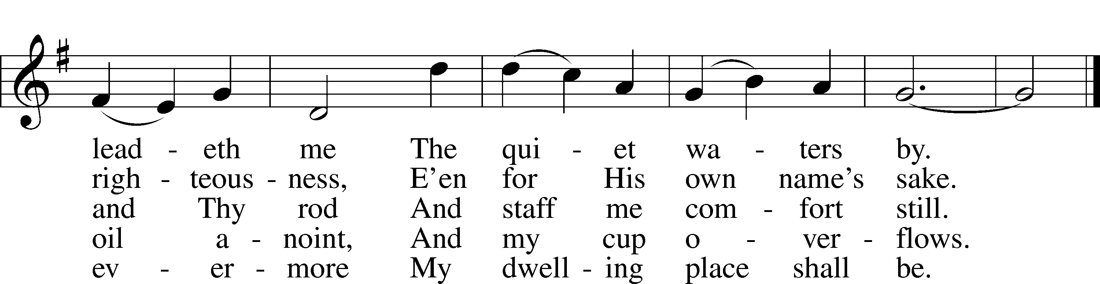

Read Acts 4:1-12
1. Where else do we read about the temple guard? Read Luke 22:4 and 52.

2. From this information what can we surmise about the confrontation in Acts 4:1?

3. Why were the captain of the temple guard and the Sadducees so disturbed?

4. Why does Luke tell us that “because it was evening they put them in jail until the next day”?

5. What was the result of the message of Peter and John? Compare to Acts 2:41.

6. Who is present at the questioning of Peter and John according to Acts 4:5-6 and what is the significance of their question?

7. With what bold statements does Peter answer their question?
Read John 10:11-18
8. To whom is Jesus speaking in John 10? Scan John 9:1-34 and read John 9:35-41.

9. How do they understand His words? See John 10:6.

10. Martin Luther wrote, “In this single little word shepherd, there are gathered together in one almost all the good and comforting things that we praise in God” (AE 12:152). Why qualities or ideas do we associate we the word shepherd?

11. How does Jesus define this word in verse 11?

12. According to Jesus in verses 12-13 what qualities characterize a “hired hand?”

13. Beginning in verse 14, Jesus uses the Good Shepherd metaphor to describe the relationship between the Shepherd and the sheep. What does He say about this relationship?

14. How do the following verses explain this relationship more fully?
- John14:20;
- John 15:10;
- John 17:8 and 21;
- Matthew 11:27;
- Luke 22:29

15. Who is included in the Good Shepherd’s flock?

16. Who is Jesus talking about in verse 16?

17. Read Hebrews 10:1-14. How is this section of Hebrews a commentary on John 10:17-18?

Devotional Thought from “The Lutheran Study Bible”
Jesus calls Himself the Good Shepherd to describe His intimate relationship with His followers and the love that moved Him to lay down His life for them. Sheep who ignore the Good Shepherd’s voice (His Word) have only themselves to blame and will fall prey to Satan. Unlike human love motivated by self-interest, Christ’s love for His own moved Him to voluntarily endure even death on a cross for our sake (TLSB, 1802).

Closing Prayer
My dear Shepherd, watch over me that I may never stray from You. Amen.

Pastor’s Bible Class
April 25, 2012

The Fourth Sunday of Easter

#710 “The Lord's My Shepherd, I'll Not Want”

Read Acts 4:1-12
1. Where else do we read about the temple guard? Read Luke 22:4 and 52.

2. From this information what can we surmise about the confrontation in Acts 4:1?

3. Why were the captain of the temple guard and the Sadducees so disturbed?

4. Why does Luke tell us that “because it was evening they put them in jail until the next day”?

5. What was the result of the message of Peter and John? Compare to Acts 2:41.

6. Who is present at the questioning of Peter and John according to Acts 4:5-6 and what is the significance of their question?

7. With what bold statements does Peter answer their question?
Read John 10:11-18
8. To whom is Jesus speaking in John 10? Scan John 9:1-34 and read John 9:35-41.

9. How do they understand His words? See John 10:6.

10. Martin Luther wrote, “In this single little word shepherd, there are gathered together in one almost all the good and comforting things that we praise in God” (AE 12:152). Why qualities or ideas do we associate we the word shepherd?

11. How does Jesus define this word in verse 11?

12. According to Jesus in verses 12-13 what qualities characterize a “hired hand?”

13. Beginning in verse 14, Jesus uses the Good Shepherd metaphor to describe the relationship between the Shepherd and the sheep. What does He say about this relationship?

14. How do the following verses explain this relationship more fully?
- John14:20;
- John 15:10;
- John 17:8 and 21;
- Matthew 11:27;
- Luke 22:29

15. Who is included in the Good Shepherd’s flock?

16. Who is Jesus talking about in verse 16?

17. Read Hebrews 10:1-14. How is this section of Hebrews a commentary on John 10:17-18?

Devotional Thought from “The Lutheran Study Bible”
Jesus calls Himself the Good Shepherd to describe His intimate relationship with His followers and the love that moved Him to lay down His life for them. Sheep who ignore the Good Shepherd’s voice (His Word) have only themselves to blame and will fall prey to Satan. Unlike human love motivated by self interest, Christ’s love for His own moved Him to voluntarily endure even death on a cross for our sake (TLSB, 1802).

Closing Prayer
My dear Shepherd, watch over me that I may never stray from You. Amen.

JESUS THE GOOD SHEPHERD
John 7:1-10:21 is devoted to what Jesus said and did in Jerusalem on the occasion of the Festival of Tabernacles (or Booths) in Jerusalem in the month of October, just six months before His crucifixion and death. The growing tension between Him and the Jewish authorities is reaching a climax. In John 9, we have the account of the healing of the blind man, a remarkable miracle which also serves as parable to show the Pharisees their obstinate spiritual blindness. The audience on the occasion of our text is Jesus' disciples, the formerly blind beggar, the Pharisees, and other Jews. The Pharisees are spiritually blind. In this parable, verses 11-18, Jesus offers both stern warning and sweet comfort.
We rightly think of this text as a very comforting one. But it is amazing that very often such comforting texts of the Gospel are found in a context of danger, hostility and anger toward Jesus. Most of the great "I AM" passages are found in such a context of hostility, apathy or danger. That's life. We live in a world which is apathetic and hostile toward the Lord Jesus and His comforting Gospel. And that's the reason why we must preach and teach this Gospel ever more assiduously.
The 26th edition of Nestle/Aland Greek text divides our text into three major paragraphs: verses 11-13; 14-16; and, 17-18. Perhaps a simpler division would be a two-fold one: verses 11-13, Jesus' relationship to His sheep; verses 14-18, Jesus' relationship to both His Father and His sheep. Central to both divisions is the fact that Jesus lays down His life for the sheep. But in the second part the act of laying down His life for the sheep is presented more fully, both in Jesus' relationship to the Father and in the result for the sheep.
Reformed theology uses this text for proof of a limited atonement.
Hendriksen: It is for the sheep, only for the sheep, that the good shepherd lays down his life. The design of the atonement is definitely restricted.
But that cannot be supported by Scripture.
Bengel: It cannot be inferred from this that He did not die also for the rest of mankind.
Lenski: When saying that he lays down his life 'for the sheep' the sacrifice of Jesus, which is for the world and all men, is viewed with reference to its actual final result, which appears in the saved. This view is taken repeatedly in the Scriptures and never furnishes the least ground for the idea of a limited atonement.
Kretzmann: The first feature which distinguishes Him as the true Shepherd of souls is that He gives His life, His own soul, as a ransom, as the one complete sacrifice, for the guilt of all sinners, who have earned eternal damnation. He becomes their Substitute.
Stoeckhardt: From these words a person sees that in this entire pericope Jesus is speaking of the elect children of God. . . The fact that Christ lays down His life for these sheep does not exclude His propitiation for the sins of the whole world.

John 10:11 "I am the good shepherd. The good shepherd lays down his life for the sheep."
Note emphatic "I am" both here and in verse 14. Subject and predicate are interchangeable. In all the "I AM" statements in John, all other possibilities are eliminated. He is unique. First Jesus stated Who He is. Then He states What He does. Common to both is "the good the shepherd." The "good" is made emphatic twice by the repetition of the article. The word "good" is carefully explained, verses 11-18. It means "excellent." The word "good," like the word "love," is a martyr among men because its meaning is often meaningless.
Jesus uses "good" in its very highest sense. Forms of "life" are found five times in this pericope. It is in the present tense.
Bengel: The whole life of Christ is a going to death.
"For" found again in verse 15, means "in the stead of," the vicarious use. He takes their place. The prophets foretold Jesus, the Good Shepherd. Read Isaiah 40:11 and Ezekiel 34:11-26. Psalm 23, in its entirety, immediately comes to mind. Hebrews 13:20 is a parallel passage. Read. Isaiah 53:6 where our desperate need but also the vicarious atonement is clearly portrayed. And although Isaiah 53 does not speak of a Shepherd, verse 10 pictures His death for us. "He will see His offspring" clearly teaches what John 10:16 says. And "the good pleasure of the Lord will prosper in His hand" reminds one of verses 17-18.

John 10:12 "The hired hand is not the shepherd who owns the sheep. So when he sees the wolf coming, he abandons the sheep and runs away. Then the wolf attacks the flock and scatters it."
The versions and commentaries offer a variety of punctuation for verses 12-15. Rather than discuss all of that here, a translation is offered. Note the utter difference and contrast between the "hired hand" and "the good shepherd." Emphasized words are an attempt to give the proper nuance to the word translated "and so, namely, and:"
The hired person, namely one who is not a shepherd, of whom the sheep are not his very own, if (or when) he sees the wolf coming, he both abandons the sheep and flees, -- and so the wolf seizes them and scatters (them) -- because he is a hired person, namely, he cares nothing about the sheep. I am the good shepherd, first, I know my sheep and my sheep know me just as the Father knows me and I know the Father, and secondly, I lay down my life in the stead of the sheep.
In summary, the contrast is as follows: The hired person is not a shepherd, does not own the sheep, sacrifices the sheep in self-interest, and cares nothing about the sheep. Jesus is here describing false teachers and false messiahs of all ages, especially the Pharisees who were listening to Him. By way of contrast, Jesus is the Excellent Shepherd, Who owns the sheep, Who knows His sheep as intimately as the Father knows the Son and vice versa, and, basic to all, He sacrifices Himself in the interest of the sheep.
"Sees, abandons, runs." These three verbs are axiomatic of the self-server. "Sees" is more than mere seeing. It means he consciously views, is fully aware of the great danger. Its object is "the wolf," an apt metaphor for the devil. He is constantly approaching. The object "abandons" is "the sheep," denoting lack of principle and courage. The hireling "flees." He is a coward.
The devil seizes and scatters. By way of contrast, Jesus gathers and leads, verse 16. The word "pastor" is the Latin word for "shepherd," Woe to the pastor who proves to be a hireling!! See Matthew 7:15 and Acts 20:29-30.
Lenski: Due to the portrait here drawn by Jesus the term 'hireling' has come to stand for a base type of character, one that is venal, mercenary, utterly selfish.
Here Jesus identifies Satan and all his agents. They are so rampant in the world today in the cults, the sects and those organizations which plainly do church work only for earthly gain. And membership in the LC-MS does not make us immune to all of this.

John 10:13 "The man runs away because he is a hired hand and cares nothing for the sheep."
Jesus is not speaking of a person who forthrightly tells another: "I don't care about you." He is speaking of a person who poses as one who cares but in actuality does not. Compare John 12:6. Under the guise of suggesting that the money be given to the poor, Judas was actually a thief.

John 10:14 "I am the good shepherd; I know my sheep and my sheep know me--"
The first six words are repeated from verse 14. And it's the third time that we find the expression "I am the good shepherd."
Bengel: Always the beginning of every good thing originates with God and Christ.
That is an astounding statement but it is true. The word "good" is now explained by two verbs: "know" and "is known." "Know" and "known" occur four times in 14-15. The Good Shepherd both knows and is known. Lenski quotes the Lutheran dogmaticians who define "know" as noscere cum affectu et effectu, "to know with love and appropriation as one's very own and to reveal that loving ownership by all the corresponding actions." Compare 2 Timothy 2:19 and Matthew 7:23 where, by contrast, the meaning comes out.
The love of the Savior for the sheep is a reflection of the relation existing between the Father and the incarnate Christ. Note that in both verses 14 and 15 the mutuality of knowing is stessed: The Shepherd and the sheep mutually; the Father and the Shepherd mutually.

John 10:15 "just as the Father knows me and I know the Father--and I lay down my life for the sheep."
"Just as" means exactly as.
Bengel: Often the relation of believers towards Christ is derived from the peculiar relation of Christ towards the Father. Compare 14:20; 15:10; 17:8.21; Matthew 11:27; Luke 22:29; 1 Corinthians 11:3; 15:28; Revelation 3:21.
All of these passages should be read at this point. It is breath-taking to realize that the relationship between Christ and me is as close as that which pertains between Christ and the Father.
The final "and" in verse 15 gives the second and basic reason why Jesus calls Himself The Good Shepherd, repeated from verse 11. The Father's love for and relationship to His Son saw the latter through much suffering and death. Likewise, the Son's love for and relationship to me sees me through much suffering and death.
Lenski notes that in verses 11-15 the wolf is mentioned twice, flanked by two observations concerning the hireling, flanked by two observations concerning the Good Shepherd. That can hardly be an accident. In our text all is utter certainty: the certainty of the coming, nature and activity of the wolf, the devil; the certainty of the character and activity of the hireling; and, the certainty, character and activity of ti1e Good Shepherd.

John 10:16 "I have other sheep that are not of this sheep pen. I must bring them also. They too will listen to my voice, and there shall be one flock and one shepherd."
"And," in Greek but not translated, means "furthermore." The verb "must" of this verse is as certain as the "must" in verse 18. "This sheep pen" is an adjectival phrase, denoting the Old Testament Covenant believers. In His omniscience Jesus foresees a much larger group, which includes the Gentile believers, you and me. "I must bring" in the sense that it is God's foreordained will in Christ. "Bring" as opposed to the seizing and scattering by Satan, verse 12. How does Jesus "bring" them? By His suffering and death. This is the cause of their hearing His voice. This is the cause of their being only one flock, one Shepherd. See Ezekiel 34:23; Zechaiah 14:8.9. Jesus is speaking about the Una Sancta, the Communion of Saints, the invisible Church. This verse is both a prophecy and a promise.
Ylvisaker: There shall therefore be one fold, one invisible church, one living communion with the one Shepherd, Jesus Christ, as Head and Overseer. Galatians 3:28; Colossians 3:11; Ephesians 2:11ff.
And it is remarkable that He mentions the one flock before He mentions the one Shepherd. The one flock and the one Shepherd stand or fall together, but they are individualized. We have no assurance that individual denominations will continue to the end of time. But we do have Jesus' assurance that there "will be one flock."
In our darker moments we must comfort ourselves with the great ones, one Lord, one faith, one baptism, one flock, one Shepherd. Furthermore, from this text we know that this "one" is not confined by ethnic, linguistic, cultural or racial limitations. The Good Shepherd laid down His life for all nations. The Gospel is to be preached to all nations. In heaven all nations, all tribes, all peoples will be represented.
Except for what is said about the hireling and the wolf in verses 12-13, this whole pericope is purest Gospel.

John 10:17 "The reason my Father loves me is that I lay down my life--only to take it up again."
"The reason" does not point backwards, but rather forwards to the causal "is that" clause. Jesus was sure of the Father's love, even in death.
Bengel: The love of the Father is to be kept in sight, in the passion of Christ, not only towards us, but also towards Christ.
Of course, the Father loves His Son irrespective of His atoning work. But, as Lenski says: "The Father's whole heart goes out to his Son as he lays his life down in the sacrifice of death." This does not contradict the fact that God forsook His Son on the cross, Matthew 27:46. The Father's great love for His Son caused the Father to forsake His Son because of our God-forsakenness.
For the third time in this pericope Jesus says "lay down my life" but this time He adds emphatic "I Myself." He did it willingly. No one compelled Him to do it. The "lay down" clause is closely bound to the "take it up." He died willingly for the purpose of rising spontaneously. Meditate on that thought. In the person of Christ, God died willingly and man rose again spontaneously, the greatest marvel and miracle in the Scriptures.
Note again that "lay down" is in the present tense. Of His own free will Jesus gave Himself into the hands of sinful men to die. John 18:4-11; 19:28-30; Matthew 26:52-54; Luke 23:46. Many times His enemies wanted to kill Him but did not allow it until His hour came. And even then He knew exactly what would happen before they knew it. The Jews availed themselves of the power of Rome, a mighty Empire, to keep Him in the grave. But they could not. On this willingness of Jesus read Hebrews 10:1-14.
Verse 9 stresses the will of the Father. Verse 10 stresses the will of Jesus which was consonant with that of the Father. The animal sacrifices in the Old Testament, performed again and again, were done contrary to the will of the animals which obviously resisted death. But the sacrifice of Jesus, happening only once, was performed willingly to bring us to God's intended goal, verse 14.

John 10:18 "No one takes it from me, but I lay it down of my own accord. I have authority to lay it down and authority to take it up again. This command I received from my Father."
The antecedent of "no one" is not the Father, but hostile powers: the devil, his agents, the world, sin, death. Jesus was surrounded by enemies, both physical and spiritual, while He was on the cross. None of them took His life from Him. The negative here, is very strong: "quite to the contrary."
Another emphatic "I Myself." For the fourth time we have "myself." The words denote manner, how He laid down His life, spontaneously. In the next sentence we have "I lay" and "I take" which denotes the right, authority, power given to Him by the Father. Pilate claimed this "authority" for himself, John 19:10, but Jesus corrected him by saying that Pilate had this "authority" only to the extent that it was given to him from God Himself. Jesus had the inherent "authority" to ask the Father to extricate Himself from trouble and death, Matthew 26:53, but "how then would the Scriptures be fulfilled as to the fact that this was necessary to happen?"
Jesus foretold His death and resurrection not only to His disciples but also to His enemies who were standing right in front of Him. Compare verses 19-21. Jesus closes by saying: "this injunction I have received from My Father," the injunction to die willingly and to rise spontaneously. Compare Hebrews 10:1-14 again.
Verses 17-18 explain each other and refer specifically and only to Christ. His enemies denied all the statements. They denied that the Father loved Him. They denied that He had right and authority. They denied that the Father had commanded Him to do and act as He did.
The third stanza of Paul Gerhardt's great Lenten hymn comes to mind here:
Yea, Father, yea, most willingly I'll bear what Thou commandest;
My will conforms to Thy decree, I do what Thou demandest.
O wondrous Love, what hast Thou done!
The Father offers up His Son! The Son, content, descendeth!
O Love, how strong Thou art to save!
Thou beddest Him within the grave Whose word the mountains rendeth.
Note the absence of particles and conjunctions at the beginning of sentences in this text. Normally each sentence begins with a particle or conjunction. This does not indicate that here we have poor Greek. There is no such thing as poor Greek in the Scriptures. But it does denote the intensity with which Jesus spoke to His enemies, not because He hated them but because He loved them. He was offering Himself to them. But note their reaction in verses 19-21. His plain words cause a second division. On the first compare John 7:43.
Several quotes from the Book of Concord are in place here:
In the Smalcald Articles, XII, Luther says: We do not concede to the papists that they are the church, for they are not. Nor shall we pay any attention to what they command or forbid in the name of the church, for, thank God, a seven-year-old child knows what the church is, namely, holy believers and sheep who hear the voice of their Shepherd.
F.C., S.D., Article XI: Thus the entire holy Trinity, God the Father, Son, and Holy Spirit, directs all men to Christ as to the book of life in whom they are to seek the Father's eternal election. For the Father has decreed from eternity that whomever he would save he would save through Christ, as Christ himself says, 'No one comes to the Father but by me' (John 14:6), and 'I am the door; if anyone enters by me, he will be saved' (John 10:9).
In other words, if anyone wants to determine whether or not he is among the elect he should simply read John 10:1-18 and apply to himself what Christ did for him.
F.C., S.D.: In order to preserve the pure doctrine and to maintain a thorough, lasting, and God-pleasing concord within the church, it is essential not only to present the true and wholesome doctrine correctly, but also to accuse the adversaries who teach otherwise (1 Timothy 3 :9; Titus 1 :9; 2 Timothy 2:24; 3: 16). 'Faithful shepherds,' as Luther states, 'must both pasture or feed the lambs and guard against wolves so that they will flee from strange voices and separate the precious from the vile.' (John 10:12-16; Jeremiah 15:19).
No mention is made of the Holy Spirit in these verses. But the Holy Spirit pervades this text. He who believes what Jesus says in these verses, is spiritual and has the Holy Spirit. There is no higher spirituality among men than to believe the Gospel. Anyone who claims that he has a higher spirituality from the Holy Spirit, sealed by a special gift of tongues (or its equivalent), quite apart from the will of the Father and the sacrifice of the Son, is self-deluded and a great detriment to the church. Such a person is an hireling, a self-server, who detracts attention from the Gospel, the only hope for sinful mortals.

