Pastor’s Bible Class

The Fourth Sunday in Lent

#571 “God Loved the World So That He Gave”
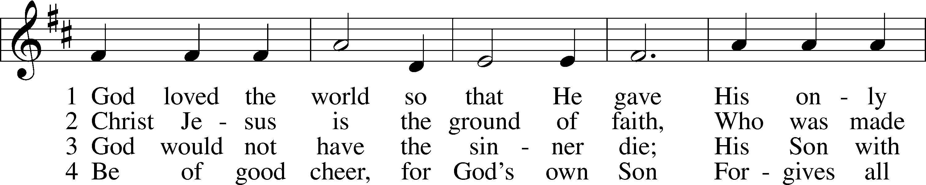
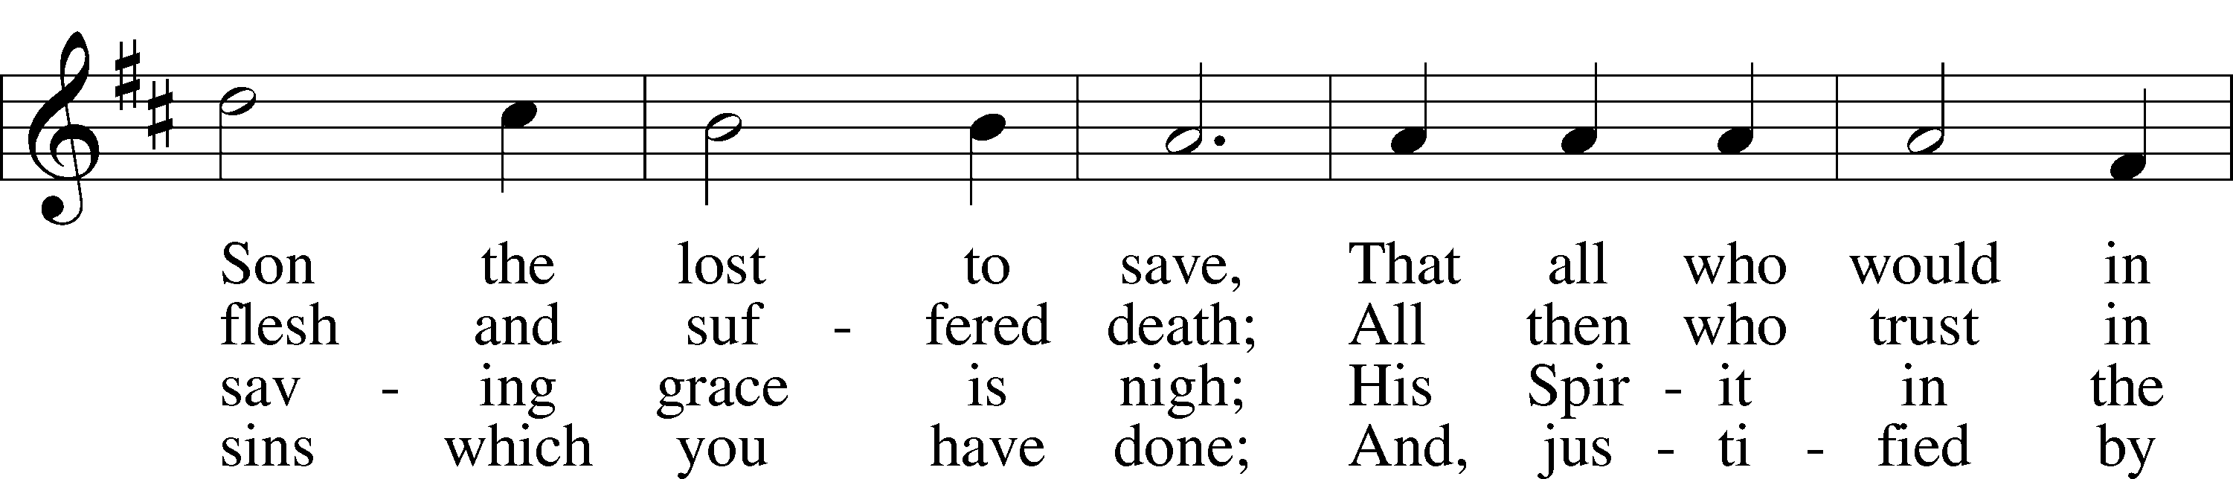
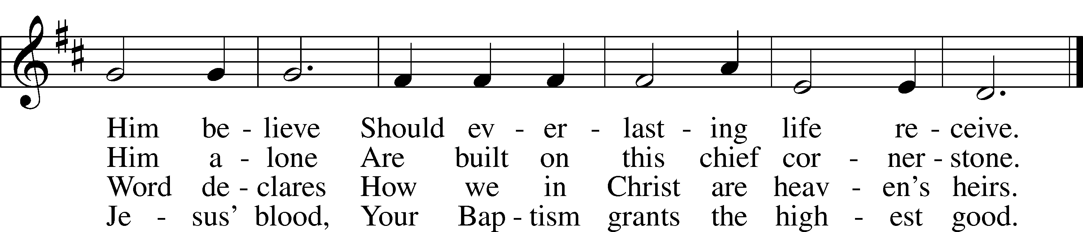

5 If you are sick, if death is near,
This truth your troubled heart can cheer:
Christ Jesus saves your soul from death;
That is the firmest ground of faith.

Read Numbers 21:4-9

1. To

Read John 3:14-21

8. What ?

Devotional Thought from “The Lutheran Study Bible”
God gives His only Son as a sacrificial gift to deliver the world from condemnation and to give eternal life to those who believe in Him. When we continue in an immoral lifestyle, we naturally resist divine disclosure of our sin and thus our need for a Savior. Do not flee the light, but repent. God has revealed His strong love in His Son, Jesus Christ, to forgive your sins and give you life (TLSB, 1783).

Closing Prayer
O heavenly Father, grant that my life may be a vivid testimony to Your sacrificial and faithful love in Christ. Amen.

