Pastor’s Bible Class

The Fifth Sunday of Easter

#601 “All Who Believe and Are Baptized”
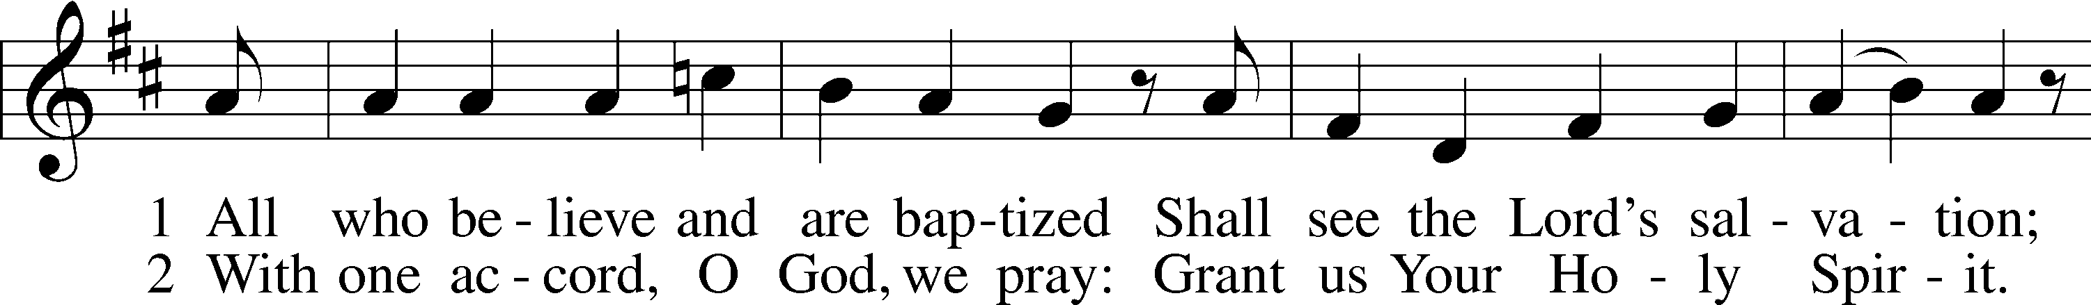
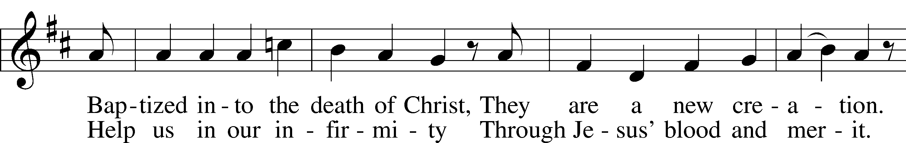
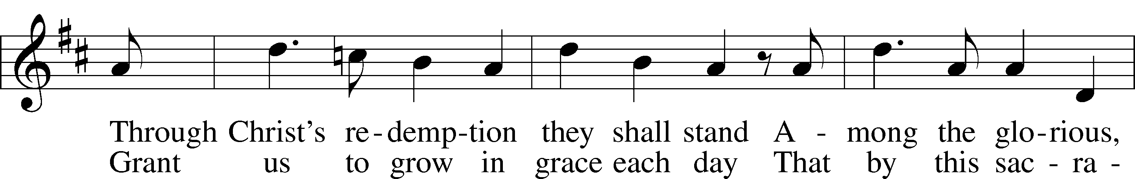
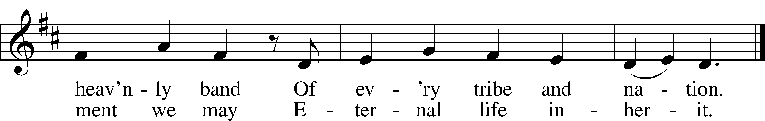

Read Acts 8:26-40
1. What do we know about Philip? See Acts 6:1-6 and 8:4-8.

2. To what kind of place was Philip called in verse 26? Contrast this with his ministry in Samaria in verses 8:5-13.

3. What details are recorded about the Ethiopian Philip meets?

4. What is the essence of the question posed to Philip about the Scripture the Ethiopian is reading?

5. Where does Philip begin his instruction with the man? Where does he end?

6. How does this account reflect the practice of adult Baptism in our church?

Read John 15:1-8
8. When does the conversation in our text take place? See 13:1-2.

9. The imagery of vineyards and vines was widely used in the Old Testament. Read Ezekiel 19:10-14 and Isaiah 5:1-7. How does Isaiah portray the Master’s vineyard and its fate?

10. How do these ominous Old Testament passages about the vine differ from the description in John 15:1?

11. According to Jesus, what happens to the branches that do not bear fruit? How about the branches that do bear fruit? To what does this imagery refer?

12. Read Galatians 5:22-23. How does Paul characterize a branch that abides in the vine?

13. According to verse 7, what leads to this kind of fruit?

14. Are the words of Jesus in verse 8 prescriptive or descriptive? Why is it so important to draw this distinction?

Devotional Thought from “The Lutheran Study Bible”
Christ is the true vine, and His disciples are the branches, vitally connected to Him and spontaneously bearing fruit under His purifying care. Christians must love one another as friends, not regard one another as enemies. By grace, God has dwelt among us in His Son and has joined us together in a fellowship of self-giving love (TLSB, 1802).

Closing Prayer
Hear the prayers of Your faithful people, who desire to do Your will, dear Lord. Amen.

Pastor’s Bible Class
April 25, 2012

The Fifth Sunday of Easter

#601 “All Who Believe and Are Baptized”

Read Acts 8:26-40
1. What do we know about Philip? See Acts 6:1-6 and 8:4-8.

2. To what kind of place was Philip called in verse 26? Contrast this with his ministry in Samaria in verses 8:5-13.

3. What details are recorded about the Ethiopian Philip meets?

4. What is the essence of the question posed to Philip about the Scripture the Ethiopian is reading?

5. Where does Philip begin his instruction with the man? Where does he end?

6. How does this account reflect the practice of adult Baptism in our church?

Read John 15:1-8
8. When does the conversation in our text take place? See 13:1-2.

9. The imagery of vineyards and vines was widely used in the Old Testament. Read Ezekiel 19:10-14 and Isaiah 5:1-7. How does Isaiah portray the Master’s vineyard and its fate?

10. How do these ominous Old Testament passages about the vine differ from the description in John 15:1?

11. According to Jesus, what happens to the branches that do not bear fruit? How about the branches that do bear fruit? To what does this imagery refer?

12. Read Galatians 5:22-23. How does Paul characterize a branch that abides in the vine?

13. According to verse 7, what leads to this kind of fruit?

14. Are the words of Jesus in verse 8 prescriptive or descriptive? Why is it so important to draw this distinction?

Devotional Thought from “The Lutheran Study Bible”
Christ is the true vine, and His disciples are the branches, vitally connected to Him and spontaneously bearing fruit under His purifying care. Christians must love one another as friends, not regard one another as enemies. By grace, God has dwelt among us in His Son and has joined us together in a fellowship of self-giving love (TLSB, 1802).

Closing Prayer
Hear the prayers of Your faithful people, who desire to do Your will, dear Lord. Amen.

