Pastor’s Bible Class

The Fifth Sunday in Lent

#440 “Jesus, I Will Ponder Now”
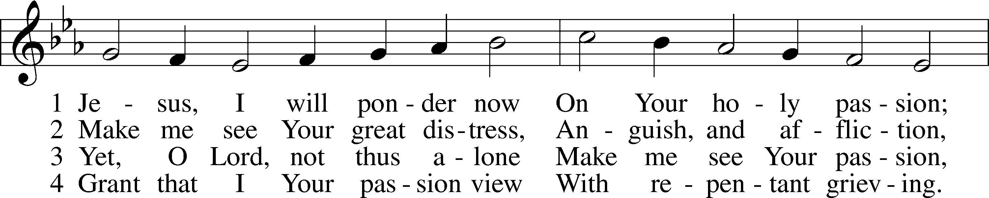
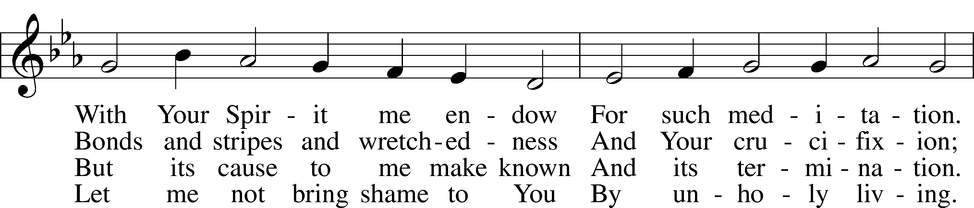
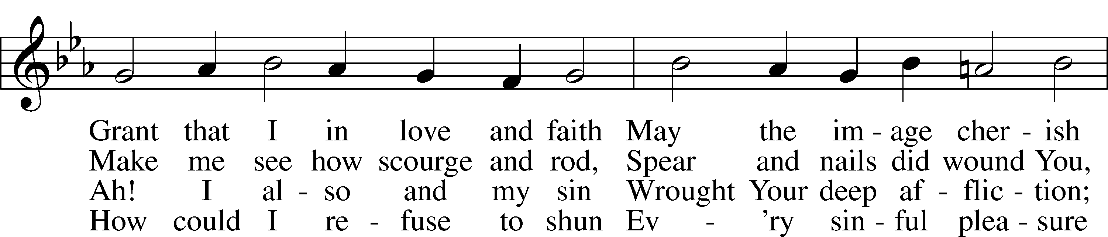
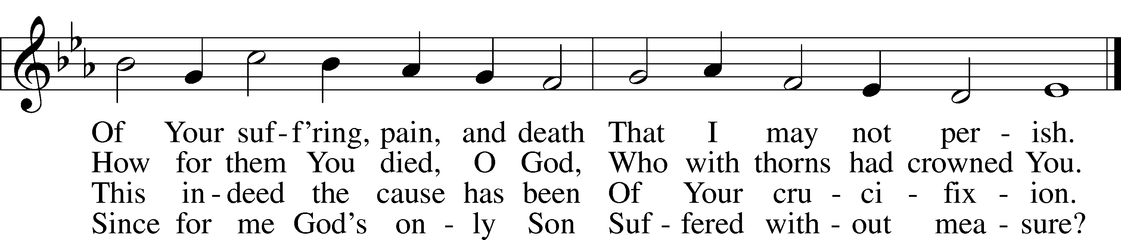

Graciously my faith renew; Help me bear my crosses,
Learning humbleness from You; Peace mid pain and losses.
May I give You love for love! Hear me, O my Savior,
That I may in heav’n above, Sing Your praise forever.

Read Jeremiah 31:31-34
1. What were the marks of the “old covenant?” See Genesis 17:5-11; Exodus 24:5-8 and Jeremiah 34:18.

2. On what is the “new covenant” based and how is it initiated? Read Hebrews 8 and Luke 22:20.

3. What significance does this understanding of the new covenant bring to the celebration of the Lord’s Supper?
Read Mark 10:32-45
4. Why would the disciples be amazed and other followers afraid in the first verse of our text? See 3:22 and 7:1.

5. How does Jesus address their concerns and how is this information perceived by the twelve? See Luke 18:34.

6. Why do James and John make their seemingly bizarre request in light of the previous verses?

7. One commentator suggests, “To share someone’s cup was a recognized expression for sharing his fate. In the Old Testament the cup of wine is a common metaphor for the wrath of God’s judgment upon human sin and rebellion, and this understanding was kept alive into the first century.” How does this help us understand Jesus’ initial response to James and John?

8. Why does Jesus seem to change his sentiments in verse 39?

9. How does Jesus redefine greatness in verses 42-44?

10. In verse 45 Jesus uses the word “ransom.” In the Bible, the act of redeeming another was often done by monetary payment, but in more important transactions it was done with the life of an animal or of another human being. The single most important passage for understanding Jesus’ use of this word is Isaiah 52:13-53:12. There, perhaps more clearly than in any other passage of Scripture. Read this section of Isaiah and reflect on the Suffering Servant who is described as offering his life as the price of redemption for the sins of many.

Devotional Thought from “The Lutheran Study Bible”
Jesus puts our welfare and needs ahead of His own as He conducts His ministry, showing us what real leadership is. Jesus shows that those who lead in the Kingdom of God serve others in humility. He leads by laying down His life as the sacrifice for our sins and calls us to similar service (TLSB, 1681).

Closing Prayer
Dear Father, You have sent Christ to serve us, although He had the right to demand our service. Forgive us Father. Lead us to give ourselves for the sake of others, that we, being last, might truly be first with Jesus in His Kingdom. Amen.

