Wednesday Bible Class

The Fifth Sunday after Pentecost

Opening Prayer and Hymn “Great Is Thy Faithfulness”
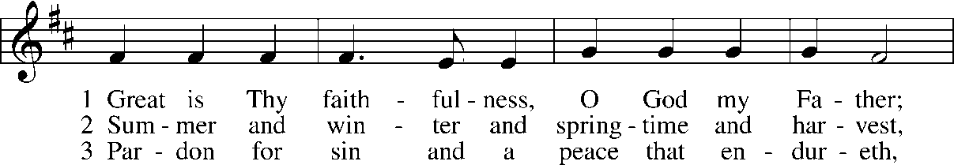
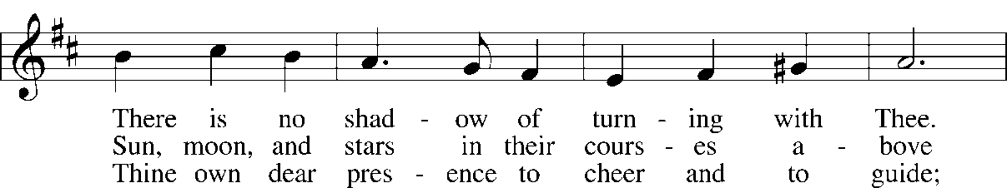
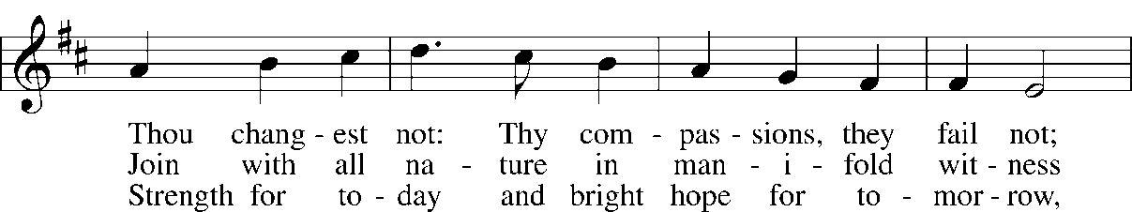
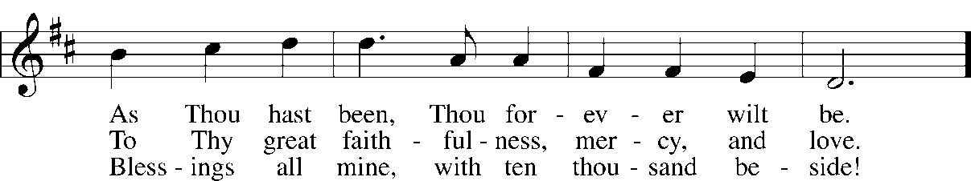
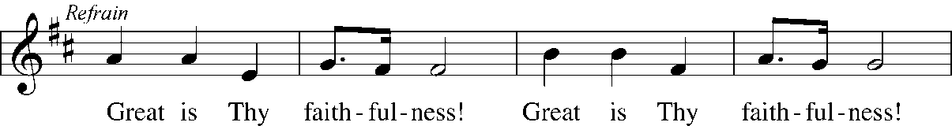
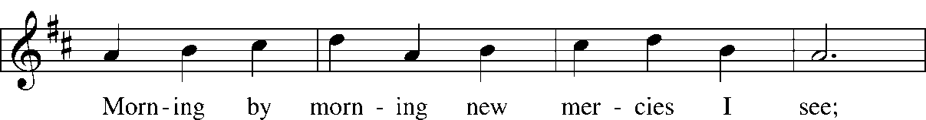
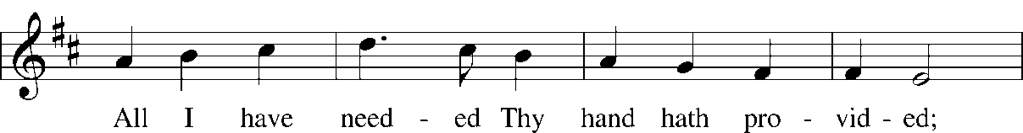
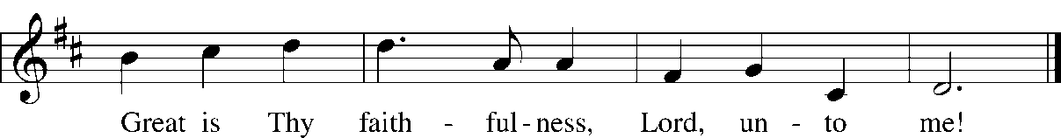

Read Lamentations 3:22-33
1. Who is the author? To whom is this written? What was the historical context? Why was it written?

2. vv. 22-24 – What do these verses tell us about God? How might we respond?
3. vv. 25-27 – To what human situation do these words speak in particular?

4. vv. 28-30 – In your own words, what do these verses tell us? Read Matthew 5:39. How does Jesus tell us to act? Compare with 1 Peter 3:18-24.

5. vv 31-33 – Does God cause grief? Read Hebrews 12:3-11. What good may come from trials? Compare with Jeremiah 18:4-6.

Read Mark 5:21-43
6. What was Jairus’ title? What did he do when he approached Jesus? Why did he do this? Were all religious leaders unbelievers and enemies of Jesus?

7. What did Jairus ask Jesus to do?

8. Describe the woman’s actions before she came to Jesus. What can we learn about her?

9. Why did she come to Jesus? What did she do? The result?

10. A woman who was “bleeding” was considered ritually unclean. What does Jesus’ reaction to the woman’s touch tell us about Jesus? What does this imply about Jesus’ concerns?

11. Is more than just a physical healing happening?

Read 2 Corinthians 8:1-9, 13-15
12. What was happening outwardly in the lives of the believers in Macedonia?

13. How does Paul describe their reaction when asked to help other believers going through difficult times?

14. What motivated the Macedonians? What response does Paul expect from the Corinthians? Why?

Devotional Thought: Jesus heals Jairus’s daughter and a woman with a chronic ailment. Like Jairus, we often worry that the Lord’s delay in answering our prayers may end up in catastrophe. But the Eternal One, who overcame death by rising from the dead, never runs out of time. In fact, His gracious promise that we shall share eternal life with Him.

Prayer: Lord, grant us to believe without doubting that You can heal every illness. Give us patience, as well, that we might be inmoved while waiting for You to act in Your own good time and in accord with Your gracious will. Amen

Hymns to sing or read and ponder:
LSB 756 Why Should Cross and Trial Grieve Me
LSB 757 Lord, It Belongs Not to My Care
LSB 760 What God Ordains Is Always Good
LSB 765 God Moves in a Mysterious Way

