Pastor’s Bible Class

The Eleventh Sunday after Pentecost

Hymn 620 “Jesus Comes Today with Healing”
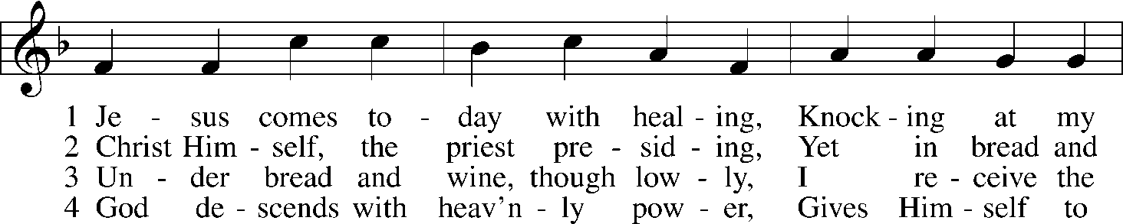
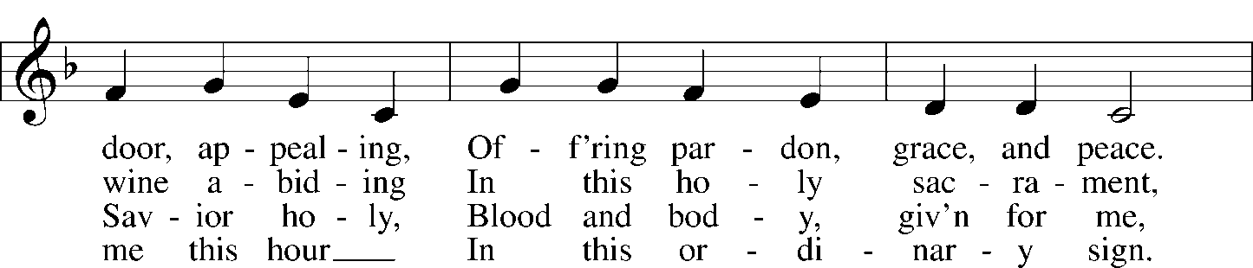
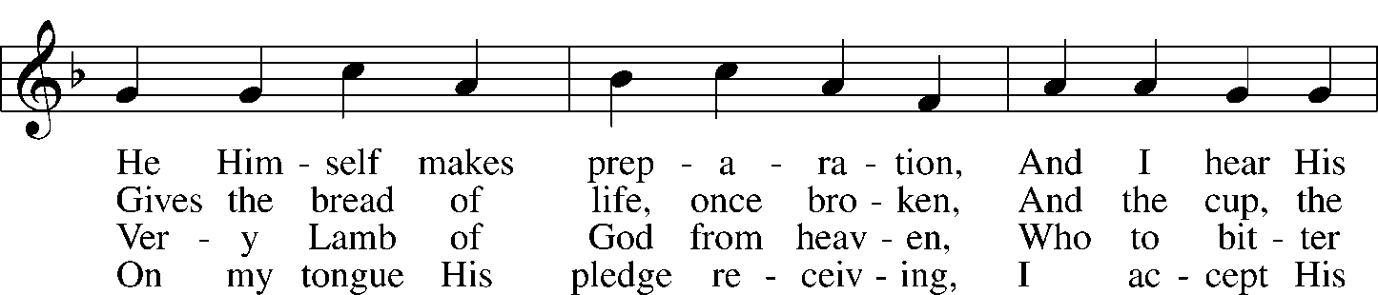
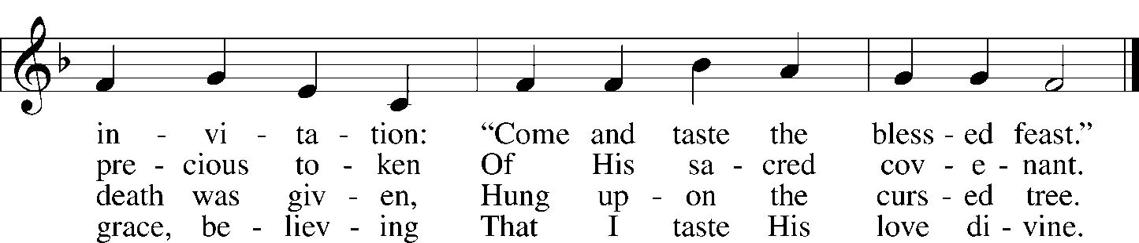

Read I Kings 19:1-8

1. I Kings 19:1 references a great display of God’s power in Elijah’s defeat of the prophets of Baal. How could Elijah have interpreted this event?

2. In reality, what happens in response to Elijah’s victory?

3. What does Elijah’s fear tell us about Elijah (and also about us)?

4. What signs from verses 3 and 4 provide insights into Elijah’s mental state?

5. In verse 5, we are introduced to “an angel” who encourages Elijah to “Arise and eat.” Later, in verse 7, we are specifically told this is “the angel of the Lord.” In Hebrew, this title “mal’ak Yahweh” is used 63 times in the Old Testament. Observe its use in the following references: Genesis 16:7-13; Genesis 22:11-12, 15-18; Genesis 31:11-13; and Exodus 3:2-6. How does “the Angel of the Lord” speak and act, and how is He recognized in these verses?

6. How does John 1:18 help us better understand identity of “The Angel of the Lord” as He appears in the Old Testament Scriptures?

Read John 6:35-51
7. How do the opening words of our text relate to the context surrounding this reading?

8. What ultimate claims does Jesus make in verses 35-40?

9. What does the grumbling of “the Jews” in verses 41-42 tell us about their understanding of these claims?

10. Jesus responds with even more pointed statements about His identity and purpose. What does He mean in verse 46 when He says: “not that anyone has seen the Father except he who is from God; he has seen the Father.”

11. In verse 51, Jesus restates His earlier claim when He says: “I am the living bread that came down from heaven.” Consider this verse alongside our Old Testament reading from I Kings 19 where Elijah receives a special meal of bread and water that sustains him for forty days and nights. How do these readings illuminate the main message of Scripture?

Devotional Thought (The Lutheran Study Bible)
Unlike the perishable manna God gave to Israel through Moses, Jesus comes down from heaven as the true bread to give life to all who believe in Him. Contrary to popular notions, no one “chooses” to believe in Christ; the initiative belongs entirely to God through His Word. Those united by faith to Christ will be raise up on the Last Day to enjoy eternal communion with the Father (TLSB, 1792).

Prayer
O God, draw me ever closer to You through Your Word and Sacraments. Amen.

JESUS LOVINGLY INVITES UNBELIEVERS TO HIMSELF
Verses 36-40 lie between last Sunday's text and today's text. A few remarks are in place. In these verses Jesus plainly tells His hearers that He has been fully revealed to them but they are rejecting Him. The one who comes to Christ does so only because he is a gift of the Father to Jesus. Such a one will never be driven away by Christ. But His hearers are resisting the Father Who wants to draw them. The will of the Father and the Son are identical. That identical will is that Jesus will not lose anyone whom the Father gives to Jesus. What's more, Jesus will raise that person on the last day. Much of verse 40 is repetition because Jesus is yearning for the people who are listening to Him. Everyone who believes in the Son has life eternal and furthermore, Jesus will raise that person on the last day. Notice how the gift of life eternal and of resurrection on the last day are a constant refrain in this sermon.

John 6:41 At this the Jews began to grumble about him because he said, "I am the bread that came down from heaven." (Buls: At that point the Jews began to grumble about Him because He said: "I am the bread which came down from heaven.")
Some commentators feel that a different audience is introduced at this point. But there is no proof for this.
The Gospel of John uses the term "the Jews" in pejorative sense, meaning Jesus' enemies, those who hated Him.
Though they grumble at Him, He does not abandon them but keeps on offering Himself to them. The cause of their grumbling is stated at the end of verse 41 and explained further in verse 42. Verses 41-51 center in the person of Christ.

John 6:42 They said, "Is this not Jesus, the son of Joseph, whose father and mother we know? How can he now say, 'I came down from heaven'?" (Buls: And so they went on to say: "Isn't this man Jesus the son of Joseph whose father and mother we know? How then does He say: 'I came down from heaven?'")
The question in the first part of the verse expects an affirmative answer. The second question amounts to doubting what Jesus said of Himself. They are plainly denying His divinity.
Lenski: 'Out of heaven have I come down.' That, indeed, is the vital point in all that Jesus said to them. It has ever been the stumbling block and rock of offense for unbelief.

John 6:43 "Stop grumbling among yourselves," Jesus answered. (Buls: Jesus answered and said to them: "Quit grumbling among yourselves.)
Lenski: In external and worldly matters let reason be the judge. But in heavenly matters and in matter of faith, when a question of salvation is involved, bid reason observe silence and hold still. 'No one' is applied here to the entire human race, to the whole world, with no one excepted, inclusive of the mightiest, the holiest, the wisest, and the most learned . . . But you come to Him when the Father shows you His great mercy, when He assures you that He will reveal Himself as having sent His Son into the world out of paternal love, as is written John 3:16.

John 6:44 "No one can come to me unless the Father who sent me draws him, and I will raise him up at the last day. (Buls: No one can come to Me unless the Father Who sent Me draw him and I will raise him up on the last day.)
This verse begins with a present general condition to which there are no exceptions. Implicit in this verse is the thought that natural man is spiritually blind, dead and an enemy of God. Lenski notes that Luther based the explanation of the third article on this verse.
The verb "draws" denotes the drawing of a dead weight, as for example in the beaching of a ship. God alone can draw. This verse excludes every vestige of synergism, also that of a Christian who is tempted often to think that he has spiritual powers of his own.
In John 12:32 Jesus uses the verb "draw" with reference to His crucifixion. There is no drawing, apart from the crucified Christ.
For the third time Jesus says: "And I will raise him on the last day." Look at verses 39 and 40. In verse 39 it is contrasted with losing a Christian: "I will not lose anyone but I will raise him." In verse 40 Jesus makes clear that where there is faith in life eternal, there the individual has the assurance of resurrection. And in verse 44 we are told that through the monergistic drawing of the Father, Jesus will raise the individual on the last day. Faith does not grumble but rejoices in the Father and the Son.

John 6:45 It is written in the Prophets: 'They will all be taught by God.' Everyone who listens to the Father and learns from him comes to me. (Buls: It stands written in the prophets: 'And they shall be taught by God;' everyone who has heard and learned from the Father comes to Me.)
Jesus correctly quotes Isaiah 54:12 which foretold justification through faith in Christ. His hearers had misquoted Scripture in verse 31 in the interest of work-righteousness.
God is the great teacher. The Father draws the individual by causing the individual to hear and learn of Jesus. That person comes to Christ which is synonymous with believing in Him. Isaiah 54 describes the blessed condition of those who believe in the Savior described in Isaiah 53.
Lenski: The fact that some, like these Galileans, hear with deaf hearts and ears and refuse to learn is here not considered by Jesus.
Kretzmann: Those that are taught of God, that have learned the lesson of their own inability and lack of strength, and therefore both hear the Father and in all things learn of Him, only they can come to faith in Christ. The Father uses no compulsion, but makes use of teaching only.
True. God uses His ordained servants of the Word so that people may hear and learn what God, the great Teacher, says.

John 6:46 No one has seen the Father except the one who is from God; only he has seen the Father. (Buls: Not that anyone has seen the Father except the One Who is from God, He has seen the Father.)
In John 6:2, 14, 30, 36, and in the first in 46 forms of "to see" are used. In all instances it is mere physical seeing, apart from faith. (In verse 40 Jesus speaks of spiritual seeing, faith, a work of God in man.) In 46b it is said of Jesus that He has seen the Father. But He is the God-Man. Jesus is making reference to both His divinity and to His humanity.
Luther: Do not stray into the belief that one can come to the Father without the Person of Christ. Therefore He binds our ears and our hearts to the Word of this Man . . . Stick to the external Word, and listen to it.

John 6:47 I tell you the truth, he who believes has everlasting life. (Buls: In very truth I tell you, the one who believes has life eternal.)
"I tell you the truth" for the third time in this sermon.
In verse 26 He revealed their true character (law). In verse 32 He offers them Himself (Gospel). Here in verse 47 He makes a summary statement: The believer has eternal life already now. Some versions insert the words "in Me" based on textual evidence. No problem, in view of what precedes and follows this verse, "in Me" is implicit here.

John 6:48 I am the bread of life. (Buls: I am the life-giving bread.)
This sentence occurs three times in this sermon, here and in verses 35 and 51. Note the "I" is emphatic -- "I and none other." The word is used this way eleven times in verses 25-71.
Incidentally, Jesus is referred to by various pronouns no less than sixty times in verses 25-71. He is attempting to draw His hearers to Himself because He wants to save them.
What is the point of comparison between "bread" and Jesus? Bread covers all food necessary for man in this life lest he die. Jesus covers all that is necessary for man for the life to come, lest he perish. He differs, of course, from ordinary food. The latter merely sustain life. Jesus gives life, spiritual life, everlasting life. "Bread" is used figuratively here. Jesus is not speaking about the Lord's Supper. More on that later.

John 6:49 Your forefathers ate the manna in the desert, yet they died. (Buls: Your ancestors ate the manna in the wilderness and yet they died.)
Jesus is not only telling them that manna could not save their ancestors but also that the kind of food which they were seeking (look at verses 26 and 34) cannot save them eternally. It cannot keep death away. They are not believing. They are not hearing and learning. They are not taught of God. They will not permit the Father to draw them. They can reason only on the unregenerate level. Therefore, they are unhappy and grumble.

John 6:50 But here is the bread that comes down from heaven, which a man may eat and not die. (Buls: This is the bread which comes down from heaven, that anyone may eat of it and so will not die.)
Though Jesus speaks in the third person, He speaks of Himself. Manna was given only to the covenant people. This bread is for all men. The bread is divine.
"Anyone" or "everyone" is an open invitation to all people to come to Jesus. "Eat" means "to believe."

John 6:51 I am the living bread that came down from heaven. If anyone eats of this bread, he will live forever. This bread is my flesh, which I will give for the life of the world." (Buls: I am the life-giving bread which came down from heaven. If anyone eats of this bread he will live forever, and what's more, the bread which I shall give is My flesh (given) in behalf of the life of the world.")
For the third time Jesus says: "I am the life-giving bread." Here we have a repetition of the thought in verse 50, except that this time He speaks of eternal life.
The last five words denotes the vicarious atonement "in behalf of the life of the world."
Ylvisaker: It is the true human nature of Jesus, the Bearer of eternal life, which faith must appropriate in order to partake of the life . . . . His human nature, or, in other words, Himself, as the One made man, is food, indeed which satisfies the inmost needs of humanity and apart from Him, this food may not be found . . . . It is ever correct to say that Jesus uses the term 'flesh' and 'blood' because He would choose a clear and adequate expression to designate His human nature, as of flesh and blood. . . . To eat is, then, in this passage, to believe. He that believes also eats and drinks Christ . . . If He were merely 'flesh', a human being only, then the eating and drinking of Him would not avail unto eternal life, it would have no beneficial effect whatsoever. But He is also 'spirit', that is, God in essence and in truth, and it is this 'spirit' which permeates and animates His true humanity which makes Him the true Bread from heaven.

The Encouragement Himself
Sermon Theme: The Lord has the answer for our discouragement.
Text: 1 Kings 19:1–8
Other Lessons: Psalm 34:1–8; Ephesians 4:17–5:2; John 6:35–51
Goal: That hearers will not be discouraged when the fruits of their labors are not visible, but will draw strength from the promises of God that Christ is with them.
Rev. Robert E. Smith, electronic resources librarian, Concordia Theological Seminary,
Fort Wayne, Indiana
Liturgical Setting
“I am the bread of life; whoever comes to me shall not hunger, and whoever believes in me shall never thirst” (Jn 6:35), proclaims Jesus as the Gospel this week begins. This reading is the second part of a three-week reading of the Bread of Life discourse in John 6. The Collect draws out this theme as we pray that the Christ, the Bread of Life, might live in us. The Introit, the Psalm, the Gradual, and the Verse for the week focus on God’s provision for his people.
Relevant Context
Our lesson occurs between Yahweh’s victory over the prophets of Baal at Mount Carmel and Elijah’s encounter with God on Mount Sinai. Elijah expected that the fire from heaven that consumed his sacrifice would bring Israel back to the worship of the true God. This did not happen. Jezebel threatened the prophet’s life, so he withdrew from Israel, went to Beersheba and then into the wilderness, where he asked God to take his life. Instead, God sent the angel of the Lord to sustain Elijah with bread and water, as God had done in the past (17:1–16). Elijah went on to Mount Sinai, where the angel of the Lord sent the wind, an earthquake, and fire to him and spoke in a whisper. God told Elijah he was not alone, that seven thousand in Israel had not forsaken Yahweh. God then sent Elijah to commission Elisha, Hazael, and Jehu to bring down the throne of Ahab and Jezebel.
Textual Notes
Vv 1–2: King Ahab went to Queen Jezebel to tell her what had happened at Mount Carmel. Jezebel sent a messenger to Elijah, threatening to take his life. She likely did not intend to carry this out, or else she would have sent an assassin instead (Werner Herman Franzmann, Bible History Commentary: Old Testament [Milwaukee: Wisconsin Evangelical Lutheran Synod, 1980], 448). She may have reasoned that causing the prophet to despair and flee would sufficiently discredit him and undermine the sudden wave of enthusiasm for Yahweh.
V 3: wayare’, “When he saw” or “Then he was afraid.” The form of the Hebrew consonants can be understood to be from the verb r’h, “to see,” or from the verb yr’, “to be afraid.” The Masoretic text points the word to mean “When he saw,” while the Septuagint and the Vulgate translate it “Then he was afraid.” Most translations and commentators follow the latter reading, concluding that Elijah feared for his life. (For example, see The Lutheran Study Bible, 570; Walter H. Roehrs and Martin H. Franzmann, Concordia Self-Study Commentary [St. Louis: Concordia, 1998], 1:233; James Alan Montgomery, A Critical and Exegetical Commentary on the Books of Kings, International Critical Commentary [New York: Scribner, 1951], 312; Martin Luther, Lectures on Genesis: Chapters 26–30, ed. Jaroslav Jan Pelikan, Hilton C. Oswald, and Helmut T. Lehmann [St. Louis: Concordia, 1999], 5:25.) Keil and Delitzsch follow the former reading, reasoning that Elijah believed his ministry was in vain. They argued that, since Elijah wished to die, the prophet’s flight was to commend his soul to Yahweh (Carl Friedrich Keil and Franz Delitzsch, Commentary on the Old Testament [Peabody, MA: Hendrickson, 1996], 3:178). Either way, Elijah leaves the kingdom of Israel, enters the kingdom of Judah, and travels to Beersheba, the southernmost city in that nation. Here, he dismisses his servant.
V 4: Elijah travels a day farther into the wilderness and stops under a broom tree. He asks God to take his life because he is no more successful than his fathers. He falls asleep under the tree.
Vv 5–7: An angel, identified later as the “angel of the Lord,” wakes Elijah to cakes cooked on hot stones and water to drink. He then goes back to sleep. The angel wakes him a second time and tells him to eat because the journey is too hard for him. This mal’ak yehwah is the angel of the Lord, who appears frequently in the Old Testament, especially in the Pentateuch. He speaks and acts as Yahweh and is recognized as God himself. Many scholars view this angel as the preincarnate Son of God. (See Charles Gieschen, Angelmorphic Christology: Antecedents and Early Evidence [Leiden: Brill, 1998], 3–25, 105.) From this perspective, it is Christ himself who feeds Elijah, giving him the strength to journey to Horeb and to speak to him as the Word of Yahweh (1 Ki 19:9).
V 8: The food strengthened Elijah for ’arba‘im yom, “forty days,” and forty nights as he traveled to Mount Horeb. The number forty is often used in Scripture for a period of testing, judgment, preparation, and discipline. God sent rain for forty days and forty nights during the great flood (Gen 7:4). Moses tended sheep in Sinai for forty years (Acts 7:30). He spent forty days on Horeb, while God gave him the Ten Commandments written on the stone tablets (Ex 24:18). The twelve spies spent forty days in Canaan (Num 13:25). The people of Israel spent forty years in the wilderness (Num 14:33). God gave Nineveh forty days to repent (Jonah 3:4). Jesus wandered in the wilderness and fasted forty days prior to his temptation by the devil (Mt 4:2). Jesus appeared to the disciples for forty days following his resurrection (Acts 1:3).
Sermon Outline
Introduction: Elijah thought the people of Israel finally got it. “The Lord, he is God; the Lord, he is God,” they said (1 Ki 18:39). At Elijah’s prayer, God sent fire from heaven to consume the sacrifice of a bull, the kindling wood, the stones of the altar, and the water he had poured over it. At Elijah’s command, the people slaughtered 450 prophets of Baal. Elijah then told King Ahab to mount his chariot and leave because it was to rain and end a three-year drought. And it happened just as the prophet said. Finally, all his work had been rewarded.
Except nothing had changed. Jezebel was not repentant but angry, threatening to kill the prophet. Now, that was it! The people had forsaken God’s covenant, broken down his altars, and killed his prophets. Elijah thought he was alone. So he left Israel, crawled under a tree, and asked God to take his life.
God always answers our prayers, but sometimes in much better ways than we ask. Certainly in this case. Far better than Elijah asked. For him just as for us,
The Lord Has the Answer for Our Discouragement.

I. When we work hard but do not see results, we sometimes become discouraged (vv 1–4).
A. We love the Lord and, like Elijah, want God’s kingdom—and our congregation here—to grow.
1. So we pray. We attend every worship service. We volunteer to teach Sunday School and to usher. We give generously of our income.
2. Yet the congregation never grows, and its finances are tight.
B. So we become frustrated, and we double down on our efforts.
1. We read the advice of others. We try new programs. We urge our church’s members to do more. We even try to be better at the roles God has given us to do in church.
2. Yet it looks as if everything we’ve ever done was a waste of time. Why bother? we think.
C. What we often forget is that we cannot make our congregation grow by our own efforts.
1. Our energy is not endless, human talent is limited, and both we and the people inside and outside our church are sinners.
2. While our work may surely succeed from time to time, it will eventually fail.
D. God does not call us to be successful, but to be faithful.
1. After all, it is Jesus who saves. It is the Holy Spirit who calls us by the Gospel and enlightens us with his gifts.
2. He calls us to hear God’s Word, to use in faith the gifts he gives us, to love him and our neighbors, to witness to his love in Jesus, to cherish and receive the Sacraments he gives us.
3. When we try to do others things, we are, at best, doing things God has not commanded us to do. And when we expect things to happen because of our own efforts, we may well burn out, sooner or later. At times like these—

II. When we are discouraged, Christ himself will raise us up.
A. The Lord gives Elijah his better answer (vv 5b–8). As God had fed his people Israel in the desert with manna, as God the Son would feed five thousand in the wilderness, so now God feeds his prophet.
1. While Elijah lay under the tree, waiting to die, God did not grant his prayer.
2. Instead, as the angel of the Lord, the Son of God came to him and brought bread and water to him. God, Christ himself, personally gave his prophet the strength to go on.
3. At Mount Sinai forty days later, God tells the prophet he is far from alone and his work is not in vain (19:15–18).
B. Jesus invites us, too, to cast our cares upon him.
1. After all, he took our sins upon himself. He bore all of them to the cross, where he died the death we deserved and paid all the debts we owed for them.
2. He won for us there forgiveness of sins, life, and salvation.
C. As the Son of God fed Elijah, he now feeds us, not with just bread and water, but with his own body and blood in the bread and wine of his Supper.
1. Here, the forgiveness and all the blessings of Jesus’ cross are given to us personally. With the sin that separated us from God removed, we have the assurance he is always with us.
2. In this way, the Sacrament gives us strength so that we are refreshed.
Conclusion: The answer for our discouragement is always Christ, for he is the one who forever feeds us and reunites us with God. With his strength, we arise and go on. And you see, being with him means we are not alone even as we look about us. God has called your brothers and sisters to the same work. Together we witness to Christ and his cross, love our neighbors, and allow God the Holy Spirit to call others to join us. Amen.

