Pastor’s Bible Class

The Thirteenth Sunday After Pentecost

#621 “Let All Mortal Flesh Keep Silence”
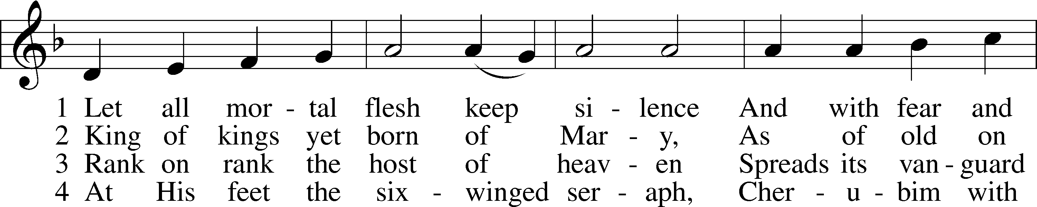
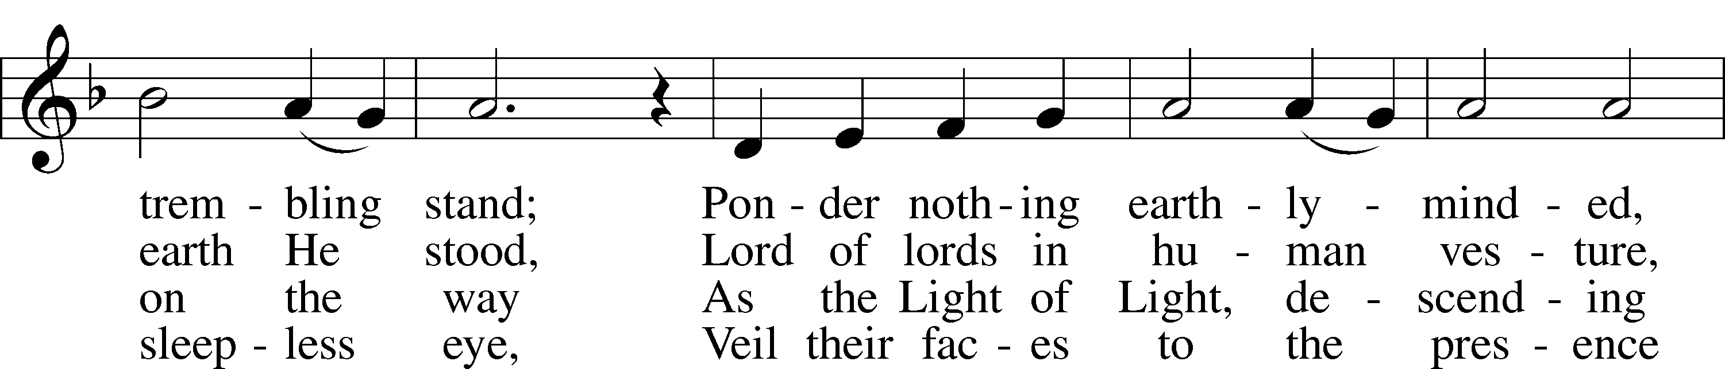
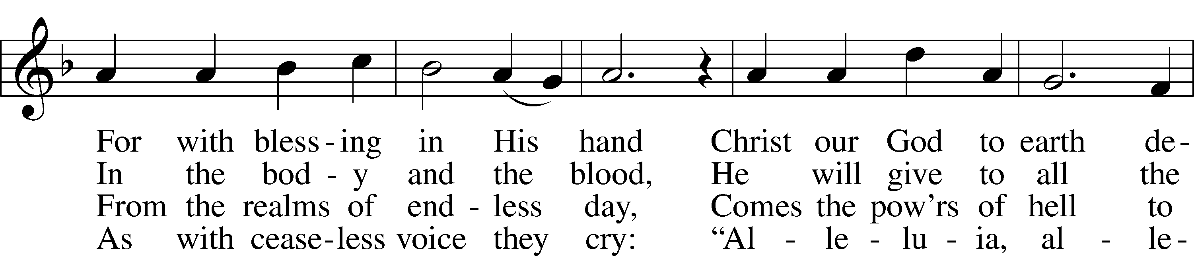
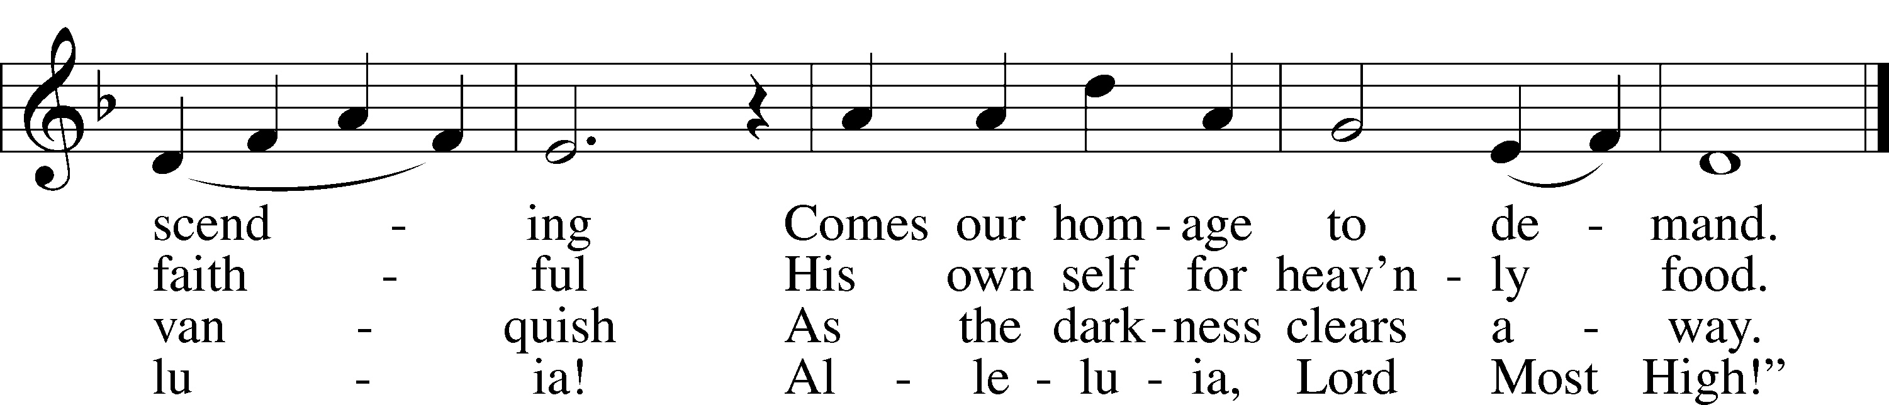

Read Jeremiah 15:15-21
1. What is the context for Jeremiah’s complaint? See Jeremiah 15:1-4 and 10.

2. About what does Jeremiah complain in verses 15-18?

3. How does God answer Jeremiah’s complaint? See verses 19-21.

4. Is this a satisfying answer? Why or why not?

Read Matthew 16:21-28

5. To what is Matthew referring when he writes, “From that time on...”?

6. What is the relationship between the knowledge of the Jesus as Messiah and His destiny with the cross?

7. What details does Jesus reveal about what He “must” do?

8. Read Acts 17:1-9. What is the essence of Paul’s message in this text?

9. What “counsel” does Peter offer Jesus and what does this tell us about Peter?

10. In the “Smalcald Articles” Luther wrote:

“Enthusiasm clings to Adam and his descendants from the beginning to the end of the world. It is a poison implanted and inoculated in man by the old dragon, and it is the source, strength, and power of all heresy…Accordingly, we should and must constantly maintain that God will not deal with us except through His external Word and sacrament. Whatever is attributed to the Spirit apart from such Word and sacrament is of the devil” (Tappert 313:9-10).

Based on these words, why was Jesus so harsh with Peter?

11. What are “the things of man?”

12. What are “the things of God?”

13. What does it mean to “deny” oneself? Read Philippians 3:8-9.

14. How do trials and temptations in the life of a believer connect him or her to Christ? See Hebrews 4:14-16.

15. How is verse 27 comforting for the believer in Christ? See Galatians 3:27 and Matthew 25:31-46.

16. What does verse 28 mean? See Matthew 24:14.

Devotional Thought from “The Lutheran Study Bible”
Peter genuinely thinks he is helping Jesus when he tries to talk Him out of suffering and death. At times, we also fail to understand God’s ways, thinking we know better. Jesus knows that He has to take up the cross for our salvation. Peter will learn this truth latter, a truth that continues to give us comfort and peace” (TLSB, 1618).

Prayer
Lord, thank you for being willing to suffer and die that I might be forgiven. Lead me to speak Your Word aright. Amen.

THE THOUGHTS OF GOD
AS OPPOSED TO THE THOUGHTS OF PEOPLE

Matthew 16:21 From that time on Jesus began to explain to his disciples that he must go to Jerusalem and suffer many things at the hands of the elders, chief priests and teachers of the law, and that he must be killed and on the third day be raised to life.
Bengel: The Gospel may be divided into two parts, from which the divine plan of Jesus shines forth. The first proposition is 'Jesus is the Christ'; the second 'Christ must suffer, die and rise again' Compare John 16:30.31.32. Jesus first convinced His disciples of the first proposition, in consequence of which they were bound to believe Him concerning the second, even before His passion. After His ascension, the people first learned the second proposition, and thence were convinced of the first. See Acts 17:3. As soon as Jesus had persuaded His disciples of the first (verse 16), He added the second (verse 21). . . . Men frequently teach all things at once; Divine wisdom acts far otherwise.
Lenski: One great task had been accomplished: the disciples had been brought to the full realization of the Divine Person of Jesus as Peter voiced this conviction for the Twelve (verse 16). Another task had to be finished: the disciples had to be made to understand the Redemptive Work Jesus was about to complete.
Fahling: It was still news to the disciples, but it was not news to their Master that Christ-must first suffer before He could enter into His glory (Luke 24:26).
Items before referred to in veiled language. Compare John 2:19; 3:14; 10:17.18; Matthew 12:39.40. LB "to speak plainly;" JB "to make it clear;" AAT "kept pointing out." Note that this clear and constant revelation is limited "to His disciples."
"Must go" denotes the necessity of God's eternal plan, prophecy (Psalm 22 and 69; Isaiah 53; Daniel 9:24-27) and oath (Luke 1:73; Hebrews 6:16-18) as well as the willing obedience of Jesus (Hebrews 10:9-10). Jesus' vicarious suffering, death and resurrection are absolutely unique in history.
He went to the place where rejection of Him was the deepest. When His hour finally came, He made Himself available to His enemies. The details are not yet given but become clearer in subsequent predictions.
Note only one article with three nouns, a group, the Sanhedrin, the highest council among the Jews.
Bengel: Three classes of those who ought to have led the people to the Messiah, corresponding nearly to the Council of Justice, the Consistory, and the Theological Faculty of modern times.
Lenski: Thus far Jesus had frustrated their schemes but now he tells the disciples that the Sanhedrin will succeed.
Stoeckhardt: The murderous attack against the Messiah of Israel will come from the highest authorities of Israel, who should have been the watchmen over the true religion entrusted to the fathers.
"To be killed " shocked the disciples at this point. We make several points:
- None of the prophets had foretold this third day. The Old Testament had alluded to this in the analogy of Jonah 's stay in the belly of the fish (Matthew 12:39.40) but Jesus in His divinity saw it more clearly than did the prophets;
- Death would not hold Him. This is the glorious part of the prediction. Evidently the disciples were so shocked at the first part of verse 21 that they practically did not hear this part;
- He would not see corruption as do all other men.

Matthew 16:22 Peter took him aside and began to rebuke him. "Never, Lord!" he said. "This shall never happen to you!"
This participle is usually used of Jesus taking someone aside. Peter acts as master and lord. AAT: "took Him aside and started to correct Him." NASB: "took him aside and began to rebuke him." Note that "explain" was used of Jesus, verse 21, and is now used of Peter.
"Rebuke" is a strong verb, denoting a strong rebuke or reprimand. AAT: "God be merciful to You, Lord. This must never happen to You." TEV: "God forbid it, Lord." Though Peter means well he is practically playing the very part of God. What Jesus said will happen, Peter says will not happen. From Mark 8:33 it is clear that Peter was speaking not only his own thoughts but also those of the other disciples. Christians are simul iusti et peccatores, both flesh and spirit, so fickle and changeable.

Matthew 16:23 Jesus turned and said to Peter, "Get behind me, Satan! You are a stumbling block to me; you do not have in mind the things of God, but the things of men."
Turning toward Peter, giving him His whole attention. It is remarkable that Jesus used these precise words on Satan at Matthew 4:10. Here Peter, though meaning well, spoke Satanic thoughts. Compare John 6:70 where Judas is called "a devil." Judas had evil intent. Peter had good intent. But similar words are used of both.
Bengel: The words of Peter were more dangerous than the assaults of Satan, mentioned in Matthew 4: 10.
True. Satan was clearly a tempting enemy. Peter was a tempting friend. But Jesus did not dilly-dally with temptation the way we often do. In our day the word "fantasy" is used so much. What do people mean by that? They mean "sinful toying with temptation." Jesus resisted temptation immediately. For the next words AAT has: "You're tempting Me to sin." LB has "You are a dangerous trap to me." Note the utter difference between God's thoughts and the thoughts of sinful men, no matter how well meant.
Bengel: Rock (verse 18) and offense (verse 23) are put antithetically. . . . The perception of Jesus is always divine. 'Of men' is the same as 'flesh and blood' in verse 17. . . . To the world the cross was offensive, to Christ whatever opposed the cross.
Stoeckhardt: The preaching of the cross of Christ is to this day a stumbling block and an offense to human reason. Even believing Christians often still harbor human thoughts instead of what God desires.
Fahling: A minute ago Peter was speaking under inspiration from heaven, but now under inspiration from another direction.
We think here of Luther's words, Smalcald Articles, Tappert 313.9-10:
Enthusiasm clings to Adam and his descendants from the beginning to the end of the world. It is a poison implanted and inoculated in man by the old dragon, and it is the source, strength, and power of all heresy, including that of the papacy and Mohammedanism. Accordingly, we should and must constantly maintain that God will not deal with us except through His external Word and sacrament. Whatever is attributed to the Spirit apart from such Word and sacrament is of the devil.
True! Jesus was speaking blessed Gospel. Peter, in the name of the others, rebuked Jesus sternly. Jesus plainly tells Peter that his thoughts, no matter how pious, were the devil's words. This was not the last time Peter thought thus. Think of his denial of Jesus. Think of how Paul had to withstand his hypocrisy at Antioch (Galatians 2:11-14) where Peter became an offense to both Gentile and Jewish Christians. But, by the grace of God, this same Peter wrote later: "You are kept by the power of God through faith unto salvation (1 Peter 1:5)."

Matthew 16:24 Then Jesus said to his disciples, "If anyone would come after me, he must deny himself and take up his cross and follow me.
Evidently Jesus spoke these words immediately after verse 23. Both Mark and Luke say that these words were spoken not only to the disciples but to all, to the crowd which was with the disciples.
To what Jesus says in each case the listener must say either "yes" or "no" to both parts. If he says "yes" to the protasis, he must do as the second part indicates. Jesus says "if anyone." Underlying the word "anyone" is the universal atonement. There is no limitation.
Jesus is speaking of the renewed will of a person. It is present tense denoting a state of mind and heart. Note that Jesus does not say "if anyone chooses." Synergism is eliminated.
Furthermore, Jesus says "wills." Grace is not irresistible. Jesus does not say "if anyone is forced" or "is anyone is destined ." To come after Jesus simply means to believe in His Person, Word and Work.
Furthermore, He says after Me, not before Me. Nothing in the life of the Christian is strange or unknown or unexperienced by Jesus. Meditate on Hebrews 2:17.18 and 4:14-16. He carried the saving cross before all men.
Now comes the apodosis, three imperatives third singular. The first two are aorist, the third present tense. He is speaking of people who have a renewed will, who have the strength by faith in Him to do as He wills. The aorist imperatives are effective (add the word "truly") and denote once for all action, decisive.
To deny oneself means to deny the sinful, fleshly self. Human flesh and blood (verse 17) are sinful, furnishing no strength. The thoughts of men (verse 23) only lead to traps. Read Galatians 5:13-26. Also Galatians 2:19-20. ln verse 20 Paul says: "I live, but no longer I," and then he adds "but Christ lives in me." The "I" of the flesh is dead. The "I" by faith in Christ is alive.
Jesus means the sinful, dead flesh. It must be disowned, though recognized as ever present. Of all people, only the Christian alone is wise. He knows the utter sinfulness of his flesh, but abandons and disowns it as Peter denied Christ "I know not the man." The Christian's greatest battle is with his own sinful self. Once he sees that he can say with Paul: "If God is for us (and He is), who can be against us?" (Nobody). Read Romans 8:31-39. Read Titus 2:11-15 and Luke 14:33. The Christian must abandon all of his own fleshly, sinful resources. Also Hebrews 10:23.
Lenski: This is true conversion, the very first essential of the Christian life. The heart sees all the sin of self and the damnation and the death bound up in this sin and turns away from it in utter dismay, seeking rescue in Christ alone.
Next comes "and let him take up his cross." Not Christ's cross, but his cross. Jesus is making a distinction. No one can carry Christ's atoning cross. But Jesus is implicitly correcting Peter who insisted that Christ would not suffer and die. Jesus is saying: "Not only must I carry MY cross but you, too, must take up your cross." This is true sanctification, a willing taking up of the individual cross. This, of course, means suffering, not just any suffering, as becomes clear in verse 25, where we will comment on this Christian living is by no means easy.
The cross is all that which the Christian bears for Jesus' sake. The moment Paul was converted he said "What do you want me to do, Lord?" (Acts 22:10). The whole life of the Christian is summed up in that question and constantly finding the answer in His Word.
Then, "and let him be constantly following Me." The first requirement of even a Christian leader is that he is a follower, not of self, but of Jesus. A follower has no will of his own, but only that of the Leader. Luther and Chemnitz, our great Lutheran Church-Missouri Synod fathers (Walther, Stoeckhardt, Pieper, etc.), Peter and Paul, became leaders only because they were such dedicated followers. Read Galatians 2:20.

Matthew 16:25 For whoever wants to save his life will lose it, but whoever loses his life for me will find it.
This verse is an explanation that is both paradoxical and axiomatic. There are two sentences, each a complex sentence , a variety of what we call the "general condition" to which there are no exceptions. Underlying the "whoever" in the first sentence is the way of the renewed, converted spirit in the believer. By way of contrast, Jesus implies in the first sentence that it is "for his own sake", the way of the selfish, sinful flesh. "Wants to save" in the first sentence denotes delusion.
Bengel: It is not said 'shall save.'
True. The wish is not fulfilled.
Bengel: The soul is the man in his animal and human capacity. 'To save' is meant physically. 'Shall lose' is meant spiritually and even physically.
Stoeckhardt: He uses the expressions' life' and. soul ' with different meanings, here referring to the old corrupt I, as well as to life itself, the soul. He who wants to preserve his natural life, in which he yields to his natural desires, will lose his soul.
Exactly. Note how the rich man (Luke 12:19) used the word: "I will say to my soul 'Soul, you have many good things etc." That parable is a good comment on Matthew l6:25ª.
Now comes the opposite side of the coin in 25^{b}. 25ª is a stern warning not to follow the lust of the flesh, the lust of the eyes and the pride of life. It covers all instances. 25^{b} is a glorious promise. The universal atonement undergirds it for Jesus says "whoever, no matter who."
Stoeckhardt: But whoever mortifies the 'I' for Christ's sake and crucifies his flesh with his lusts and yearnings, will rescue his soul unto eternal life.
Bengel: 'Loses' physically and naturally, having cast away all ego by self-abnegation. It is not said 'who wishes to lose'. (Bengel means that he has no will of his own). 'For my sake' is the object of self-abnegation. 'Shall find' in Mark and Luke it reads 'shall save' i.e. spiritually and also physically. The world is full of danger. The soul that is saved is something that has been found.
Fahling: He who will cheerfully give up everything in this life, if need be, for the sake of the Gospel and of Christ will find true and everlasting life in the Redeemer.
Ylvisaker: They must give up the earth in order to win that which is of heaven.
Lenski: Does his case (that of the Christian) seem sad and deplorable? Far from it! In and by the very loss he shall find the 'life' for the sake of and blessed with Christ and with God. But note the significant phrase 'on my account' which explains 'his cross' in verse 24. Compare Matthew 5:10.11; 10:18; Mark 8:35; 10:29 (for My sake and the Gospel's). On the one hand (25ª) the gain is only temporal and a delusion, while the loss is irreparable; on the other hand (25^{b}) the loss is only minor while the gain is immense and eternal.
Exactly. There is something decidedly wrong with Christians who constantly complain about how much they have to give up, who complain even about church services and functions not being 'thrilling' enough, who serve and give grudgingly. The Christian loses his life for Jesus' sake cheerfully. And don't we all need repent because of the way in which we like to look back as did Lot's wife? Read hymn #430 in The Lutheran Hymnal . It takes real repentance to sing that hymn cheerfully.
Of course, Jesus is not saying that rightful pleasures, which are in keeping with the third use of the Law, are wrong. The correct use of sex in marriage, the correct use of money, the enjoyment of a God-pleasing banquet, etc., are not sinful per se. The true Christian enjoys the things of this life in a God-pleasing way as no worldling can.

Matthew 16:26 What good will it be for a man if he gains the whole world, yet forfeits his soul? Or what can a man give in exchange for his soul?"
"What" introduces two rhetorical questions. The first question is a future less vivid condition which comes close to being contrary to fact. If we read it as future less vivid it comes out this way: "If a human being should gain the world in its entirety but loses his own soul, in what respect would he be benefitted?" Answer: "None at all." lf we read it as contrary to fact it comes out this way: "If a human being were to gain the world in its entirety (which is done by no one) but loses his own soul, in what respect would he be benefitted?" Answer: "None at all."
Jesus knew what this temptation was like. Read Matthew 4:8-10. In the first place, it was not for Satan to give Christ the world and its kingdoms. In the second place, Satan 's giving was delusive and conditional "IF you will worship me." The sinful flesh in its delusion wants to gain the world in its entirety. But no one ever did that, nor can he. The avaricious miser is never satisfied. Even if he could gain all this world's wealth, pleasure and treasure but thereby would lose his own soul, in what respect would he be benefitted or helped? Jesus purposely does not answer the question because the answer is plainly obvious.
Stoeckhardt: The old corrupt 'I' clings to the world, the treasures, joys, and pleasures of the world.
Lenski: All the world's wealth, the world, the sweetness of all the delicacies that it ever offered, the grandeur of all the high things that ever towered aloft on it, all sensations, all enjoyments, all achievements, all satisfactions. Of course, such a thing is frankly impossible to any human being, and that is understood. But granting the impossible and for the moment accepting it as actual, what is this man benefitted if, though he have the whole world, he forfeit his 'soul'? The question answers itself. . . . Satan needs no such price to buy men's souls; all he needs is a little piece of this world.
And now the second rhetorical question: "What shall a human being give as an equivalent for his soul?" An equivalent ought not be of less value than the soul for which it is given. There is no such equivalent. On the verbs read the remarkable parallel at Philippians 3:7-11. At the heart of worldly gain lies selfishness and selfrighteousness. At the heart of heavenly gain lies repentance and the righteousness of Christ, imputed righteousness.
Above we compared Judas and Peter. Of Judas Christ said: "One of you is a devil (John 6:70)." He remained adamantly impenitent. To Peter Christ said: "Be gone from Me, Satan." Note that Christ did not say: "You are Satan." Peter's thoughts were Satanic and dangerous, but Peter, though he sinned, always repented. He bore his cross, followed the Lord, lost his life for Jesus' and was deeply concerned about his hearers even when he was about to die. Read 2 Peter 1:1.

