Pastor’s Bible Class

The Fourteenth Sunday after Pentecost

“Jesus Sinners Doth Receive” #609
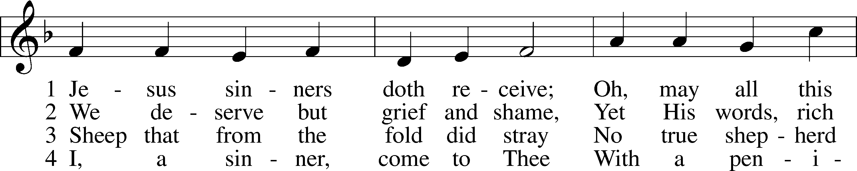
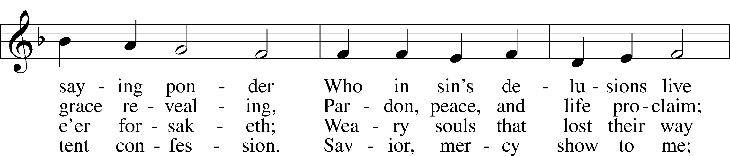
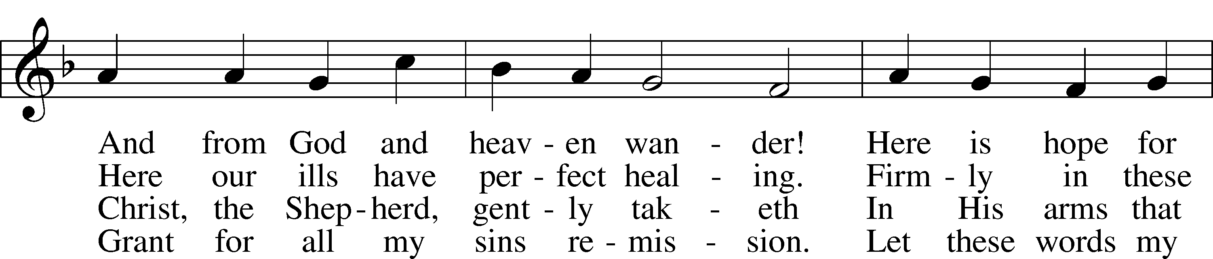
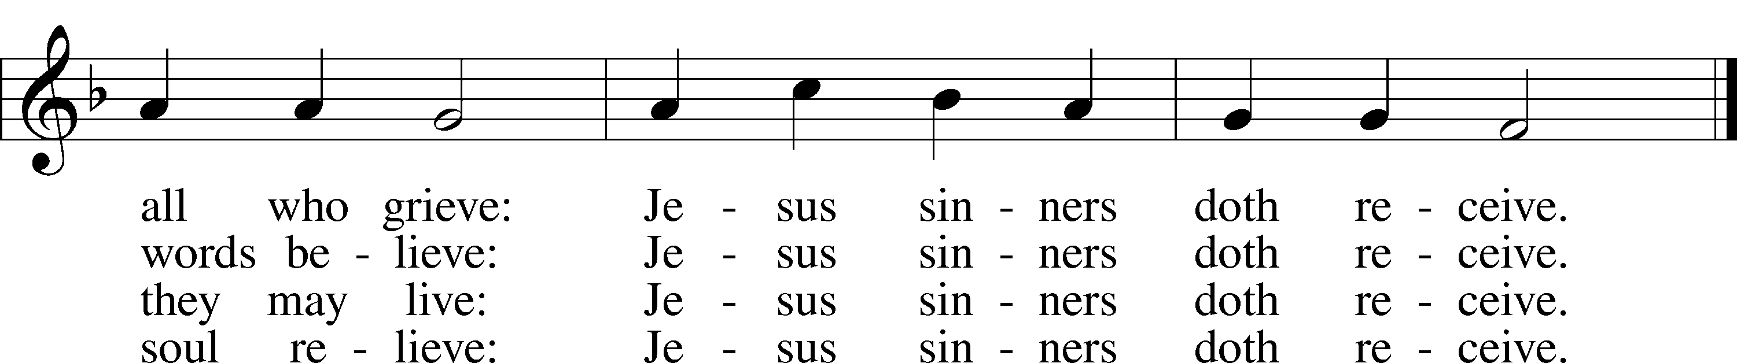

7) Jesus sinners doth receive;
Also I have been forgiven;
And when I this earth must leave,
I shall find an open heaven.
Dying, still to Him I cleave:
Jesus sinners doth receive.

Read Ezekiel 33:7-9
1. Explain the scenario described in Ezekiel 33:1-5.

2. Explain the scenario described in Ezekiel 33:6.

3. What important context do these verses provide for today’s text?

4. According to this reading, what responsibility do we have?
Read Matthew 18:1-20

5. What does the disciples’ question in Matthew 18:1 say about them? See also Matthew 20:21 and Luke 22:24.

6. In the ESV translation verse 3 reads, “unless you turn and become like little children, you will never enter the kingdom of heaven.” What exactly does this mean?

7. In verse 6, Jesus shifts from talking about little children to little ones. What’s the difference and who are the little ones?

8. Why does Jesus speak such stern words of warning in verses 7-9?

9. According to verse 14, what is the will of the Father? See also I Timothy 2:4.

10. Verses 15-20 deal with a very practical application of the theology found in the first 14 verses of Matthew 18. How does Jesus make this all very personal?

11. One scholar writes that this is, “Not necessarily a personal injury or injustice; if a member of the Church sins before my very eyes, then he has sinned against me, he has violated the honor of God, which is the chief concern of the believer. What is done to a believer in Jesus is performed as against Jesus.” How does this expand our understanding of a sin against our brother?

12. Briefly describe the process Jesus describes in Matthew 18:15-20. What does this look like in “real life?”

13. What is always the goal is this process?

14. In verse 18, Jesus gives the authority to forgive the sins of the repentant or retain the sins of the unrepentant. We call this authority, “The Office of the Keys.” To whom is this authority given from what you read in verses 19 and 20.

Devotional Thought from “The Lutheran Study Bible”
“Jesus commands the Church to do all it can to regain an unrepentant sinner. To humbly and lovingly speak to such a brother or sister is to follow the example of the shepherd who searched for one lost sheep. Christ has promised to stand behind the actions of the Church in either forgiving or refusing to forgive sins. We need personally to cherish His gifts and to present His Law and Gospel to anyone caught in the grip of sin. Through the precious gift of forgiveness, the door of heaven is opened to each repentant sinner” (TLSB, 1622).

Prayer
Loving Lord, help me to act as my brother’s keeper, even as You care for me and keep me by grace. Amen.

MY OBLIGATION TOWARD MY BROTHER
Ylvisaker: In this discourse Jesus taught us that they who desire to be His disciples must seek true greatness in self-abasement (1-4), that such persons are for Jesus' sake held in high esteem in heaven (5-14), that we shall for this reason employ all diligence in our effort to reclaim the one who has sinned (15-17), that a Christian church in this respect possesses great power (18-20), that we, as brethren who are united in the strong bonds of brotherly love, shall be ever willing to forgive one another (21-35).
Beck's AAT has these brief captions:
- Who Is the Greatest? 1-5;
- Do I Lead Others to Sin? 6-14;
- Tell Him His Fault 15-20;
- Forgive! 21-35.
Fahling: The heavenly Father has but one will, the will to save. This includes all, young and old. It also includes those who have fallen into sin, but who by loving patience and hard work might be won back.
The parable of the lost sheep (verses 12-14) shows how valuable the straying sinner is to Jesus. Galatians 6:1-5 is similar but yet dissimilar to Matthew 18:15-20. Our pericope speaks of my obligation toward an erring brother who must be convinced of his sin. Galatians 6:1-5 speaks of my humble obligation toward a penitent sinner who has been overpowered and overcome by sin. In Galatians 6:1-5 the use of Gospel is primary. In Matthew 18:15-20 clearly Law must be used first. If acknowledgment of sin takes place, Gospel must be applied.

Matthew 18:15 If your brother sins against you, go and show him his fault, just between the two of you. If he listens to you, you have won your brother over.
Fahling: It is not necessarily a strictly personal offense, but an evident act against a certain word of God.
Ylvisaker: Not necessarily a personal injury or injustice; if a member of the Church sins before my very eyes, then he has sinned against me, he has violated the honor of God, which is the chief concern of the believer. What is done to a believer in Jesus is performed as against Jesus.
Compare Leviticus 19:17 for the same thought in the Old Testament. Note that, though he is in danger, he is still to be treated as brother. This shows that it is a sin, unrepented, which endangers his relationship to God.
You take the initiative. Don't wait til he comes to you, which will likely never happen. In the Large Catechism, under the 8th Commandment (Tappert 402.277-283), Luther quotes verses 15 and 16 as a proper antidote for governing the tongue and thus not gossiping behind our brother's back. Gossiping destroys proper church discipline.
Don't be surprised if you need approach a fellow Christian for the purpose of pointing out a clear case of unrepented sin in his life. Furthermore, go expecting him to listen to you effectively. Read Luke 5:7 and 10. Heaven reverberates when confession of sin and forgiveness thereof occur.

Matthew 18:16 But if he will not listen, take one or two others along, so that "every matter may be established by the testimony of two or three witnesses."
"If" in 15 denotes progression of thought but the three "if" in 16 and 17 denote failure to bring to repentance. In verses 15-17 we have five conditions, in fact they pervade the whole pericope. In other words, don't be surprised if this happens.
"One or two others," more frequent in Matthew than in the other Gospels, often denotes close association, here evidently implying careful choosing. The principle here enunciated (taken from LXX Deuteronomy 19:15) is found also at John 8:17; 2 Corinthians 13:1 and 1 Timothy 5:19.
Bengel: This passage is one of those which prove that the principles and rules of the forensic law of Moses are not entirely excluded from the polity of the Church of Christ.
In verse 15 we had only one to one, which is most conducive to restoration, assuming pliability on the part of the erring brother. But in 16 we have "one or two more" assuming a certain amount of rigidity on the part of the erring brother. One or two more will the more easily break through this rigidity. Furthermore, there may be necessity later to call the one or two more as witnesses, in the event of failure.
For the word "every matter" we have a variety of translations: "word, accusation, matter, charge, fact." Perhaps AAT is simplest and neatest: "So that you have two or three witnesses for everything," for everything said and done. Sometimes the way in which something is handled is just as important as what is said.

Matthew 18:17 If he refuses to listen to them, tell it to the church; and if he refuses to listen even to the church, treat him as you would a pagan or a tax collector.
"Refuses to listen" means "to close the ears to." Six of our translations, from RSV to NKJV have "refuses." The verse implies that the two or three have spoken.
"Tell it to the congregation." That is plainly the meaning here. Christian congregations had not yet been established, but the omniscient Jesus looks ahead. It is obviously clearly implied that the original person and the witness(es) are members of the same congregations as is the accused.
Does the "if" mean "refuses to listen even to the church" (RSV, NIV, NASB) or "won't even listen to the church" (AAT)? We think the former is preferable. The local congregation is the highest spiritual authority on earth, no matter how small. If the accused refuses to listen even to the congregation, there is no higher authority on earth.
Compare the specific case at 1 Corinthians 5:1-13 and 2 Corinthians 2:3ff. If the accused refuses to acknowledge his sin "let him be to you just as the Gentile and the publican." "Go to him" denotes first the accuser of verse 15, but surely includes all members of the congregation. The Gentile was not under the covenant of grace. The publican was considered as one who had rejected the covenant of grace. The meaning is clear: "Don't consider the impenitent sinner under the covenant of grace so long as he rejects it by his impenitence." We think of John 3:36^{b}; Hebrews 3:12-19.
This is the major New Testament passage on excommunication. There is nothing in the whole wide world so truthful as is Christianity. It does not blink at unrepented sin. It rescues the repentant sinner from hell and everlasting condemnation. It hardly need be said that the steps in church discipline proceed from love of restoring the lost sheep (verses 12-14).

Matthew 18:18 I tell you the truth, whatever you bind on earth will be bound in heaven, and whatever you loose on earth will be loosed in heaven.
Compare the parallel passages at Matthew 16:19 and John 20:23. Compare what was said of verse 19 in the pericope for Pentecost XIV.
Book of Concord, Tappert 324.24.: The keys do not belong to the person or one particular individual but to the whole church, as is shown by many clear and powerful arguments, for after speaking of the keys in Matthew 18:19, Christ said' If two or three of you agree on earth ' etc. Therefore, he bestows the keys especially and immediately on the church, and for the same reason the church especially possesses the right of vocation.
Book of Concord, Tappert 203.138: Christ is talking about the remission of sins when he speaks Matthew 18:18. This remission removes eternal death and brings eternal life.
Book of Concord, Tappert 311.1: The keys are a function and power given to the church by Christ (Matthew 16:19; 18:18) to bind and loose sins, not only the gross and manifest sins but also those which are subtle and secret and which God alone perceives. So it is written 'Who can discern his errors?' (Psalm 19:12). And Paul himself complains (Romans 7:23) that in his flesh he was a captive to the law of sin'. It is not in our power but in God's alone to judge which, how great, and many our sins are.
By the way, two translations are here rejected: TEV "prohibit--permit" and "forbid--allow." The Christian congregation should never relinquish this power, given to it by Christ, to an individual or council. Synod is not a church in the sense that the local congregation is.
Formerly we were known as "The Evangelical Lutheran Synod of Missouri, Ohio and other States." For several reasons it was changed to "The Lutheran Church-Missouri Synod." We must remember that here the word "church" is synonymous with the word "synod," a federation of local congregations, not a "church" which usurps the office of the keys.
Ylvisaker: The Saviour has now cited the steps of admonition which applies in church discipline even today. There are instances in Holy Writ where the two first steps in order are omitted (1 Timothy 5:20). Paul disregarded both in the case of Peter (Galatians 2:11). But Scripture does not state that they must be ignored in such cases and that the matter forthwith must be placed before the church. Charity, which is the supreme law, may urge that we observe the regular rule, even in instances when the sin is apparent to all.

Matthew 18:19 Again, I tell you that if two of you on earth agree about anything you ask for, it will be done for you by my Father in heaven.
Bengel: The same thing is repeated in somewhat different language.
This is followed by JB which translates "I tell you solemnly once again." However, Lenski differs.
Lenski: Again, is like 'furthermore'. It adds something that is necessary as a separate point.
This is followed by TEV which translates "And I tell you more." The second is preferable. There are similarities:
- The antithesis of "on the earth" and "in heaven" repeated from verse 18;
- The assurance that joint actions by Christians are effective in heaven.
But there is the added element of the two (verse 16) talking things over and praying. Furthermore, this verse might apply to verse 15 in the event that the erring brother has acknowledged his sin and been forgiven.
Luther in the Smalcald Articles, Tappert 310:
The Gospel offers counsel and help against sin in more than one way, for God is surpassingly rich in his grace: First, through the spoken word, by which the forgiveness of sin (the peculiar function of the Gospel) is preached to the whole world; second, through Baptism; third through the holy Sacrament of the Altar; fourth, through the power of the keys; and finally, through the mutual conversation and consolation of brethren, Matthew 18:20.
"Concerning every matter which they shall ask." To what does this refer? The context speaks of forgiving sins or withholding forgiveness in the event of impenitence. To these there are no exceptions: "It shall be to them from My Father in heaven." But it should be obvious that this verse does not cover personal requests in an unqualified way. Such requests must be made with the added thought "if it by Thy will."

Matthew 18:20 For where two or three come together in my name, there am I with them.
This verse gives us the reason on which the truth of verse 19 is based. "Where" is best treated as a periphrastic construction "have been and still are gathered together." "Two or three" denotes a small number. This does not mean that every time two or three gather, there you have a Christian congregation. But, it surely does indicate that a Christian congregation, though very small in number, has the same power of the keys as does a large congregation.
Most translations (eight of them) translate "in my name." LB has "because they are mine." AAT reads "to be with Me." Bengel suggests that it read "unto my name" meaning "with the object of worshipping it." The question is whether "in" is static (in) or denotes purpose. In any case it denotes the faith relationship between believer and Savior. "Where--there." Jesus speaks not only of a place, but also of a relationship.
The last part of verse 20 reminds one of Matthew 28:20. What they have in common is the promise not just of the omnipresence of the exalted Christ, but rather His gracious presence. He sits right with us in church. He goes with Christian husband and wife. The whole point is the assurance of His gracious presence.
Verses 21-35, which follow our pericope, are devoted to the necessity of constant forgiveness. Therefore, as Luther points out (in the reference to the Smalcald Articles quoted above), verses 19-20 speak of Christians consoling each other mutually with the Gospel. If only husbands and wives, parents and children, and Christians in general, would use the many opportunities to console each other with the Gospel!
We owe it to each other to unburden guilty consciences, to quiet fears caused by the guilt of sin The Father in heaven forgives when Christians forgive. The Lord Jesus is in the midst of Christians who exercise the Office of the Keys. He heartily approves of what they say and do.
The Christians' greatest need is the Gospel. If only we would remember that! Nothing binds Christians so closely together as does constant and mutual assurance of the forgiveness of sins. The preacher ought press this point in his sermon.

