Pastor’s Bible Class

The Eleventh Sunday After Pentecost

#575 “My Hope Is Built on Nothing Less”
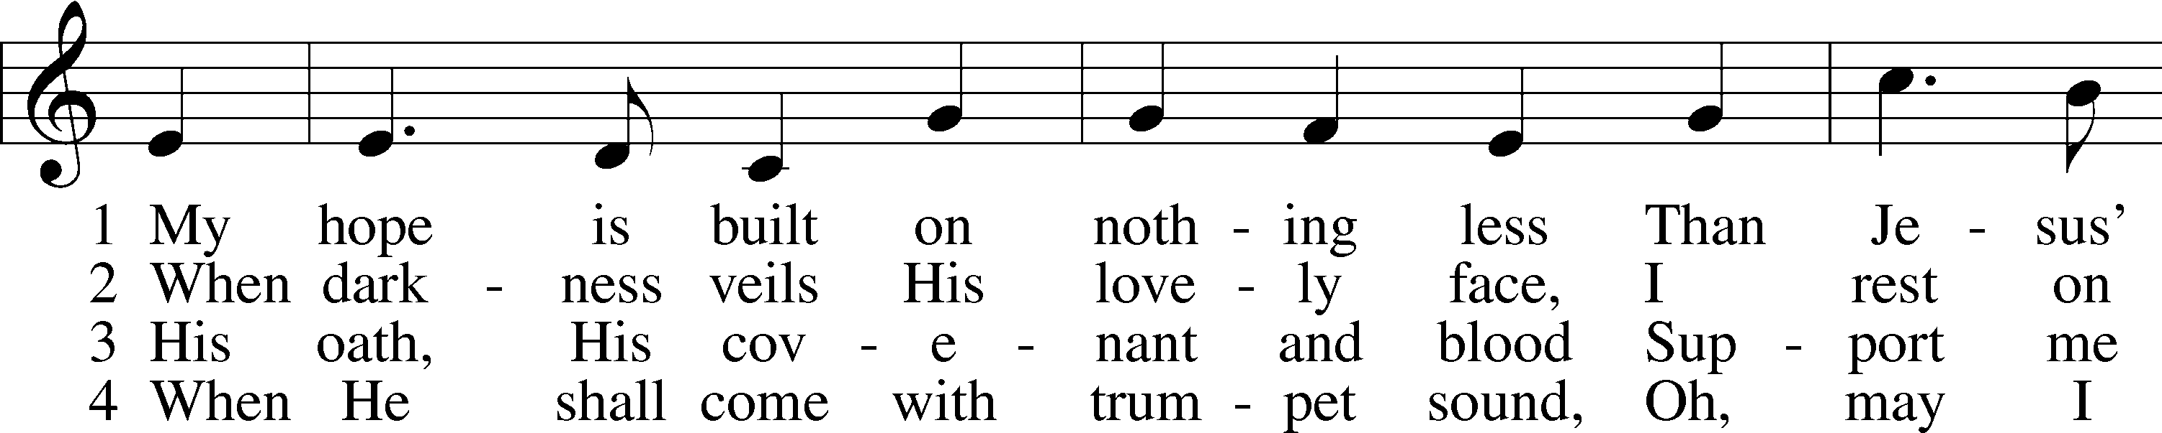
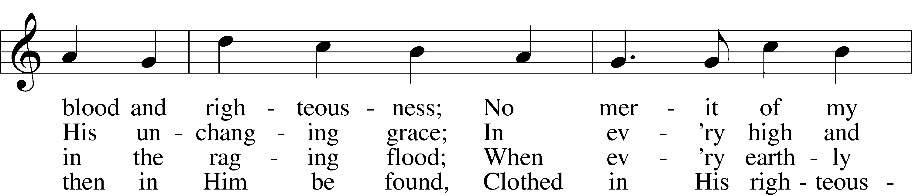
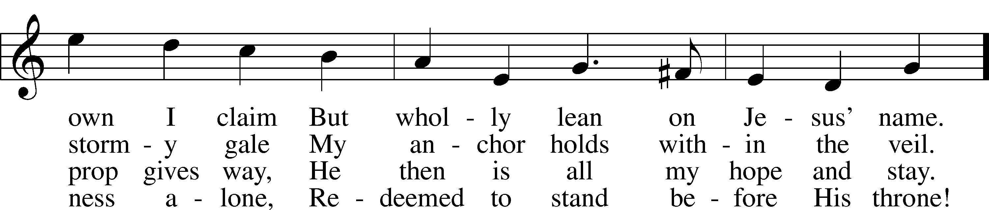
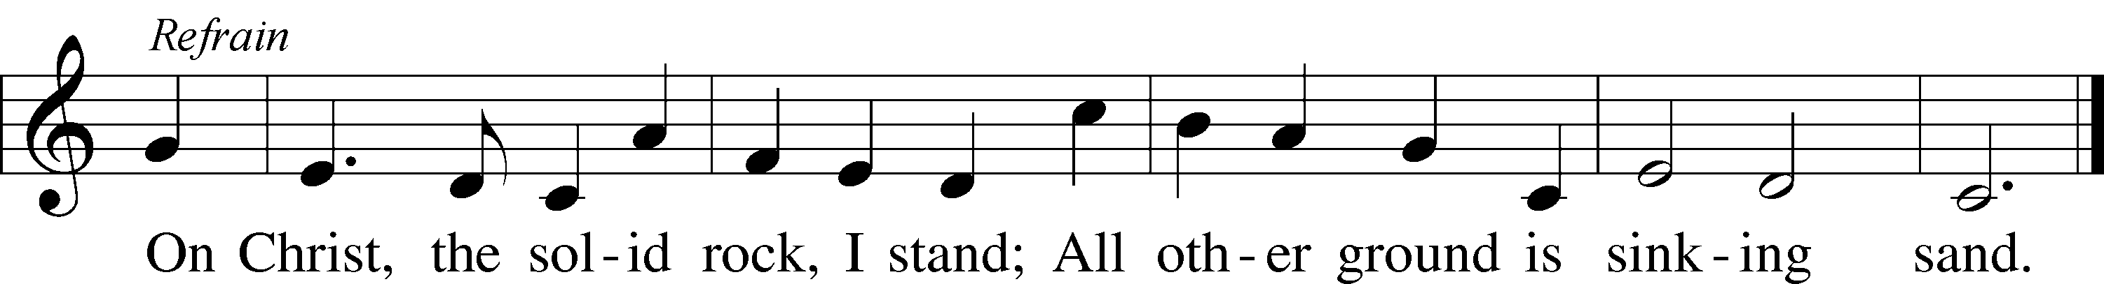

Read Isaiah 51:1-6

1. “Rock” language shows up in both of our readings. From what “rock” does Isaiah tell his readers they were hewn?

2. What does Scripture teach us about this “rock” from which God’s chosen people were brought forth? See Hebrews 11:8-12.

3. Read I Corinthians 1:27-28. How are these words reflected in Isaiah 51:2-3?

4. In verse 4, God says, “my justice will become a light to the nations” and in verse 5, “My righteousness draws near speedily…” To what is He referring and what will the results of God’s justice and righteousness be?
Read Matthew 16:13-20

5. What is the focus of Jesus’ question in verse 13?

6. Who responds to the question and what answers are given? See Matthew 14:2 and 17:10.

7. How does Jesus’ second question differ from His first?

8. What is the significance of Peter’s answer? See John 1:41 and John 4:25.

9. What does Jesus’ response in verse 17 tell us about Peter’s (and our) confession of faith? See Galatians 1:11-24.

10. In verse 18, Jesus says, “You are Peter, and on this rock I will build my church.” In Greek, this verse reads, “You are Peter (Petros) and on this rock (petra) I will build my church.” About this verse, Isidore of Seville, (a bishop of the Church of Rome, 602-636 A.D.), in a writing called Etymologies wrote:
“Petros got his name from petra, that is from Christ, upon Whom the Church is founded. For petra is not derived from petros, but petros from petra, just as Christ is not derived from Christian, but vice versa, and in keeping with this the Lord said: 'You are petros, and upon this petra I will build my church' because Petros had said: 'You are Christ, the Son of the living God.' Then the Lord said to him 'Upon this petra, which you have confessed 'I will build my church. ' For petra was Christ, upon which foundation also Peter himself was built.”

What is the rock on which the Church is built? See Matthew 7:24-25; Romans 9:33; I Corinthians 10:4 and Ephesians 2:20.

11. What gift does Jesus promise in verse 19? To whom is this gift given? See Matthew 18:18 and John 20:22-23.

Devotional Thought from “The Lutheran Study Bible”
Peter’s confession of Jesus as the Messiah and the Son of God was a key event in Jesus’ ministry. To confess Jesus as Savior and Lord is also essential in every believer’s life. Some Christians will remember the very moment this first happened. Other Christians, baptized in infancy, have made this confession again and again in daily life. Like Peter, none of us can by our own reason or strength believe in Jesus Christ, but the Holy Spirit has called us by the Gospel and as royal priests of God we, “proclaim the excellencies of Him who called us out of darkness and into His marvelous light” (TLSB, 1614).

Prayer
Grant us grace, Heavenly Father, to confess Jesus and so remain on the unshakable rock of our salvation. Amen.

YOU ARE THE CHRIST,
THE SON OF THE LIVING GOD
There is no direct connection between this pericope and that which precedes. Nor do the parallels (Mark 8:27-30; Luke 9:18-21) indicate a connection. But, from a study of the Gospels, we know that, at this point, we are less than a year from Jesus' suffering and death. It is not the same incident as John 6:69, where Peter confessed Christ. That was just a year prior to Jesus' death. The last year of Jesus' life involved increasing rejection of Him by Israel. He spent much of His time during that last year alone with the disciples teaching them and preparing them for the ordeal of His suffering and death.

Matthew 16:13 When Jesus came to the region of Caesarea Philippi, he asked his disciples, "Who do people say the Son of Man is?"
They came out of the land of Israel, toward the north "into the district of, to the territory near, to the region of, to the neighborhood of" the city of Caesarea. The city (not on the coast but north of Galilee) was rebuilt and beautified by Philip, Herod's son. He named it after himself "Caesarea Philippi."
Jesus and the disciples spent time alone, near the city. "He was asking His disciples," not for His own sake (for information) but for their own sake.
"The Son of man" is in the predicate. This term is derived from Daniel 7:13 where it is used eschatologically. In the Gospels it is used both of the state of humiliation (e.g. John 1:51) and of the state of exaltation (e.g. Luke 21:27). It is also derived from Psalm 8:4 (compare Hebrews 2:6) where it is applied primarily to the state of humiliation of Christ. The term is applied to the incarnate Christ with emphasis on His humanity. It is clear from Jesus' question to the disciples that they understood that Jesus meant Himself.

Matthew 16:14 They replied, "Some say John the Baptist; others say Elijah; and still others, Jeremiah or one of the prophets."
"They" not just Peter. There are variety of people with a variety of opinions. For the first opinion see Matthew 14:2. Some people followed Herod's opinion. For the second opinion see Matthew 17:10, a mere forerunner, not the Messiah. "Jeremiah or one of the prophets," probably legends among the Jews which said that Jeremiah or one of the prophets would come back to life and precede the Messiah.
Bengel: They did not think that anything greater could come than they had already had.
Stoeckhardt: They considered Him a mere man, though equipped by God with exceptional gifts and powers.
Ylvisaker: The people find in Jesus only a precursor of the Messiah and not the Messiah Himself. He did not fulfill the political expectations of the people.
Fahling: The public opinion upon the whole was favorable, though crude. . . . A prophet, but not THE prophet. They thought well of Him, but not well enough.
Lenski: What he (Jesus) desires is to have the disciples state the wrong opinions of men in order to set over against them their own right conviction.
Beginning with the confession of the Baptist (John 1:29) the disciples had already made confessions of Jesus (John 1:41.45.49; Matthew 14:33; John 6:69). Peter had made the confession at John 6:69, shortly before this, in the name of all the disciples. He was primus inter pares, first among equals but not exclusively.

Matthew 16:15 "But what about you?" he asked. "Who do you say I am?"
"You" means all the disciples, not just Peter. It is crystal clear from this question that Jesus equates Himself with "the Son of man" in verse 13. The Unitarians and rationalists claim that Jesus never called Himself "the Son of man." That is patently wrong. Peter's answer in the next verse clearly shows that they and Jesus identified Jesus with "the Son of man."

Matthew 16:16 Simon Peter answered, "You are the Christ, the Son of the living God."
From the previous verse it is clear that Peter speaks for all, as he did at John 6:69. His confession is also that of the other disciples. Peter is saying: "You exclusively, no one else etc." "The Christ" is God-incarnate, anointed with the Holy Spirit. Compare John 1:41; 4:25, and in the Old Testament Daniel 9:25.26.
On "Son of God" compare Daniel 3:25; Matthew 14:33; 26:63. "The Son of God" is the incarnate Christ with emphasis on His divinity. "Of the Living God" is genitive of relation. He is not only "living" but "life-giving." Compare John 1:4; 6:54.68.
By the way, John 6:68 clearly shows that the disciples came to this conviction through the means, the Gospel.
Lenski: As 'the living' who has life and power in himself, God is me opposite of all other gods who are dead, lifeless, powerless idols.
He is living, gives life, and associates Himself with me living, not the dead. Compare Luke 20:38.

Matthew 16:17 Jesus replied, "Blessed are you, Simon son of Jonah, for this was not revealed to you by man, but by my Father in heaven.
"Blessed" always denotes the blessedness of the repentant and believing child of God. Its specific meaning is governed by the context. Compare the beatitudes at Matthew 5:3-11. The blessedness is always a gift of God.
Three translations are rejected: TEV "good for you;" JB "you are a happy man;" NEB "you are favoured indeed." Jesus calls Peter "Simon, son of Jonah."
Bengel: This express naming signifies that the Lord knoweth them that are his.
Compare Isaiah 43:1 and Luke 10:20.
Lenski: The name 'Simon, son of John' significantly points to what Peter was by nature. Over against his natural powers and abilities Jesus intends to place his new spiritual gifts.
Compare Galatians 1:11-17 where Paul tells the Galatians that he received the Gospel not by conferring with "flesh and blood" (verse 16) but by revelation from God. The apostleship of Peter and Paul was identical, not of sinful, human origin but by revelation. In Matthew 16:14 we have the products of "flesh and blood," mere opinions which fall far short of truth, helping no one.
Ylvisaker: The conception which the people had formed of the Messiah was a carnal caricature (John 6:14.15).
Lenski: What is true of the inability of Peter's flesh and blood is equally true of the inability of the flesh and blood or the natural powers of all men. . . . The revelation here referred to goes beyond mere intellectual knowledge and extends to spiritual conviction and apprehension. . . . The Father revealed Jesus to Peter through Jesus himself. . . . This word of Jesus is proof for our own confession: 'I believe that I cannot by my own reason or strength believe in Jesus Christ, my Lord, or come to Him etc.
Compare Matthew 11:27. The preaching and teaching of the Gospel brings the revelation which sinful flesh and blood can never bring. By the way, note Jesus' great humility. He had revealed the Father to His disciples by His Word and miracles, but He gives all glory to the Father as the Revealer.

Matthew 16:18 And I tell you that you are Peter, and on this rock I will build my church, and the gates of Hades will not overcome it.
In verse 16 Peter, owing to the Father's revelation, confessed Christ. In verse 17 Jesus, Himself the very revelation of Truth, confessed Peter. Read Matthew 10:32. In verse 18 the confession is extended: "And I also say to you that you are Peter etc." Peter had confessed Christ. Now Christ confesses Peter. He pays Peter high honor but, except for the fact that Peter was an Apostle, Christ pays Peter no higher honor than He pays any confessor of Christ. Thus far Christ is acknowledging Peter as His very own.
Note that "Peter/petrus" is masculine but "rock/petra" is feminine. Jesus is making a clear distinction. The two are not identical. Even Bengel, who is usually trustworthy, errs here by saying that in the original Aramaic (which Jesus spoke) no such distinction of gender can be made. Jesus did make a distinction in Aramaic because we have the words recorded in Greek, which makes a distinction.
Ylvisaker: We are not concerned with the Aramaic terms which we have before us. Beyond these even an angel has no right to venture, and according to them we must admit that Simon is not "Peter (feminine)" , he is merely "Peter (masculine)."
"Peter (feminine)" a character as of the rock; and such a character he has become, because he, in faith, which was expressed so gloriously in his confession, is built upon Him who is the true rock, Jesus Christ. He is in Scripture often called a rock, while in no other passage do we find even an intimation to the effect that human beings should be so designated (Matthew 7:24.25; Romans 9:33; 1 Corinthians 10:4; 1 Peter 2:7). Christ is admittedly the rock in this passage also, upon which the Church shall be built; He is likewise the foundation (1 Corinthians 3:11) and the chief corner-stone (Ephesians 2:20).
Fahling: Jesus does not say that His Church is to be built on the person of Peter, but upon 'this rock' . . . Peterlike faith admits into the kingdom of heaven.
Lenski: The feminine term (Peter/rock) indicates what made Peter a rock. That was, of course, not his confession but the divine revelation from which that confession sprang and to which Jesus refers to significantly in verse 17. But this revelation was not intended for Peter alone; all the disciples shared it, and, due to this revelation, all of them confessed Peter's confession.
Isidore of Seville, a bishop of the Church of Rome, 602-636 A.D., in a writing called Etymologies (Book VII, IX, par. 2) wrote (in Latin):
Petrus got his name from petra, that is from Christ, upon Whom the Church is founded. For petra is not derived from petrus, but petrus from petra, just as Christ is not derived from Christian, but vice versa, and in keeping with this the Lord said: 'You are petrus, and upon this petra I will build my church' because Petrus had said: 'You are Christ, the Son of the living God.' Then the Lord said to him 'Upon this petra, which you have confessed 'I will build my church. ' For petra was Christ, upon which foundation also Peter himself was built.
This quote clearly shows that in 600 A.D. the Church of Rome did not yet call Peter Christ's vicar on earth. That came later.
To sum up all of this: "petra" here involves us immediately with Christ, the foundation, the revelation of God through Christ, the Apostolic Word (Ephesians 2:20), and the resultant confession of the believer. The word petra does not point to "flesh and blood" but to the Christ, the Son of the living God.
Now follow two future verbs in the first person singular, one in this verse and one in the next. Both refer to Christ. "I will build," not Peter, but Christ. "MY Church." Not Peter's, but Christ's.
Here "church" is the Una Sancta , the sum total of all believers. This word occurs in the Gospels only once more, at Matthew 18:17, where it denotes the local congregation. Jesus is speaking of the New Testament Church which was born on Pentecost Day.
"And" means "and therefore" (because CHRIST builds the Church). "The gates of hell" denotes the formidable powers and forces of Satan, his angels and all his followers among men. They will not overpower or conquer it.
Only three translations are recommended:
- AV "the gates of hell;"
- LB "the powers of hell;"
- AAT "the forces of hell."
For obvious reasons the following are rejected:
- RSV and NEB "the powers of death;"
- TEV "not even death;"
- NIV (used in these Notes), NKJV, NASB "the gates of Hades;"
- JB "the gates of the underworld."
Plainly, in Matthew 16:18 "hell" means far more than death or the realm of the dead. "The gates of hell" pictures the citadel of Satan, a formidable power indeed, but unable to overcome or overpower the true church.

Matthew 16:19 I will give you the keys of the kingdom of heaven; whatever you bind on earth will be bound in heaven, and whatever you loose on earth will be loosed in heaven."
"I will give to you" is a gift of Christ. You should not be limited to Peter for, if that were the case, what did Jesus give (or not give) to the other disciples? In view of Matthew 18:18 and John 20:23 Jesus gave the keys to all Christians after Pentecost. Jesus is speaking of the New Testament Church.
"Of the kingdom" is telling us what kind of keys. The expression means "the kingdom of grace which leads to the kingdom of glory." The giving of Christ results in binding and loosing. Two translations are rejected: TEV "prohibit-permit;" NEB "forbid-allow." It is far more than that. We recommend NASB "whatever you shall bind on earth shall have been bound in heaven, and whatever you shall loose on earth shall have been loosed in heaven." The expression "whatever" is found in both parts, covering all aspects of the life of the members of the church.
But notice the contrasts: "bind - loose, shall have been bound - shall have been loosed, on earth - in heaven." All of this denotes the proper use of Law and Gospel by individuals and congregations in the New Testament Church. The pastor ought read again the fifth chief part of Luther's Small Catechism "The Office of the Keys and Confession," so lucid, so simple, so Scriptural.
Only when individuals and congregations, by revelation through Scripture, properly confess Christ, Who then confesses them, can they be sure that He is building the church among them, and then can properly handle the Office of the Keys, not according to the standards of flesh and blood. The perfect participles indicate that the Keys are applied on the basis of what is already true.
The sins of impenitent sinners "have been bound", are already unforgiven before God. The sins of penitent sinners "have been loosed" because such forgiveness is based on the universal atonement. The use of the Keys applies to every aspect of the work of the church: preaching, teaching, absolution, baptism, the Lord's Supper, individual calls, etc. It is the very life of the church.

Matthew 16:20 Then he warned his disciples not to tell anyone that he was the Christ.
This verse involves us in a strict prohibition. We know from other passages that the death, resurrection and ascension of Christ lifted this restriction.
Bengel: Had they done so (told people that Jesus was the Messiah), those who believed in any way that Jesus was the Christ might have sought for an earthly kingdom with seditious uproar; whilst the rest, and by far the greater number, might have rejected such a Messiah at that time more vehemently, and have been guilty of greater sin in crucifying Him, so as to have had the door of repentance less open to them for the future.
Ylvisaker: Only after the carnal Christ illusion had been forever nailed to the cross could the apostolic preaching without jeopardy join the Christ name to the name of Jesus. Nor were the disciples yet fitted to proclaim Him as the Messiah. The carnal conceptions of the populace still adhered to them. . . . When they were sent upon their first missionary journey, Jesus did not ask them to proclaim Him as the Messiah, but they should preach the advent completed on earth, the world was to ring with the confession that this Jesus was 'the Christ', Acts 3:13-26; 4:10-12; 5:30-32 etc.
The Book of Concord quotes verse 15 once, verse 18 ten times, and verse 19 five times, in other words, sixteen references to this pericope. This is indicative of the fact that the Reformers restored the proper understanding of the Office of the Keys, so vital to the life of the church, so beclouded by the Papacy and the hierarchy of the Church of Rome.
Treatise on the Primacy of the Pope, Tappert 324.23: These words (verse 15) show that the keys were given equally to all the apostles and that all the apostles were sent out as equals. . . . As to the statement 'On this rock I will build my church' (Matthew 16:18) it is certain that the church is not built on the authority of a man but on the ministry of the confession which Peter made when he declared Jesus to be the Christ, the Son of God. Therefore Christ addresses Peter as a minister and says 'On this rock' that is, on this ministry)'
The Apology quotes verse 18 no less than four times, with reference to Justification twice (Tappert 119.85 and 145.26), with reference to Repentance (Tappert 191.63) once, and with reference to the Mass once (Tappert 251.11.12). What these references have in common is this that the declaration of the forgiveness of sins for Jesus' sake, by faith, cannot be overthrown by the forces of hell. The Solid Declaration and the Epitome quote Matthew 16:18 (along with John 10:28 and other passages) three times with reference to the article on Election. The references are found at Tappert 495.5; 617.8 and 624.50. One sentence from these references summarizes all:
Our salvation is so firmly established upon it (election) that the gates of hell cannot prevail against it (John 10:28; Matthew 16:18).
In these days of so much false ecumenicity we must proclaim these truths clearly and courageously for thus we confess Christ before men, as did Peter.
In verse 18 Jesus said: "Thou art Petros." It has often been noted by exegetes that Christ is speaking of the rocklike character of Peter on this occasion. True. But Peter is not the exception, but rather the rule, among Christians so long as this God-given confession of Christ is truly believed. That becomes clearer in the verses which follow our text. In verse 22 Peter became an offense, a stumbling block, to Christ. Though meaning well, Peter was practically saying that Christ should not suffer, die and be raised again on the third day. That was plainest unbelief. Was Peter the exception or does he represent the rule, in this case? That will be taken up in the next pericope.

