Pastor’s Bible Class

The Eighteenth Sunday after Pentecost

#571 “God Loved the World So That He Gave”
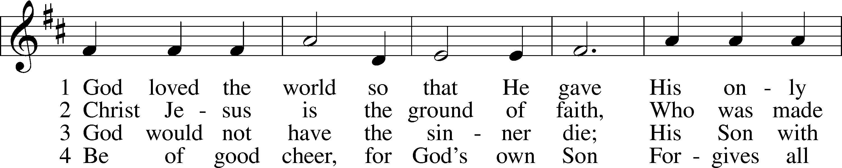
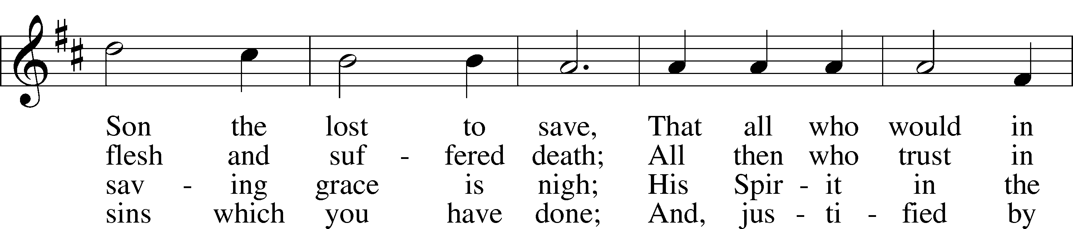
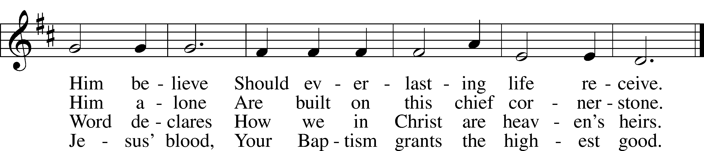

5 If you are sick, if death is near,
This truth your troubled heart can cheer:
Christ Jesus saves your soul from death;
That is the firmest ground of faith.

6 Glory to God the Father, Son,
And Holy Spirit, Three in One!
To You, O blessèd Trinity,
Be praise now and eternally!

Read Isaiah 5:1-7
1. Who is the subject of Isaiah’s song?

2. In this parable, Isaiah tells a story that describes all that God had done for His people, referred to here as “choice vines.” List some of the ways in which God uniquely blessed Israel. See Romans 9:1-5.

3. What is the result of all the vinedresser’s work?

4. In verse 3, Isaiah reveals his audience. To whom is God speaking and what question does He ask in verse 4?

5. Without waiting for an answer, God launches into a section full of stern judgment. What does He promise in verses 5-7?

Read Matthew 21:33-46

6. How do Christ’s words in 21:28-32 set the stage for this parable?

7. What similarities exist between Isaiah’s parable in Isaiah 5:1-7 and the opening words of this parable? Why does this matter?

8. What new elements are introduced in verses 33-34?

9. Who is represented by the string of “servants” sent by the Master to collect the fruit? See Acts 7:52.

10. And the Son?

11. To whom does Jesus direct His question about the parable in verse 40?

12. Explain the quotation from Psalm 118 spoken by Jesus in verse 42.

13. What is the result of Jesus’ parable?

Devotional Thought from “The Lutheran Study Bible”
“Jesus warns His opponents that rejecting Him will ultimately lead to their exclusion from the Kingdom. Judgment is based on one’s reaction to Jesus. Those rejecting Him are excluded from God’s kingdom and are consigned to the only other option: an eternity apart from God in hell. In His great wisdom and mercy, God used the murder of His Son to work salvation, and He used the rejection of Israel’s leaders to hasten the extension of the Kingdom to the Gentiles ” (TLSB, 1630).

Prayer
Heavenly Father, keep us united by faith to Christ, our source of life, lest we ever turn away, reject Him and lose our hope of salvation. Amen.

