Pastor’s Bible Class

The Last Sunday of the Church Year
Christ the King Sunday

Hymn 524 “How Sweet the Name of Jesus Sounds”

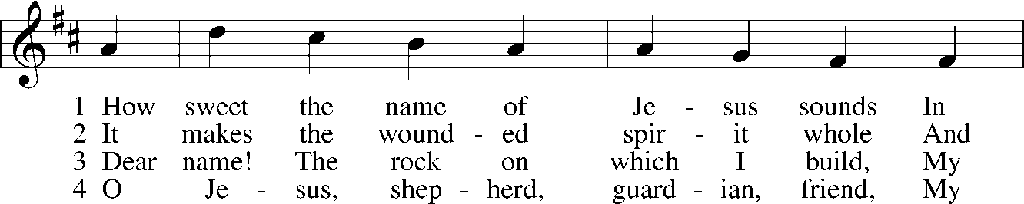
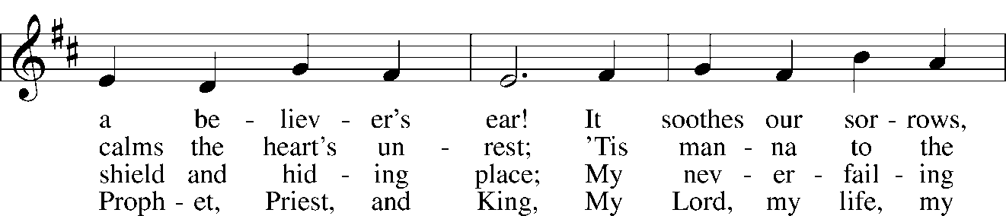
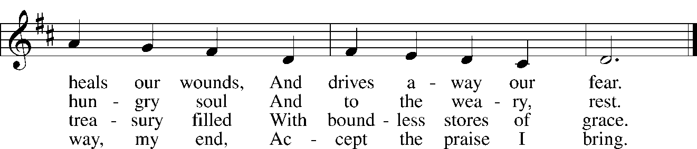

Read Daniel 7:9-10, 13-14
1. This reading opens in the throne room of the Ancient of Days. The book of Daniel is the only place in Scripture where this phrase is used to describe God. What does this title imply? See Isaiah 43:12-13; Psalm 90:1-2; I Timothy 1:17.

2. Read Revelation 1:12-18. How do these verses help to explain the identity of the Ancient of Days from Daniel 7?

3. What do the following images from Daniel’s vision mean?

A. his clothing was as white as snow and the hair of his head was white like wool; (See Isaiah 1:18)

B. his throne was fiery flames; (See Exodus 19:16-18)

C. a thousand thousands served him, and ten thousand times ten thousand stood before him

D. the court sat in judgment, and the books were opened (See Revelation 21:22-27)

4. What is Daniel describing in verse 13? See also Matthew 25:31 and 26:64.

5. Jesus uses the term “Son of man” 81 times in the Gospels to describe Himself. After reading Daniel 7:13, what was Jesus saying about Himself by using this title?

6. Summarize the scene in verses 13-14?

Read John 18:33-37
7. What is the reason for Pilate’s question in verse 33? See Luke 23:2.

8. How does Jesus answer this loaded question in verse 36?

9. In what ways is Jesus a king and how is this different from the understanding Pilate and the opponents of held?

10. The explanation associated with Luther’s Meaning of the Second Article speaks of the “threefold office” of Christ. How do the following verses help us better understand Christ’s office of King?

- Matthew 28:18
- 2 Timothy 4:18

Devotional Thought
Jesus declares that he left his kingdom to witness to the truth. For this purpose He was born. In this expression, Jesus affirms His eternal nature, intentional incarnation, and that He is the manifestation of truth – the Word made flesh. All who are of the truth hear and continue to hear his voice. Those who receive this witness belong to the truth as loyal subjects of Christ the King.

Prayer
Lord Jesus Christ, so govern our hearts and minds by Your Holy Spirit that, ever mindful of Your glorious return, we may persevere in both faith and holiness of living; for You live and reign with the Father and the Holy Spirit, one God, now and forever. Amen.

